Intermediate

Crime Scene Search

Course Number 2106
Texas Commission on Law Enforcement

Revised 2019

Abstract

This guide is designed to assist the instructor in developing an appropriate lesson plan to teach the course learning objectives. The learning objectives are the minimum required content of the Intermediate Crime Scene Search Course. This course is a required course to obtain the Intermediate proficiency certification.

Note to Trainers: It is the responsibility of the coordinator to ensure this curriculum and its materials are kept up to date. Refer to curriculum and legal resources for changes in subject matter or laws relating to this topic as well as the Texas Commission on Law Enforcement website at www.tcole.texas.gov for edits due to course review.

Target Population: | Texas Peace Officers desiring Intermediate certification.
Student Pre-Requisites: | None
Instructor Pre-  Requisites: | Subject Matter Expert and experience teaching in the law enforcement environment.
Certification Requirements: | Individuals must meet the applicable certification standards found in Commission Rule 221.1 and 221.3.
Length of Course: | A minimum of 40 hours.
Facility Requirements: | Classroom and access to area for scenario training.
Training Options: Refer to graphic below for presentation options for this course. The Highlighted “classroom” means that this course can only be taught in a classroom format.
CLASSROOM BLENDED e-LEARNING ANY OPTION
Assessment: Assessment is required for completion of this course to ensure the student has a thorough comprehension of all learning objectives. Training providers are responsible for assessing and documenting student mastery of all objectives in this course.

Reference Materials
Refer to Bibliography for the entire course.

Glossary
Refer to Appendix A, for a definition of terms used throughout the course.

Table of Contents

Unit Topic | Page
1.0 Legal Aspects of a Crime Scene Search | 4
2.0 Preparing for a Crime Scene Investigation | 9
3.0 Investigating a Crime Scene | 15
4.0 Sketching and Photographing | 19
5.0 Fingerprinting | 26
6.0 Identification, Collection, and Preservation of Evidence | 35
7.0 DNA Evidence | 45
8.0 Specific Crime Scene Searches | 53
9.0 Simulated Crime Scene | 75
10.0 Computer and Other Electronic Evidence | 76
Bibliography | 84
Recommended Reading/Resources | 89
Appendices
Appendix A: Glossary | 91
Appendix B: Crime Scene Safety | 100
Appendix C: Best Practices for Seizing Electronic Evidence | 106
Appendix D: Technical Resources List | 112
Appendix E: Nationwide Technical Training List | 117

Legal Aspects of a Crime Scene Search

Unit Goal 1.1 The student will be able to summarize the legal aspects of a crime scene search.

1.1.1 The student will be able to explain certain objectives and legal obligations that
must be followed during a crime scene search
A. Objectives of a crime scene search
  - A crime scene search is a planned and coordinated legal search of a crime scene to locate physical evidence or witnesses to the crime under investigation
  - The objectives in conducting a search of a crime scene are to aid in
the following:
a. Can help establish that a crime has been committed. (i.e., identify the type of crime and establish the elements of the crime.)
b. Can be used to place the suspect at the scene (i.e., shoe
impressions may match those of a known suspect in the community.)
- Can be used to eliminate persons, such as through DNA testing.
- Can cause suspects confronted with physical evidence to
confess the crime
- Witness’s testimony can be supported with physical evidence.
- Can help establish where the crime was committed? How the crime was committed (M.O.)? Why the crime was committed (motive)? When the crime was committed?
B. Follow the Law
1. Local, State, and Federal laws must be abided to ensure admissibility of evidence in a court of law
2. This can be done by keeping up to date with current laws and department policy, as well as communicating with legal authorities.
3. Determine the need of a search warrant.
4. If the crime scene does not fall under your agency’s jurisdiction, identify the jurisdiction and contact appropriate agency.

1.1.2 The student will be able to identify related constitutional and criminal laws related to a crime scene search.
- Due process, U.S. Constitution, and the Bill of Rights
1. 14th Amendment – three classes of rights: 1) privileges and immunities of citizens of the U.S., 2) due process of law, and 3) equal protection under the law.
2. 4th Amendment – unreasonable searches and seizure clause; warrant clause
- 5th Amendment – self-incrimination clause
- 6th Amendment – right to confrontation clause; right to counsel clause
- Legal issues for searches
1. Probable cause
2. Exclusionary rule
- Fruit of the Poison Tree Doctrine (due process)
a. Silverthorne Lumber Co. v. United States, 251 US 385 (1918)
- Search incident to lawful arrest
  - Chimel v. California, 395 U.S. 752 (1969)
  - Maryland v. Buie, 494 U.S. 325 (1990)
  - United States v. Sokolow, 490 U.S. 1, 7 (1989)
- Good faith exception
  - United States v. Leon, 468 U.S. 897 (1984)
  - Massachusetts v. Sheppard, 468 U.S. 981 (1984)
  - Illinois v. Rodriguez, 497 U.S. 177 (1990)
- Inevitable discovery doctrine
  - Nix v. William, 467 U.S. 431 (1984)
- Computer errors exception
  - Arizona v. Evans, 514 U.S. 1 (1995)

1.1.3 The student will be able to define a search warrant
A. Definition of a search warrant (or search-and-seizure warrant)– a judge’s written order authorizing a law enforcement officer to conduct a search of a specified place and to seize evidence (Black’s Law Dictionary, 7th Ed., 1999, West Group, Inc.)
B. Specific types:
- Anticipatory – based on an affidavit showing probable cause that
evidence of a certain crime will be located at a specific time and place, at a future date.
- Blanket – authorizes officials to search more than one area; serves as
an unconstitutional warrant authorizing the seizure of everything found at a given location, without specifying which items may be seized.
- No-knock – authorizes officials to enter premises without knocking
and announcing their presence and purpose before entry (a prior announcement would lead to a destruction of items searched for or would endanger the safety of the police or another person).

1.1.4 The student will be able to describe certain requirements of a search warrant.
A. In order for a warrant to be legal, it must meet constitutional guidelines,
legal requirements, the authorization of a magistrate, and contain certain information.
B. Once a warrant is authorized, it must be executed promptly; other items
of contraband/evidence should not be sought, unless they are specified in the warrant. Items seized, other than those specified in the warrant, are not considered “within the scope of the search” and will probably be excluded from the trial, as evidence obtained illegally.
- The search process consists basically of three stages: 1) the affidavit,
2) execution of the search warrant, 3) and the search warrant return.
1.1.5 The student will be able to explain some advantages of using a search warrant.
  - Has proved to be one of the most valuable tools in criminal investigation.
  - Some of its many uses include:
1. To recover stolen property; seize drugs or other contraband
- To seize any other specific type of property used in the commission of a crime.
C. Evidence seized through the use of a search warrant may be more readily
accepted by courts than if seized without a warrant or incident to arrest.
D. An officer may be protected from civil liability.
E. May shift the legal burden to the defendant to show that the evidence was
seized illegally.
1.1.6 The student will be able to discuss search warrants according to Texas statutes.
A. Definition of search warrant | CCP 18.01
B. Grounds for issuance | CCP 18.02
C. Issuance of search warrant to photograph injured child | CCP 18.021
D. Search warrant may order arrest | CCP 18.03
E. Contents of warrant | CCP 18.04
F. Execution of warrants | CCP 18.06
G. Days allowed for warrant to run | CCP 18.07
H. Power of officer executing warrant | CCP 18.08
I. Shall seize accused and property | CCP 18.09
J. How return made | CCP 18.10
K. Custody of property found | CCP 18.11
L. Disposition of abandoned or unclaimed property | CCP 18.17
M. Disposition of gambling paraphernalia, prohibited weapons, criminal instrument, and other contraband | CCP 18.18
N. Disposition of explosive weapons and chemical dispensing devices | CCP 18.181
O. Deposit of money pending disposition | CCP 18.183
P. Disposition of seized weapons | CCP 18.19
Q. Interception and use of wires, oral, or electronic communications – Definitions | CCP 18.20
R. Testing for communicable diseases following certain arrests | CCP 18.22

1.1.7 The student will be able to explain some exceptions of a warrantless search.
- 4th Amendment – Unreasonable searches and seizure clause. “The right of
the people to be secure in their persons, houses, papers, and effects, against unreasonable searches and seizures, shall not be violated.” Warrants clause: “No warrants shall issue, but upon probable cause, supported by oath or affirmation, and particularly describing the place to be searched and the persons or things to be seized.”
- Regardless of how much probable cause an officer may have, if he or she
searches without a search warrant, there can be a legal presumption that the search is unconstitutional, so be very cautious of electing to search without a warrant.
- Exceptions of warrantless searches authorized under law.
1. Consent
  - Florida v. Royer, 460 U.S. 491 (1983)
  - Bumper v. North Carolina, 391 U.S. 543 (1968)
  - Schneckloth v. Bustamonte, 412 U.S. 218, 93 S. Ct. 2041, 36 L. Ed. 2d. 854 (1973)
  - Florida v. Jimeno, 500 U.S. 248 (1991)
- Emergency (exigent circumstances)
  - Danger
  - Threat of the suspect escaping
  - Threat of the removal or destruction of evidence (e.g. flushing it down the toilet)
  - Relevant case law:
      - Ker v. California, 374 U.S. 23, 42 (1963)
      - Cupp v. Murphy, 412 U.S. 291 (1973)
      - Warden v. Hayden, 387 U.S. 294, 303 (1967)
      - Mincey v. Arizona, 437 U.S. 385 (1978)
      - Wilson v. Arkansas, 514 U.S. 927 (1995)
- Incident to lawful arrest
  - New York v. Belton, 453 U.S. 454 (1981)
- Stop-and-frisk
  - To investigate suspicions circumstance
  - To make identification of a subject
  - Relevant case law:
      - Terry v. Ohio, 392 U.S. 1 (1968)
      - Minnesota v. Dickerson, 508 U.S. 366 (1993)
- Plain-view
  - United States v. Henry (1958)
  - Harris v. United Stated, 243 F. 3d 806 (1968)
  - Coolidge v. New Hampshire, 403 U.S. 433 (1971)
  - Horton v. California, 496 U.S. 128 (1990)
  - Michigan v. Tyler, 436 U.S. 499 (1978)
  - Mincey v. Arizona, 437 U.S. 385 (1978)
  - Texas v. Brown, 460 U.S. 730 (1983)
  - United States v. Irizarry (1982)
  - Arizona v. Hicks, 480 U.S. 321, 107 S. Ct. 1149, 94 L. Ed. 2d. 347 (1987)
- Automobile
  - Carroll v. United States, 267 U.S. 132, 153 (1925)
  - New York v. Belton, 453 U.S. 454 (1981)
  - United States v. Ross, 456 U.S. 798 (1982)
  - California v. Acevedo, 500 U.S. 565, 114 L. Ed. 2d 619, 111 S. Ct. 1982 (1991)
  - Pennsylvania v. Labron, 518 U.S. 938, 116 S. Ct. 2485 (1993)
  - Wyoming v. Houghton, 525 U.S. 295, 956 P. 2d 363 (1999)
- Open-field
  - Oliver v. United States, 466 U.S. 170, 181 (1984)
  - United States v. Dunn, 480 U.S. 294, 304 (1987)

1.1.8 The student will be able to explain some justifications for denying unauthorized persons access to a crime scene.

A. Criminal Trespass PC 30.05
B. Tampering with or fabricating physical evidence PC 37.09
C. Sealing premises of deceased CCP 49.22

Preparing a Crime Scene Investigation

Unit Goal 2.1 The student will be able to summarize a process for preparing a crime scene investigation.

2.1.1 The student will be able to identify a guide for organizing a plan of action.
A. Mentally reconstruct the crime based on:
1. Information from the responding officer(s)
- Quick observation/scan of the scene
- Physical evidence that is in plain view
B. Based on a mental reconstruction, establish an organized plan of action.
1. Basic guideline include:
  - Assign one person to be in charge
  - Establish a command post center (headquarters) consisting of a
search team, tools and equipment, communications, etc.
  - Task assignments should be disseminated in writing; verbal
direction may be misinterpreted or simply disregarded.
  - Personnel given assigned tasks must be made aware of the
specifics of their assignments; no assumptions can exist in this area.
  - Trading of assignments should not to permitted without
authorization by the officer in charge.
  - Utilize a systematic checklist or other method to insure a
duplication of job effort is avoided.
g. Make assignments concurrent with the aptitude and training of the personnel involved.
h. Do not permit personnel to begin the search until a briefing has been conducted describing the goals and direction of the search to all persons involved.
i. Make no inferences that one duty is of greater or lesser
significance than other tasks.
- Written reports are to be submitted for all assignments.
- For major or complicated crime scenes searches, establish an
area in a separate location for communication and decision-making.
l. Ensure that agreements with all agencies in multi-jurisdictional
crime scene searches are coordinated.

2.1.2 The student will be able to explain important considerations for establishing a command post center and a search team.
- Establish a headquarters and assemble personnel outside the area to be
searched.
- This command center can also be used for providing protective gear and
wardrobe, special equipment, food and shelter, medical assistance, duty/shift assignments, and security to personnel.
- In order to resolve any questions during the crime scene search, establish
contact between medical examiners, laboratory personnel, and the prospective attorney.
D. Relevant information given to the search party should include:
1. Basic information on the crime that was committed.
2. The type of materials to be sought and reasons.
3. The search method(s) to be used.
4. Guidelines for proper evidence recovery.
E. The need for a careful and thorough search must be emphasized to the search party
1. A defeatist attitude is contagious and results in a poor search.
2. Emphasize the necessity:
a. That evidence will likely be located if the time and effort are expended in a methodical manner
b. That nothing is to be excluded from consideration and the search will not be concluded until personnel are certain all possibilities have been explored
c. Extensive/detailed note taking
F. Remind the party to proceed with caution and coordinated movements
G. Provide some means of communication, such as radio contact between the search parties and the officer in charge
H. The supervisor's responsibility is to ensure a complete, thorough and careful search of all areas. This may require a recheck of areas previously covered.
1. An effective procedure for rechecking is to:
a. Alternate search groups
b. Alternate searchers within the groups

2.1.3 The student will be able to identify a guideline for determining the search method and a starting point of the search.
A. Determine the search method
  - Consider the size and type of area to be searched.
  - Consider personnel and equipment necessary and available.
a. Indoor scenes, depending on their size and content, usually require only a 2-person team.
b. Outdoor scenes, performed by two or more individuals, are more effective if the search is well organized.
3. Consider the degree of thoroughness required depending on the following:
a. Relevant case circumstances
  - Physical evidence sought
c. Purpose of the search
B. Determine the starting point of the search
1. Since all crime scenes are unique in circumstances and characteristics there can be no set procedure that will apply in each search.
2. Each scene must be studied and thoroughly planned to ensure complete coverage of the search area.

2.1.4 The student will be able to list the various types of search methods
A. Strip or line search
- This method, in both double and single form, is among the most
effective for outside searches due to its thoroughness.
- Stakes and lines are useful in setting up lanes.
- Natural landmarks may be used as boundaries or lane markers.
B. Grid search
1. A variation of the strip or line search utilizing two compass directions.
2. This type of search is useful for providing two views of the same area.
C. Circular (spiral or concentric) search
1. This type of search is useful when an item is missing from the center and the search must be conducted rapidly.
2. The search may begin in the inside working outward, or vice-versa as the circumstances dictate.
D. Quadrant, sector, or zone search
1. This type of search is effective for indoor and outdoor scenes that have regular patterns or defined borders.
2. This type of search also permits different types of searches in the different sectors.
3. Subdivide the scene into areas or sectors:
a. A building into rooms
b. A bookshelf into sections
c. A vehicle into sections

2.1.5 The student will be able to identify some investigative tools and equipment that are recommended for performing crime scene searches.
- Refer to department policy and protocol
- Recommended tools and equipment:

Personal Protective Equipment (PPE, Universal Precautions) (i.e. Gloves, protective suit, shoe covers, face shield, mask, hair cover, respirator, etc.)

Writing implements (pens, pencils, markers)

Body bags and body bag tags

Communication equipment (cell phone, radio)

Flashlight

Body ID tags

Camera – DSLR recommended (with extra batteries, media cards, external flash, chargers, etc.)

Investigative notebook

Measurement instruments (tape measure (25’, 300’), ruler (6” , 12” and ABFO scale), rolling measuring tape, laser measure, etc.)

Watch

Preservation bags (for hands, feet, etc.)

Specimen containers (for evidence items and toxicology specimens)

Disinfectant (Universal Precautions)

Departmental scene forms (consent to search, field notes packet, graph paper, evidence submission log, important phone lists, etc.)

Evidence packaging material

Clean white linen sheet (stored in plastic bag)

Evidence tape

Foul-weather gear (raincoat, umbrella, coat, hat, gloves, etc.)

Tape, rubber bands, and string

Pocketknife

Trace evidence kit (see 2.1.6 Collection Kits)

Thermometer

Crime scene tape

First aid kit

Latent print kit (see 2.1.6 Collection Kits)

Plastic trash bags

Gunshot residue collection kits (GSR)

Photo placards / evidence markers (signage to ID case in photo)

Rubber Boots

Hand lens / loupe (magnifying glass)

Portable lighting

Barrier sheeting aka, privacy screens (to shield body/area from public view)

Reflective vest

Audio/video recorder

Basic hand tools (bolt cutter, shovel, trowel, paintbrushes, sheetrock saw, machete, etc.)

Personal comfort supplies (insect spray, sun screen, hat, etc.)

Presumptive blood test kit

Chalk / marking paint / snow wax

Directional marker/compass

Tarps – to protect evidence from weather

Traffic cones and flares

Biohazard bags

Impression recovery kit (see 2.1.6 Collection Kits).

Tool kit (screwdrivers, hammer, socket set, wrenches)

Chemical enhancement supplies

Entomology (insect) collection kit (see 2.1.6 Collection Kits).

Extension cords

Forensic light source (barrier goggles / filters)

Generator / power inverter

Shooting trajectory kit (see 2.1.6 Collection Kits).

Metal detector

Mirror / fiberoptic scope

Refrigeration or cooling unit

Shoe print lifting equipment

2.1.6 The student will be able to identify samples of evidence collection kits recommended for crime scene searches.

Latent Print
Lift cards (various sizes, black and white, etc.)
Brushes (fiberglass, magnetic, feather, camel hair, etc.)
Presumptive chemicals
Chemical enhancement supplies
Cyanoacrylate (super glue) wand/packets
Lift tape (various sizes)
Forensic light source
Measurement scales

Blood Collection

Bindle

Coin envelopes

Disposable scalpels

Distilled water

Ethanol

Evidence markers

Sterile swabs / gauze

Photographic ruler (ABFO scales)

Bloodstain Pattern Documentation

Measurement scales (adhesive, magnetic, etc.)

Scientific calculator

Tape

Permanent markers

Protractor

Calipers / loupe

String

Yard stick

Impression / Pattern Print Recovery

Dental stone

Bowls/mixing containers

Boxes

Water

Evidence markers

Measurement scales (L scale, tri-fold)

Permanent markers

Snow print wax

Casting frame

Impression hardner (spray adhesive)

Chemical enhancement supplies

Gel lifters

Wide format lift tape

Electrostatic dust lifter

Paper or large lift cards

Excavation

Cones / markers / flags

Evidence identifiers

Metal detectors

Paintbrushes

Shovels/trowels

Sifting screens

String

Plumb bob

Wooden / metal stakes

Trajectory

Rods

Canned smoke

Protractor

Laser

White and black cards

String

Mirror

Toolmarks

Casting materials

Measurement scales

Trace Evidence Collection

Acetate sheet protectors

Bindle paper

Clear tape / adhesive lift / sticky note

pads

Flashlight (oblique lighting)

Forceps/tweezers

Metal tins

Trace evidence vacuum with disposable collection filters.
Plastic Specimen containers
Razor blades

Entomology

Butterfly net

Disposable tweezers

Ethyl alcohol

Ethyl acetate

16 oz. kill jar

2 oz. glass jar

24 oz. plastic maggot container

Pipettes

Cotton balls

Trowel

Labels

Thermometers

Magnifier

Camera

DSLR camera with kit lens, strap, and user manual

Lenses (Macro (or diopters) / telephoto)

Tripod

Shutter release

Level

Filters (UV, neutral density, polarizing, barrier)

External flash with sync cord

Batteries and chargers

Media cards (SD, CF, etc.)

Measurement scales

Unit Goal 3.1 The student will be able to summarize major issues of crime scene
investigation.

3.1.1 The student will be able to list a basic guideline for conducting a crime scene search.
- The basic steps of which a crime scene search normally progresses are as
follows:
  - Approach scene
  - Secure and protect
  - Establish entry and exit
  - Preliminary survey
  - Narrative description
  - Photograph scene (overall photos)
  - Identify, mark, and document evidence
  - Sketch scene
  - Detailed search
  - Mark and document additional evidence
  - Collection of evidence and establish chain of custody
  - Fingerprints / Latent prints
  - Debriefing
  - Final survey to ensure conditions of the crime scene have been
documented as thoroughly as possible and all evidence is collected
  - Transport evidence, body, etc.
  - Notify next of kin
  - Create case file
  - Lab results, autopsy, etc
  - Press release or news conference
  - Follow-up investigation
Note: Refer to department policy/protocol for particular order of steps.

3.1.2 The student will be able to identify the methods of conducting a preliminary
investigation.
Basic steps of a preliminary investigation
1. Upon arrival at the scene, determine if a crime has been committed. (The specific crime and elements of the offense.)
2. Cautiously approach and enter the crime scene, perform a “walk through,” remaining observant of any person, vehicles, events, potential evidence, and environmental conditions.
3. If applicable, provide first aid to injured persons, request emergency medical attention and advise them of the areas of potential evidence to minimize destruction (i.e. cutting through bullet holes, knife tears, etc.)
4. Determine if a weapon is involved and secure it. Leave weapon in place unless it constitutes an immediate threat.
5. Locate and interview victims and witnesses. Keep witnesses
separated. Be aware of any persons or vehicles attempting to leave the scene.
6. Obtain identification of witnesses’ name, date of birth, address,
residential telephone number, place of employment, and work phone
number and other important information.
7. Document specific information in “field notes” regarding the crime
scene.
8. Identify and arrest the person responsible, if possible. Determine
whether a "fresh pursuit" would be of value (if the suspect is still in the vicinity).
9. Conduct a neighborhood or door-to-door canvass, if necessary.
10. Remain alert and attentive.

A. Protection of a crime scene
1. Establish defined entry and exit points to minimize loss, destruction and contamination of evidence
2. Establish an inner and outer perimeter using street barricades, ropes, crime scene tape, or additional personnel around the perimeter to keep unauthorized persons out.

B. Field notes (see Appendix for example)
- Develop a note-taking system, such as using initials instead of complete names. However, do not make it difficult for others to interpret your notes.
- Use spiral notebooks, field interview (FI) cards, crime scene field note packet, tape recorders, body camera video(s), etc.
  - Obtain and record the following information:
a. Who: observed the crime? Saw the suspects? Committed the crime? Had a motive for committing the crime? Accompanied the suspect? Called the police? Is/was the victim?
b. What: crime was committed? Was stolen, damaged, or
otherwise affected? Evidence has been located? Statements were made? Additional information is needed?
c. When: was the crime reported? Did the crime occur? Were
the police notified? Was any evidence located?
d. Where: did the crime occur? Was the evidence located? Do
the suspects live? Do the witnesses live?
e. Why: was the crime committed? Was that victim chosen? Was
that location chosen? Was that specific property taken? Was that specific property taken?
f. How: did the suspects get in? Was the crime committed? Was
evidence discovered?

C. Potential evidence
1. Once evidence has been located, remind personnel not to touch, move, or handle the items, in any way, until the evidence has been:
a. Photographed
b. Sketched
  - Documented

3.1.3 The student will be able to explain the importance for establishing a chain of custody.
- A record of all individuals who handle the evidence, as well as any details of
of events.
- Documentation should begin during the preliminary investigation.
- Ensure that evidence bags, envelopes, and tags are created and filled out properly.
- Each time the evidence exchanges possession from one person to another,
or moves from one location to another, the investigator must record this transaction.
- It is critical to record all pertinent information possible and maintain the chain
of custody.
- Always follow department policy and protocol.

3.1.4 The student will be able to explain the importance for debriefing the search team.
  - Usually established and conducted by investigator(s) who oversee the search
  - Conducted before the final survey to ensure that any additional revelations discovered by investigative personnel is addressed
  - Provides an opportunity for input regarding future follow-up investigation, special requests for assistance, and the establishment and verification of post-scene responsibilities (Body identification, notification, press relations, and evidence transportation).
  - Determines/identify the need for a specialist (e.g. crime laboratory personnel, social services, entomologists, anthropologist, OSHA, etc.).
  - Communicate with the pathologist about responding to the scene or to schedule an autopsy, if necessary.
  - Share investigative data (if collaborating with other law enforcement agencies/jurisdictions).
  - Helps in following ways:
  - Determine what evidence was collected
  - Discuss preliminary scene findings with team members.
  - Discuss potential technical forensic testing, crime laboratory, storage facility, and the sequence of tests to be performed.
  - Good opportunity for investigators and other responders to ensure that the crime scene search is complete.
  - Allows law enforcement officials to prepare a press release or public news conference, if necessary.
  - Allows the investigator (s) in charge make special requests and to remind all responders of maintaining confidentiality of case.
  - Follow department policy and protocol.

3.1.5 The student will be able to explain the importance for conducting a final survey of
the crime scene.
- Consists of a final walk through of the crime scene
- Ensures that evidence has been collected and scene has been processed prior to release.
- Ensures that evidence, equipment, or materials are not inadvertently left behind and dangerous materials or conditions have been reported and addressed.
- During the walk through, the following should be ensured:
  - Each area identified as part of the crime scene is visually inspected
  - All evidence collected at the scene is accounted for
  - All equipment and materials generated by the investigation are removed
  - Any dangerous materials or conditions are reported and addressed.
  - Any damage created by investigative personnel is documented and photographed
5. Crime scene is released in accordance to department policy

3.1.6 Discuss process of securing the remains and notifying next of kin.
A. In the event of a death investigation where appropriate:
1. Ensure the body (remains) is secure
2. Ensure the labeling, packaging, and documentation of the body
3. Ensure the appropriate ID tag is placed on the body to preclude misidentification upon receipt at the examining agency.
4. Ensure all potential evidence is safe-guarded and property and clothing remain on the body.
5. Prior to leaving the scene, ensure the body is protected from
further trauma or contamination, and unauthorized removal of therapeutic and resuscitative equipment.
6. Ensure all property of the person is identified
7. Ensure all DNA samples are recovered
8. Ensure the body is properly placed in the bag and an evidence locking device prevents the bag from being opened
9. Supervise the removal of the remains
10. Maintain jurisdiction over the body and record any transactions
11. Ensure appropriate officials sign the death certificate and other respective documents
12. Next of kin of a deceased victim(s) should be notified as soon as possible
13.Notification initiates disposition of the remains and facilitates the collection of additional information relative to the case and informs the family of the following:
a. If an autopsy is required
b. Available support services (e.g. victim assistance, police, social services, etc.)
c. Appropriate agencies to contact with questions or additional information

3.1.7 The student will be able to explain the importance for maintaining a case file
- Reports and other documents are compiled into a case file by the
investigator(s) in charge of the search
- The file is a record of all actions taken and evidence collected at the scene.
- This documentation allows for independent review of the work conducted, or if
preparing a case for prosecution
- A case file contains the following information:
  - Initial responding officer(s) documentation
  - Emergency medical personnel documentation
  - Crime scene log for Entry and exit documentation
  - Photographs/videos / 3-D scans
  - Crime scene sketches/diagrams
  - Evidence documentation/copies of tags
  - Other responder’s documentation
  - Record/copy of consent form or search warrant
  - Forensic reports, as they become available

3.1.8 The student will be able to explain the importance for conducting a follow-up
investigation.
A. Reasons for conducting a follow-up investigation:
1. Conducted to follow-up on leads pertinent to the case once the preliminary investigation has been concluded.
2. Should be based on what is discovered or learned during the preliminary investigation.
3. Consists of double-checking on addresses, possible escape routes,
and other leads that may provide important new information.
B. Tasks performed in a follow-up investigation include the following:
1. Analyzing reports and documents to ensure accuracy.
2. Reviewing official departmental records and files for more evidence.
3. Gathering information on friends and associates of suspect (s).
4. Examining the victim’s background.
5. Checking police intelligence files to develop potential suspect (s).
6. Organizing police actions, such as neighborhood canvassing, raids,
and search warrants.
7. Returning to the scene to collect additional photographs and evidence
based on new information developed during the follow-up investigation.

Sketching and Photographing

Unit Goal 4.1 The student will be able to summarize the use of sketches during crime scene searches.

Sketches

4.1.1 The student will be able to define a crime scene sketch.
A. Definition of a crime scene sketch - a rough drawing, which represents the crime scene and serves to supplement photography by providing accurate information concerning distance between various points in the scene.

4.1.2. The student will be able to list the main reasons of using crime scene sketches.
A. Reasons for preparing crime scene sketches:
- To provide a permanent record of conditions otherwise not easily
recorded (i.e., distance, photography, and movement of suspect).
2. To reconstruct the crime scene
3. To record the location and spatial relationships between pieces
of evidence and the surroundings
4. To help refresh the investigator’s memory
5. To help corroborate testimony of witnesses
6. To eliminate unnecessary and confusing details
7. Can be enlarged for use as an exhibit during courtroom testimony

4.1.3 The student will be able to identify the contents of a crime scene sketch.
A. The crime scene sketch should include the following information:
1. Investigator’s complete name and rank.
2. Date, time, type of crime, and assigned case number, complete name of other officers assisting in the making of the sketch (measuring, etc.).
3. Address of the crime scene, its position in a building, landmarks, and so on.
4. Scale of the drawing (if no scale, indicated by printing “not to scale”).
5. Primary items of physical evidence and other critical features of the crime scene, located by detailed measurements from at least two fixed points of reference.
6. Key or legend identifying the symbols or points of reference using in the sketch.
7. Dimensions of rooms or areas contained in the sketch

4.1.4 The student will be able to list the types of crime scene sketches.
A. Types of sketches
1. The rough sketch
a. A rough sketch is a basic drawing of a crime scene.
b. Usually drawn on 8 ½ by 11-inch note or graph paper, using
a clipboard and a pencil. It is not drawn to scale.
c. It should be as accurate as possible, under the circumstances,
without deliberate distortion, and it should contain all measurements necessary to make a scale drawing.
d. The rough sketch must be done entirely at the scene.
Additional "remembered" details should never be placed on a rough sketch after you have left the scene.
2. The finished sketch
a. A finished sketch is a precise rendering of the crime scene.
b. Like the rough sketch, the typical finished sketch is not drawn to scale (this fact should be clearly indicated on the sketch), but it should contain all the necessary information for producing a scale drawing of the crime scene.
3. The scale drawing
a. The scale drawing is a blueprint of the crime scene, drawn in ink
on a large display board (Ex: 30 inches by 36 inches); and to be used for court presentations. All details in the drawing should be large enough to be seen at least 15 feet away by jury members.
- The drawing should be drawn to exact scale, with the scale
reduction (Ex: ½ inch equals 1 foot), indicated clearly on drawing.
c. Since the drawing is to scale, distance arrows and measurements indicating the exact location of the evidence should not be included.
d. If requested, dimensions and descriptions can be placed on
the scale drawing in the courtroom by using your rough or finished sketch for reference.
4. The perspective sketch
a. Objects are drawn or computer generated as they appear to the eye with reference to relative distance or depth.
5. The projection sketch
a. Most frequently used.
b. All places and objects are drawn in one plane, as seen from
above.
c. Cross projection drawing is where walls and ceiling of a room are seen as folded out into the same plane on the floor.
d. This type of drawing is used to illustrate interrelationships between objects in different planes, such as bullet holes and blood stains.
6. The schematic sketch
1. Used to represent an orderly combination of events that has occurred. (Ex: tracing the path of a fired bullet through glass, flesh, or walls; tracing the path of a skidding vehicle.)
7. The detailed sketch
- Used when describing a small area which is not illustrated due
to the scale chosen for the rough or finished drawing.
2. Used when small items of evidence must be illustrated prior to their removal from immovable objects. (Ex: bullet holes, tool marks, blood spots or patterns, on the location of a latent fingerprint.)
8. Prevalent sketch
1. Sketch of the general locality.
a. A sketch of the scene of the crime and surrounding
environment.
b. This sketch would, for example, include other buildings,
roadways or the presence of miscellaneous material nearby.
c. An arson scene is an example of one that might require this type of sketch in order to illustrate the proximity of combustible material.
9. Three Dimensional (3D) Rendering
1. Created using “laser” scanning technology
2. Computer generated via device software
3. Precise measurements of scene and evidence

4.1.5 The student will be able to describe the elements of crime scene sketches.
A. Measurements
1. A decision must be made on the scope of the sketch
2. Take measurements with equal accuracy whenever possible. Always indicate the method used to arrive at a given dimension, such as the rule or pace.
3. The sketcher should always have control of taking and observing the measurements.
4. While measurements may be indicated between movable objects to establish a correlation, at least one set of dimensions must reach immovable objects or positions. This should be clearly identified in the notes as reference points.
B. Compass direction
1. A standard arrow of orientation pointing to the north must be present in order to facilitate proper orientation of the sketch.
C. Scale or proportion
1. This will normally be dependent upon the area to be portrayed, the amount of detail to be shown, and the size of the drawing paper. The scale can be determined by dividing the longest measurement of the drawing paper. (Ex: A scene 70' X 100' and drawing paper approximately 8" X 10", would require a scale of 1" = 10 feet.)
Formula: 100 feet = 10 feet/inch or 1 inch = 10 feet.
10
2. Areas may not be in proper proportion in the sketch but this will be corrected when proper measurements are reproduced to the scale.
3. Legends or key
a. An explanation of symbols used to identify objects in the sketch.
- Excessive lettering should be avoided, so objects are given
numerical or letter designations.
- When the scene consists of large outdoor sites, conventional
signs used on maps can be used advantageously.
- When possible, the legend must be unmistakably related to the
sketch so the sketch will have meaning.
5. Title
a. The title should contain data necessary to authenticate it.
- The following information should be included:
  - Case identification (number)
  - Date and hour of case or incident (when sketch is prepared)
  - Scene portrayed
  - Location sketched
  - Person who sketched the scene
  - Scale
  - Legend or Key

4.1.6 The student will be able to identify types of methods for developing a sketch.
A. Triangulation – a bird’s eye view of the scene
1. Measurements are made by triangulation from two fixed permanent objects within the area of the crime scene to the point you desire to plot and illustrate in the sketch. (Ex: fixed starting points may be the corners of a room. From these fixed points, measurements are made to the various objects within the scene.)
NOTE: By calculating the reduced distances on a scale drawing and scribing arcs from the fixed points indicated, the point at which the arcs intersect is the exact location of the object.
B. Rectangular coordinates
- Objects are located in this method by their distance from two mutually
perpendicular lines.
- Graph paper can be used for making these straight-line measurements.
3. Make sure that the straight-line measurements taken from a given base line are taken with the rule at right angles with the given base line. Only then will the finished scale drawing be an accurate representation of the scene.
C. Transecting base line
- Transect crime scene by laying down tape at some convenient
point so it crosses entire area as from A to B
2. Measure perpendicular distance C and record
- Now objects within the crime scene can be located or plotted by
measuring their distance from this established base line.
- Distances, for example, from points 1, 2 and 3, and so on, to
your base line are measured at right angles to the tape.
- This system is particularly useful in large, irregularly shape
outdoor areas where no satisfactory natural base line exists.
- This system could be used in large outdoor scenes such as; major disasters, airplane crashes, scattered human remains, etc.
D. General considerations: Sketching, if properly accomplished, can lend accuracy and precision to an officer's testimony. The officer's position in court is enhanced by being able to produce accurate measurements showing the location of evidence and their location relative to other evidence.

Unit Goal 4.2 The student will be able to summarize the use of photographs during crime scene searches

Photographs

4.2.1 The student will be able list the main reasons for photographing a scene.
A. Reasons for taking crime scene photographs:
1. Photographs set forth a visual record and chronology of the crime scene investigation.
2. Crime scene photography is one of the major integral facets of the
entire investigative process.

4.2.2 The student will discuss general camera equipment and accessories

DSLR camera with kit lens, strap, and user manual

Digital Single Lens Reflex (DSLR) camera with detachable lenses are versatile and can be used in a variety of environments

B. Lenses (macro, telephoto, zoom)

Macro lenses are used for examination quality (close-up) pictures

Zoom lenses are used for general crime scene photos

C. Tripod

Used to stabilize and align camera to produce sharply focused photos

Useful in timed exposure or low light situations

D. External flash

1. Used as supplemental light for various crime scene environments

4.2.3 The student will be able to explain important considerations of crime scene photography.
A. If at all possible take photographs before the scene is disturbed.
B. Numerous photographs should be taken. If there is ever doubt as to whether a photograph should be taken, the best solution is to take it.
C. Measurement scales
- Measurement scales should be used when photographing elements of
a crime scene for size and distance relationships.
2. Subject matter should first be photographed as is before a scale is added.

4.2.4 The student will be able to identify three major vantage points involved in the
coverage of a crime scene, as they relate to photography.
- A sequence of photographs showing all pertinent locations in an organized
manner must be compiled to adequately exhibit a crime scene.
- Subject matter found in a crime scene should be represented by a
progression of "general to specific."
- To achieve a progression, the crime scene should be covered by
photographs from three major vantage points:
1. Overall / Long-range photographs
a. These are usually an overview of the scene and are considered
location establishing photographs
- Examples include: overview of a location, aerial photographs from drone or aircraft, etc.
2. Mid-range photographs
- Usually taken in a manner which portrays the scene from
approximately ten to twenty feet of distance from the subject.
- In order for the viewer to associate the general crime scene with
separate areas photographed, sufficient detail should be contained in each photograph to allow this association.
3. Close-up photography
a. Normally taken five feet or less from the subject matter.
- Detailed photographs of items that could not be effectively seen
and studied in long-range or mid-range photographs.

4.2.5 The student will be able to identify the different categories of "range" photographs.
- The different "range" photographs can usually be categorized by the
following:
1. Focusing on the location of the crime
- These photographs depict various places that are part of the
crime scene area. Example: aerial photographs (exterior and interior).
2. Concentrating on the nature of the crime
- The nature of the crime should try to be depicted which will
assist the investigator in determining type of crime committed.
3. Centering on the results of the crime
- Example: a homicide may have begun with a house break-in
through a kitchen window, continued with vandalism and culminated with homicide when the victim confronted the intruder.
- The results of each portion of a crime are depicted in sequence
to reproduce events
4. Featuring the physical evidence existing at the scene
a. These are of great relevance to the investigation
- Pictures of all evidence as it relates to a crime scene will
ultimately enable the connection of the evidence to be made with the scene
c. Examination quality photos include:
- Must include a scale
- Must be taken at 90 degrees to the plane of the surface
- Must use low ISO setting (i.e. ISO 100 or 200
5. Focusing on follow-up activity not directly occurring at the scene
- Example: autopsy photographs; photographs of live victims or
suspects to show bruises or other wounds.

4.2.6 The student will be able to identify some general standards used to review the
credibility of crime scene photographs.
A. No matter how extensive the photographic efforts are at a crime scene, they
must withstand the test of legal admissibility.
B. General standards used to review the credibility of crime scene photographs:
1. Accurate representations
2. Free of distortion
3. Material and relevant
4. Unbiased

4.2.7 The student will be able to describe the relationship between crime scene sketches and crime scene photographs.
A. General comparisons of crime scene sketches and photographs:
- Sketches combine features of both notes and pictures
- Photographs portray great detail
- Sketches eliminate unnecessary detail
- Photographs provide permanent record of items that may be overlooked or forgotten
- Photography, being a two-dimensional representation of the scene of a crime, does not provide accurate information concerning the distance between various points in the scene.
- A sketch provides true distance relationships which will complement and supplement photographic representations of the crime scene.
- In a photograph, objects in the foreground are often distorted as compared with those in the background.
- Frequently only part of a scene can be shown in a photograph.
- Sketches are not a substitute for notes or photographs. They are merely a supplement to photographs.
- Sketches, photographs, and notes can be utilized together to provide the most accurate account of what happened.

4.2.8 The student will be able to demonstrate crime scene sketching and photographing.

Fingerprinting

Unit Goal 5.1 The student will be able to summarize the process of producing fingerprint evidence during a crime scene search. The term fingerprint will be used throughout to refer to the friction ridge skin that covers the palmer surfaces of the hands and the plantar surfaces of the feet.

5.1.1 The student will be able to explain the value of fingerprints as physical evidence.
A. Fingerprints as evidence
- Relate directly to the ultimate objective of every criminal investigation,
the positive identification of the offender.
2. Prove person's presence at crime scene.
3. Frequently present at a crime scene.

5.1.2 The student will be able to explain why fingerprints are unique and persistent
A. Fingerprints are unique
1. Fingerprints are formed during fetal development
2. Differential growth
B. Fingerprints are persistent
1. The arrangement of the fingerprint detail remains throughout life
barring injury or disease
2. Permanent record of individual throughout life

5.1.3 The student will be able to explain fingerprint comparison and identification.
A. Types of fingerprint patterns
1. Arch
2. Loop
3. Whorl
B. Comparisons are performed side by side between the latent and the known
C. Fingerprint identification
      - Fingerprints are unique and persistent.
a. An identification is made by comparing the ridge detail in two prints to determine whether or not they originated from the same source.
2. Points/characteristics used for comparison
a. Bifurcation – ridge splits into two ridges
b. Ending ridge – ridge ends
c. Dot – single ridge unit
E. There is no scientific basis for a specific number of comparison points
required for an identification.
F. The quality/clarity of the latent print affects the amount of information needed to reach a definitive conclusion.

5.1.4 The student will be able to describe the differences between latent, patent, and plastic prints. The term “latent prints” will be used to describe the following three types of prints.
A. Latent prints
1. Prints are hidden or unseen and require some form of development.
2. Flashlight can be effective for searching.
3. If located, photograph prior to processing and recovering.
B. Patent prints
1. Print is visible without any development.
2. Visible prints can be left in material such as blood, oil, grease, or
another contaminant.
3. Photograph and collect if possible.
C. Plastic prints
1. Print is left in a three-dimensional medium like clay or wax.
2. Photograph and collect if possible.

5.1.5 The student will be able to explain the process of searching and recovering latent print evidence.
A. Techniques for locating latent prints
1. Flashlights are effective search tools. Utilize both oblique and direct
lighting.
2. Points of entry and exit should be carefully examined.
3. Any surface that has been touched is a potential place to locate latent
prints.
B. Protecting latent print evidence
1. Utilize PPE (especially gloves) to prevent leaving your own prints.
2. Always be mindful of how objects/surfaces are handled to avoid
destroying fragile latent print evidence.
C. Collecting evidence from scene
1. Porous evidence and moveable objects are commonly collected to be
processed in a controlled environment away from the scene.
2. Avoid packaging multiple non-porous objects together as they can
rub against each other.
3. Paper bags, envelopes, and boxes are typically the best way to
package the evidence.
4. Avoid packaging adhesive surfaces in paper bags; instead lightly place
them on acetate sheets or non-stick foil prior to packaging.
D. Processing on scene
1. Large objects that cannot be easily collected commonly need to be
processed on scene.
2. When latent prints are located during visual examination, photograph
with scale prior to processing (DSLR camera with macro lens/diopters).
The scale should contain relevant case information.
3. Apply fingerprint powder to areas of interest utilizing appropriate
brush/wand.
a. Black powder is the most commonly used powder and can be
used on most non-porous surfaces regardless of surface color.
b. When used a dark colored vehicle, oblique lighting is utilized
to visualize the developed latent prints.
c. Black powder usually provides optimum contrast against a white
background of a lift card.
d. Other colors are available as needed to provide optimal
contrast (ex: bi-chromatic, grey, and fluorescent powders).
4. Avoid using too much powder and use care when brushing the surface
of interest.
5. Once a latent print becomes visible, be careful not to over process and
potentially destroy the latent print.
6. It is sometimes possible to brush away excess powder by careful
brushing around the latent print with a camel hair brush.
E. Recovering developed latent prints
1. When latent prints are developed, photograph with scale prior to lifting
(DSLR camera with macro lens/diopters). The scale should contain
relevant case information.
2. Obtain a piece of tape (or other type of lifter) that is large enough to
cover the latent print.
3. Press the sticky side of the tape onto the impression while avoiding
air bubbles.
4. Ensure the tape completely adheres to the surface by rubbing the
entire surface starting in the center and working toward the edges. A
small squeegee or small plastic card can be used to disperse air bubbles.
5. Carefully remove the tape and place onto a contrasting background
(ex: black powder lift on to a white latent lift card).
6. Record relevant case information onto lift card including but not limited
to:
a. Date
b. Case number
c. Description of lift location
d. Diagram with orientation arrow
e. Initials of official
7. Gloves should be worn through the lifting process; however, if they
were not, make sure to strikethrough any prints that were inadvertently left
on the edges of the tape and initial the strikethrough.
8. Subsequent lifts can be attempted if desirable results were not
achieved.
F. Superglue fuming
1. Effective method of processing non-porous and semi-porous surfaces
and potentially protecting latent print evidence.
2. Place appropriate amount of superglue [depends on size of tank; a
dime size amount is appropriate for the size of an aquarium] on a foil dish.
3. A hot plate can be used to accelerate development.
4. Place a test print inside the tank to monitor the fuming process.
5. Take care not to over-fume the evidence (fuming times vary; 8-15
minutes is usually sufficient in an aquarium-sized tank utilizing the hot
plate.)
6. Developed prints can appear white; further processing may be required
to visualize all developed prints.
G. Conditions that affect latent print development
1. Weather
2. Condition of the skin
3. Transferable material
4. The surface area
a. Wet items should be allowed to dry prior to processing
H. Forensic Light Sources
1. Can be used to search for inherent latent print fluorescence
2. Can be used to view items treated with fluorescent powders or
other fluorescent chemicals.

5.1.7 The student will be able to describe the use of the Automated Fingerprint Identification System (AFIS).
A. How AFIS works
1. Fingerprints are imported into an AFIS computer.
2. AFIS utilizes algorithms to search unknown prints against known database(s).
3. Potential candidates can be provided from the automated search
for a latent print examiner to compare.
4. Unidentified latent prints can be stored in AFIS and will constantly
be compared with new fingerprint records.

5.1.8 The student will be able to explain the methods of rolling a full set of legible
fingerprints on a standard DPS/FBI fingerprint card.
A. Condition of a person's hands prior to fingerprinting
1. Visually examine the person's hands and fingers.
a. There are temporary disabilities affecting an individual's hand,
which are sometimes beyond the control of the identification
officer. Example: fresh cuts or wounds, bandaged fingers, occupation (carpenter, bricklayer, and other), blisters, excessive perspiration, or any other disability.
b. Considerations:
(1) Excessive perspiration causes the inked impressions to
be indistinct. In this case, wipe the finger with a cloth and
then immediately ink the finger and roll it on the fingerprint card. This process should be followed with each finger. Fingerprints should then be wiped with alcohol.
(2) When an injury is temporary, the prints, if at all possible,
should not be taken until after the injury has healed. If printing cannot be performed at a later time, document the injury on the relevant portion of the fingerprint card.
(3) Different fingerprinting techniques can be used when
physical problems so indicate. The most common
equipment includes: spatulas, small rubber roller, curved
holder for individual finger, block or strip cardstock.
- Have the person clean their hands and fingers with soap and water or
a good waterless hand cleaner.
B. Techniques for rolling fingerprints
1. Use the following recommended equipment:
a. Inking plate.
b. Cardholder.
c. Printer's ink (paste type).
d. Roller.
2. To obtain clear and distinct fingerprints, practice the following:
a. Use a thin coating of ink.
b. The inked surface should be at a height where the person's
forearm can assume a horizontal position when the fingers are
being inked.
c. Use standard 8" x 8" fingerprint cards and card holder(s).
- Person should stand in front of and at forearm's length from the inking
plate.
- In order to take advantage of the natural movement in making finger
impressions, the hand should be rotated from the more difficult to the easiest position as follows:
  - This requires that the thumbs be rolled toward the center of the
person's body.
  - This requires that the finger be rolled from the center of the
persons body.
  - The thumbs and fingers should be rolled from end to end,
respectively. The hand should be rotated almost to 180º angle.
  - This process relieves strain on the body. It also leaves the
fingers relaxed once they are rolled, so that they may be lifted easily from the card without danger of slipping, which can smudge and blur the prints.
- The degree of pressure to be exerted in inking and taking rolled
impressions is important, and this may be determined through experience and observation.
  - It is important that the subject be cautioned to relax and refrain
from trying to help by exerting pressure.
b. This prevents the technician from gauging the amount of pressure needed.
6. Rolled impressions are taken individually.
- In taking rolled impressions, the side of the bulb of the finger is
placed upon the inking plate, and the finger is rolled to the other side until it faces the opposite direction (i.e., fingernail to fingernail).
- Care should be exercised so the bulb of each finger is inked
evenly from the tip to below the first joint.
- By pressing the finger lightly on the card and rolling in exactly
the same manner, a clear rolled impression of the finger surface may be obtained.
- It is better to ink and print each finger separately, beginning with
the right thumb and then, in order, the index, middle, ring, and little finger.

NOTE: Stamp pad ink, printing ink, ordinary writing ink, or other colored inks do not produce a suitable fingerprint, are too light, too thin, and do not dry quickly.

Identification, Collection, and Preservation of Evidence

Unit Goal 6.1 The student will be able to summarize the process of identifying, collecting, and preserving crime scene evidence for examination/analysis.

6.1.1 The student will be able to explain important considerations of identifying,
marking, collecting and preserving evidence during a search.
A. When collecting, marking, and packaging physical evidence, the following considerations should be made:
    - The individual who will examine the evidence
    - Collect the most transient to least transient items of evidence
    - The evidence should be physically separated, so contamination does not occur
    - The packaging should be property labeled and contents identified, to include; make, model, color, and serial number to prevent subsequent unnecessary handling of the item(s)
    - Make sure that you adhere to department SOP on the collection and preservation of evidence
B. Marking the evidence
1. The following details should be included on the evidence label:
a. Case number
b. Item number (when numerous items are collected)
c. Date and time of collection
d. Name and description of articles
e. Location
f. Signature or initials of officer collecting the evidence
2. Avoid conclusions in marking
a. Avoid the use of phrases, such as “Murder Weapon”. This is due to the possibility that such notations will complicate subsequent admissibility of evidence in court.
3. Marking instruments
a. Specialized writing instruments, such as; permanent markers, wax pencils, welders marking chalk, tungsten carbide scribe Note: Placing a strip of transparent tape over the writing will keep the writing from rubbing off.
C. Proper chain of custody should be utilized to ensure a total accounting of the evidence.
1. This chain of custody is established by adhering to certain guidelines:
a. The number of persons handling evidence from the time that it is
collected should be limited. If the evidence leaves the
possession of an officer, he or she should record in the notes: to
whom the evidence was given, the date and time, and the reason it was turned over.
b. Anyone who handles evidence should affix his or her name, personal identifier, and date to the package containing evidence.
c. A signed receipt should be obtained from the person accepting the evidence. In turn, the investigator should sign a receipt or log when the item is returned.
d. When a piece of evidence is turned in, the investigator should check his or her identification mark on it to ensure that it is the same item.
D. Packaging
1. The purpose of proper packaging is to prevent the following:
a. Breaking
b. Spoiling
c. Loss
d. Contamination (containers should be tight)
2. Each different item should be packaged separately
3. Do not staple evidence packaging. Evidence packages should be sealed with tape in a manner to prevent loss or contamination.
E. Submit evidence, when appropriate, to a qualified laboratory.

6.1.2 The student will be able to identify different classes of evidence (not all-inclusive).
A. Soil
1. Soil can be encountered on many different types of evidence. For example, it can be encountered adhering to the shoes of a victim/suspect.
2. Even a very small amount of soil may be significant.
3. Dry soil to prevent mold growth.
4. If soil is present on clothing, submit the clothing.
5. Handle evidence with care to keep soil intact on evidence item. If soil is loosely adhered or loose, collect soil of interest into a separate container.
7. Soil adhering to a plaster cast can be used if a enough is present
8. The exact locations from which exemplars are collected should be
noted in a sketch.
9. Evidential and exemplar samples must be packaged separately.
10. Soil can be packaged in a metal tin/paint can, envelope with sealed corners, or other appropriate containers.

B. Liquids
1. Often occurred in arson, alcohol or drug related cases.
2. Relating to arson, drug, or alcohol related cases.
3. If liquid is not already in an airtight container, place in screw cap vial or
other glass container with lid.
4. If absorbed into another material, the material should be placed into an
airtight container (ex: clean, unused paint can with lid).
5. Mark the suspected liquid on the container.
6. Beware of acids and caustics that are explosive, corrosive, and/or
dangerous.
7. Flammable liquids and accelerants evaporate easily. Liquid evidence
should be weighed for content in metric units.
8. Some liquids need to be refrigerated to prevent degradation or spoilage

C. Firearms and Tool Mark Evidence
- Firearms Safety
  - Treat all firearms as though they are loaded.
  - Keep your finger outside the trigger guard until you are on target and have decided to fire.
  - Always point the muzzle in a safe direction
  - Be sure of your target and what is beyond and around it.

- General Handling of Firearms
  - Gloves shall always be worn.
  - Prior to handling a firearm, note/document the position of the manual safety and/or hammer of the firearm; if possible (see documentation section below).
  - All firearms must be treated as they are loaded.
  - Keep fingers away from the muzzle area of the firearm.
  - Loaded firearms [*make all firearms safe if your agency directs you to]:
    - Semi/Full Auto Firearms:
      - Remove the magazine (if applicable)
      - Remove the unfired cartridge from the chamber(s)- if applicable
      - Visually and physically inspect the chamber(s) for an unfired cartridge or fired cartridge casing [Note: some 22 caliber rifles have recessed chambers and a cartridge cannot always be visually seen in the chamber; hence, physically inspect the chamber with a finger].
      - Secure firearm in safe position by inserting a zip tie in magazine well and through the ejection port. Do not insert a zip tie through the barrel of a firearm. [Note: if you choose to turn the manual safety (if applicable) in the “ON” position prior to submission, please document on packaging/notes the position of the safety when you first collected the firearm.]
    - Revolvers
      - Prior to opening the cylinder of the revolver, index the cylinder with a silver, black, red, blue, or green permanent marker. This is done by drawing a line on both sides of the top strap of the revolver to indicate which chamber was aligned with the barrel at the time the revolver was collected.
      - To make a revolver safe that is cocked, first try to open the cylinder, if you cannot, CAREFULLY lower the hammer by pulling the trigger slowly and with your finger controlling the movement of the hammer forward. Ensure the muzzle of firearm is in a safe direction.
      - If unfired cartridges and/or fired cartridge casings are present in the chamber(s) of the cylinder, give each chamber a unique identifier (i.e. 1, 2, 3, 4, 5, or A, B, C, D, E). Remove from chamber(s) and note which chamber the fired casing or unfired cartridge came from. This can be done via photography, notetaking, and/or sketching.
      - Secure revolver by inserting a zip tie through a chamber of the cylinder.

Note- some agencies require that a CSI or Firearms Examiner shall make the firearm safe and document the firearm; however, if you cannot make a firearm safe inform a Firearms Examiner and/or Property Section and/Lab that the firearm is loaded (or possibly loaded-some firearms are rusted and you cannot open the action to look for an unfired cartridge).

  - Never stick anything down the barrel of a firearm to make it safe (such as a zip tie) or in attempt to dislodge debris (such as a pencil or tool). This could damage the individual characteristics within the barrel.
  - Do not attempt to dry fire, fire, clean, disassemble or reassemble a firearm when found.
    - Document the condition of the firearm and package all pieces together.
  - Package firearm in an envelope, evidence bag, or gun box and properly seal.
  - Magazines:
    - Package in a container with parent firearm; if loaded:
      - Unload and package unfired cartridges together and then put package with magazine. Document the caliber and brand of ammunition.
      - Keep magazine loaded.
      - Do not unload magazine to document unfired cartridges and then reload magazine to submit to Property/Lab.

- Documentation Utilizing Photography and/or Note Taking
  - Physical appearance of the firearm before it is moved
  - The position of the slide/bolt or cylinder
  - The exposed hammer position (is firearm cocked?)
  - The manual safety position (Safe or fire position)
  - Is the firearm loaded?
    - If so, and you are directed to unload the firearm; package the unfired cartridge from the chamber separate from other unfired cartridges found in the magazine or on scene and label cartridge (packaging) as being found in the chamber of firearm.
  - Is trace evidence present? (Anything that does not belong on a firearm, such as red brown stains [possible blood], hair, dirt/debris, etc.)
    - If yes, document with photography, note taking, and/or sketches and collect trace in a separate package and seal. Document the location of the trace evidence (if applicable).

Note- some agencies require that a CSI or Firearms Examiner to collect the trace evidence on a firearm.

- Firearms Found in Water
  - If a firearm is found in water, document the location of the firearm itself prior to handling firearm via photography, note taking, and/or sketches.
  - Do not dislodge any dirt/debris that is present in the barrel of the firearm.
  - Collect the same water that the firearm was found in and place the water into a seal proof container.
  - Photograph the firearm immediately when recovering from water.
  - Completely submerge the firearm in water and package in a leak-proof container. *Rust will occur at a faster rater the more time a firearm is not submerged in the water it was found in.
Note: if you cannot make a firearm safe inform a Firearms Examiner and/or Property Section and/Lab that the firearm is loaded (or possibly loaded-some firearms are rusted and you cannot open the action to look for an unfired cartridge.
- Collect trace evidence, place in / on an appropriate container such as a screw top container, paper fold, or sticky note
- Process weapon for latent prints (if necessary)
- Marking of Firearms
  - Do not mark the firearm; exception revolvers.
  - Mark the package that the firearm is sealed in or fill out an evidence tag and attach to the trigger guard of the firearm.
- Recovery of Firearms Evidence (fired bullets, cartridge casings, wads, and pellets)
  - Gloves shall always be worn
  - Document via photography, note taking, and/or sketches of the location of the recovered firearms evidence prior to handling.
  - Collect each item of evidence and depending on location or if biohazard material is present, the items (i.e. bullets, casings, pellets, etc.) can be packaged together or in separate envelopes with information of the recovery documented on packaging. If multiple items of firearms evidence are collected in small envelopes, place all envelopes in one large envelope, seal, and label envelope with applicable information regarding crime and evidence.
  - Dislodging projectiles:
    - Document via photography, note taking, and/or sketches of the location of the recovered firearms evidence prior to handling.
    - Carefully remove the projectile from the site of impact as to not damage the individual markings on the projectile. Do not use a tool to pry or scrape the bullet out.
      - If the projectile is embedded in a wood or plaster material, cut around the projectile until it falls free.
      - Collect material surrounding projectile as trace evidence, package, label, and seal appropriately.
      - If the projectile cannot be dislodged easily a portion of the site of impact may be submitted to the Property/Laboratory as a whole. Allowing the forensic scientists to dislodge the projectile.

- Tools and Tool Mark Evidence
  - Gloves shall always be worn.
  - Document via photography, note taking, and/or sketches.
    - Physical appearance and characteristics of tool or tool mark evidence (i.e. screwdriver and padlock) prior to handling tool or tool mark evidence.
  - Is trace evidence present? [Anything that does not belong on a tool, such as red brown stains [possible blood], hair, dirt/debris, etc.)
    - If yes, collect trace in a separate package, seal, and document where it came from (if applicable).
  - Do not mark tool or tool mark evidence (exception see below)
  - Package tool and tool mark evidence separately. Package multiple tools separately.
  - Tool Mark Evidence:
    - If collecting the evidence requires that the item be cut or damaged to remove the tool mark (i.e. wires), when making cuts, DO NOT use suspect tool(s).
    - Mark the side of the item that you made the cut on.
    - Some tool mark evidence is too large to collect (i.e. a door or window frame), if so, cast the tool mark(s) and submit casts to Property/Laboratory.

Note: Consult a Firearms Examiner/Laboratory that performs Tool Mark Examinations prior to collecting tools and tool marks.
F. Glass evidence
1. Glass fragments can result from many circumstances. Example: a bullet can shatter glass by passing through it, or glass purposely broken will leave behind fragments in the crime scene and on the perpetrator. When collected, glass could be used to:
a. Show the direction of travel of a projectile.
b. Show the sequence of impact of a projectile.
c. Compare to other broken glass.
2. Collection and preservation of glass evidence:
a. Carefully collect and package all glass
b. If glass remains in the window frame, mark the glass with the words, "outside" or "inside," before removing. The purpose of doing this is so that the fracture pattern may be utilized to determine the direction from which the breaking force was applied.
c. Latent impressions lifted from the window glass should have a notation as to which side the latent was found.
d. Exemplar glass should be properly marked and photographed
before it is removed. Samples of glass should be taken preferably from all four corners in the window frame rather than possibly contaminated glass on the ground. The purpose for this is to discern if the physical properties of the questioned glass are within the range of the physical properties of the exemplar.
e. Glass on the ground should be carefully examined for latent and
shoe prints.
f. The clothing of a suspect should be carefully handled to prevent
the loss of evidence. Dry clothing if wet. Clothing is best wrapped in paper to avoid the loss of trace evidence and then packaged in new paper bags.
g. The clothing of suspects should never be included in the same
container with exemplar glass, suspected tools, or other trace
evidence.
h. Large pieces of glass should be packaged carefully to avoid
breakage, shifting and chipping. Properly mark containers in order to prevent them from being cut.

G. Paint evidence
1. Collection and preservation of paint evidence:
- If paint cannot be removed without alteration, and if practical, submit the item bearing the questioned paint.
- Collect samples with a clean-bladed instrument and include all paint layers. (Afterwards, throw blade away or retain as evidence.)
- Obtain paint samples from all damaged areas on a vehicle because of composition, thickness and/or order of layers frequently vary at different locations.
- Attempt to collect samples down to the metal or plastic substrate in at least 1/2” x 1/2” sample size.
- Smeared paint, particularly metallic automotive paints, may appear quite different from original paint.
- Document the location where an individual paint sample was removed.
- Paint fragments may be mixed with other debris. This debris may be collected by picking, sweeping or vacuuming into a container that will not permit any loss.
- Victim and/or suspect clothing should be submitted to the laboratory for examination. Small paint chips can be recovered from the weave of the fabric.
- Do not use tape lifts to collected paint evidence. The adhesive can interfere with the chemical analysis of the paint.
- Do not use plastic bags when packaging paint evidence. Static electricity strongly holds the chips, making their removal intact very difficult.
- When packaging, use a paper fold, evidence tin, or other secure packaging method.
- If using letter envelopes, seal corners prior to use to prevent loss

H. When removing clothing from a person:
1. A person’s clothing should be collected in the following manner:
a. When feasible, have person stand on a large sheet of paper while removing clothing
b. Allow clothing to dry, if wet.
c. Do not attempt to remove evidence from the clothing. The location of the evidence on the clothing may be important.
d. Package clothing items in separate paper bags.
e. After all articles of clothing are collected, carefully fold the paper the person was standing upon so as not to lose any trace evidence. Collect paper as evidentiary item.

I. Seized drugs / Controlled substances
1. Suspected drug evidence can be encountered in a variety of forms:
a. Solids such as powder cocaine, crack cocaine, crystal methamphetamine, tar heroin, marihuana plant material, and tablets/capsules.
b. Liquids such as codeine cough syrup, PCP liquid, inhalant paint thinner, acids/bases used in clandestine labs.
c. Gases are less frequently encountered but may be identified at clandestine labs or when being used as an inhalant (nitrous oxide).
2. Potential hazards exist from exposure to suspected drug evidence
a. Effects from direct contact/ingestion/inhalation of the drugs themselves (fentanyl, cocaine, PCP, etc.).
b. Inhalation/ingestion of vapors causing dizziness, nausea, asphyxiation.
c. Inhalation of mold from marihuana or wet items.
d. Chemical burns from acids/bases.
e. Biohazards from body fluids present on evidence.
3. When collecting suspected drug evidence appropriate personal protective equipment should be worn including gloves and masks when there is a possibility of substances becoming air borne and inhaled.
4. Proper packaging is critical to ensure that evidence is not lost, contaminated, or changed in any way.
a. Drug evidence from different sources (persons, locations) should be packaged separately so that its source can be identified later.
b. Evidence should generally be left in its original packaging when possible to minimize the risk of exposure and should be placed into additional suitable packaging for collection, transfer, and storage.
(1) Dry solids including plant material can usually be packaged in plastic zippered bags or heat-sealed bags.
(2) Wet evidence should be dried if possible. If this is not possible it should be placed into leak proof containers.
(3) Fresh plants should be placed in paper or other material such as burlap sacks that can allow for drying while in storage and minimize the potential for mold growth. If this is not possible, then the container should be labeled with the identity of the contents.
(4) Liquids should be placed into sealable plastic bottles making sure not to overfill the bottle to allow room for expansion.
(5) Glass containers should be avoided due to the risk of breakage. If glass is used it should be placed inside of a zipper bag or box and packaged to avoid breakage.
(6) Puncture resistant containers should be used for sharps such as syringes, knives, razor blades, or broken glass.
c. Leaving drug evidence in its original packaging also helps preserve the packaging for possible latent prints or DNA testing.
5. The weight of drug evidence is often critical to the filing of charges. However, to preserve the evidence and minimize the risk of exposure, substances should be left in their packaging if weighed and all weights should be noted as including packaging. Alternatively, packaging weights can be estimated and subtracted from total weights, but this should also be noted.

J. Biological Stains (for safety precautions, see Crime Scene Safety, Appendix B; for DNA evidence)
1. Blood
a. Bloodstain(s) and bloodstain patterns can provide investigator(s) with valuable information
c. Investigators should remember that not all bloodstains found at
a crime scene belongs to the victim.
d. Indeed, a bloodstain may belong to the perpetrator, who might
have been injured while committing the crime.
e. In any case, it is usually a good idea to adhere to the following
guidelines when considering the collection of blood:
(1) Good photos (taken at 90 degrees with a scale included) and videos should be taken of bloodstains and bloodstain patterns.
(2) Samples should be taken from all bloodstain patterns and isolated stains
(3) insure swabs are air-dried prior to packaging to prevent degradation
2. Semen
a. Approximately 2 to 5 ml. of seminal fluid is released during
ejaculation
b. Acid Phosphatase is an enzyme that can catalyze the hydrolysis of certain organic phosphates
(1) Seminal Acid Phosphatase (AP) is found in human
semen in uniquely high levels (400 times greater) compared with other body fluids and plant tissues
(2) No variation has been found between males with
normal sperm count and those that are infertile or have
had vasectomies
(3) Utilizing an alternate light source (ALS) at 455nm and an
orange barrier filter is optimal for visualizing seminal
florescence
(3) AP Spot is a presumptive test that is suitable for testing
seminal stains
3. Saliva and urine

K. Prints and impressions
1. Print and impression evidence should be regarded as fragile and
must be protected.
2. Examples of impression evidence include:
a. Tool marks (usually found on metal doors or window frames and on locked metal desks, cabinets, and safes).
b. Tire impressions.
c. Foot impressions.
3. Prints, such as latent prints and shoe prints, should be protected
against smearing, weathering, and all types of mechanical damage.
4. Heat may destroy some prints.
5. For this reason, access to the scene should be limited to a few persons
who are directly involved with the collection of evidence.
L. Hair and fibers
1. This type of evidence can be easily lost. For example, blown by wind, movement by people, or transfer by contact.
2. It may be necessary to close all doors/windows to keep things from
being blown away. (Make note of all open doors and/or windows.)
3. The best way to avoid any of these occurrences is to restrict access to
the scene until the investigation of the scene is complete.
4. This evidence should be prioritized by collection.

6.1.3 The student will be able to explain Universal Precautions; which is an approach to infection control to treat all human blood and certain human body fluids as if they were known to be infectious for HIV, HBV and other bloodborne pathogens during a search.

HBV and HIV can be transmitted in similar ways, but hepatitis B is more infectious. Both are passed on by contact with body fluids which contain the virus such as blood, semen and vaginal fluid, or from a mother to her baby during pregnancy or delivery.

- Universal precautions should be taken to avoid contracting infectious diseases at a crime scene.
- All blood and body fluids should be treated as potentially infectious.
- Disposable gloves (latex or nitrile) should be worn when there is potential for contact with body fluids.
- After completing crime scene processing, remove gloves and wash hands thoroughly with anti-bacterial soap and water.
- Hands or other exposed skin surfaces should be washed thoroughly and immediately after accidental contamination with blood or body fluids.
- In the case of an accidental wound, immediately clean wound and seek medical attention.
- Avoid being punctured by soiled needles, knives, razors, or other sharp instruments.
  - Do not attempt to re-sheath needles.
  - Use caution when searching clothing in case needles are present.
  - Place sharp objects in puncture proof containers.
- Spills of blood or other potentially contaminated body fluids should be flooded with liquid germicide before cleaning and then decontaminated with a fresh germicidal chemical, such as any of the following:
  - Diluted household bleach - 1:10.
  - Lysol.
- If cardiopulmonary resuscitation (CPR) is necessary, mouthpieces/shields and ventilation devices should be worn.
- Evidence stained with blood or body fluids should be handled with disposable gloves (latex or nitrile) and placed in properly labeled paper bags.
  - Wet evidence must be dried prior to packaging to avoid leakage to other pieces of evidence.
  - Transport evidence to the laboratory as soon as practicable.
- Do not scrape dried bloodstains. This can cause blood flakes to be inhaled or become lodged in the eye.
- Even after evidence has been properly dried, it is still considered infectious. Place biohazard stickers on the outside of each evidence container.

6.1.4 The student will be able to list safety precautions, safe work practices, and
personal protective equipment (PPE) recommended for personnel processing crime scenes in hazardous environments. For more detailed information on this subject area, refer to Crime Scene Safety, Appendix B.
A. Routes of exposure
1. Inhalation
2. Skin contact
3. Ingestion
4. Injection
B. Safety
1. Bloodborne pathogen safety
2. Chemical safety
3. Confined space safety
C. Personal protective equipment
1. Hand protection
2. Eye protection
3. Foot protection
4. Respiratory protection
5. Head protection
D. Hazardous materials transportation
1. Title 49 (Code of Federal Regulations)

6.1.5 The student will be able to identify special storage needs for certain types of
evidence.
A. Blood
1. Liquid blood must be refrigerated.
2. Dried blood must be stored in paper, not plastic, and away from moisture.
B. Explosives
1. Follow department policy and SOP
2. Maintain a safe distance and evacuate the premises
a. Consult ATF website for safe distances:
https://www.atf.gov/explosives/table-distances
3. Have dispatch notify an appropriate agency (i.e. Fire Marshal’s Office,
Bomb Squad (DPS), EOD team, ATF, etc.)
C. Tools
1. Protect the working surfaces from the following:
a. Mechanical damage.
b. Rust and corrosion.

6.1.6 The student will be able to identify methods of preserving evidence during foul
weather.
A. Preservation of physical evidence during foul weather.
1. Photograph any evidence threatened by foul weather first
2. Try to protect shoe and tire impressions from rain, dew, snow, and hail by covering with boxes, plastic, or anything available.
3. Collect the evidence that will suffer the most loss.

6.1.7 The student will be able to demonstrate methods of identifying, collecting,
marking, and preserving crime scene evidence.

DNA Evidence

Unit Goal 7.1 The student will be able to summarize the process of collecting and preserving potential DNA evidence. Ensure that you are following your department’s policy, protocol, and current laws

7.1.1 The student will be able to define DNA (deoxyribonucleic acid)
- Definition of DNA (deoxyribonucleic acid) – the molecule that encodes
genetic information. DNA is contained within the nucleus of cells and determines each person’s individual characteristics.
- An individual's DNA is unique except in cases of identical twins.
- DNA is most commonly recovered from crime scenes in the form of
hair, blood, semen, saliva, body tissues (i.e. muscle, organ, etc), sweat, bones, epithelial (skin) cells, and teeth.
- Biological fluids should be treated as potentially infected with bloodborne pathogens.

7.1.2 The student will be able to describe the basic methods of serology and DNA testing.
A. Serology– process of testing in the laboratory that assists the DNA analyst in determining what type of biological fluid is present on the evidence.
B. DNA testing – the process of developing a DNA profile from an evidentiary stain and performing a comparison to known sample to determine if the individual could be a possible contributor to the evidentiary stain.

7.1.3 The student will be able to describe important considerations of DNA evaluations.
A. DNA is analyzed from cells found within the human body, including those found in body fluids, biological stains, etc.
B. The results of DNA analysis of questioned biological samples are
compared with the results of known samples.
- DNA analysis of known samples is an examination may associate
victims(s) and/or suspect(s) with each other or with a crime scene.
C. Examinations may determine the following:
1. Presence of potential biological fluids (e.g. blood, semen, saliva, or sweat)
2. If DNA extracted is human or higher primate
3. If an individual is included or excluded as a potential contributor.
D. DNA analysis cannot determine the age or the race of a person.

7.1.4 The student will be able to explain the importance of maintaining a “chain of custody” when collecting and preserving potential DNA evidence.
- The key point is to keep a detailed list of individuals and locations where the evidence was in the possession of or stored, from collection to final disposition.
- It is imperative that the investigator and the agency treat all investigations with the mindset that every action taken during the search may one day be under the scrutiny of a jury.
- Start maintaining a chain of custody of potential evidence as soon as an item is collected.
- Create evidence tags for each piece of evidence that is identified and
collected:
  - Time and date of collection
  - Unique agency case number
  - Unique item number
  - The owner of the evidence before it was seized, or who provided the information.
  - A complete description of the evidence, including the quantity.
  - Name of individual, and crime laboratory or storage facility, who received the evidence from the investigator and the signature of the recipient.
  - Date of transfer.
- Each time the evidence exchanges possession from one person to another,
or moves from one location to another, the investigator must record this transaction.
- It is critical to record all pertinent information possible and maintain the chain
of custody.
- Ensure that you are following department policy, protocol, and current laws.

7.1.5 The student will be able to identify the methods of collecting known samples.
A. Only qualified medical personnel should collect blood samples
from an individual.
B. Known blood samples need to be collected in purple–top tubes with EDTA as an
anticoagulant for DNA analysis and drug or alcohol-testing samples in
gray-top tubes with NaF (sodium fluoride).
C. Each tube should be identified with the date, time, subject’s name,
location, collector’s name, case number, and evidence number.
D. Refrigerate, do not freeze blood samples. Use cold packs, not dry ice
during shipping. Ensure the outer container is labeled appropriately (biohazard, refrigerate upon arrival).
E. Submit blood samples to a crime laboratory as soon as possible.
F. Buccal swabs can also be collected as a known DNA sample and are preferred over blood samples.
1. Use sterile cotton swabs to collect known saliva samples.
2. Rub the inside surfaces of the cheeks and gums thoroughly.
3. Air dry the swabs and place in a clean envelope with sealed
corners.
4. Do not use plastic containers.
5. Identify each sample with the date, time, subject’s name, location,
collector’s name, case number, and evidence number.
6. Samples do not need to be refrigerated.

7.1.6 The student will be able to identify the methods of collecting different types of blood samples.
- Liquid blood collection
1. Absorb suspected liquid blood onto a sterile cotton swab.
3. Air-dry swab and pack in clean envelope with sealed corners.
4. Do not use plastic containers.
B. Dried blood collection
1. Absorb suspected dried blood onto a sterile cotton swab moistened with sterile distilled water.
2. Air-dry swab and pack in clean envelope with sealed corners.
3. Do not store in plastic containers.
C. Bloodstains on garments or other items that are easily collected.
1. Air-dry wet bloodstained garments in a protected, secure area.
2. Wrap dried bloodstained garments in clean paper or package directly into properly labeled brown paper bags.
3. Do not place wet or dried garments in plastic or airtight containers.
4. Place all debris or residue that has fallen off the garments in clean paper or a white envelope with sealed corners.
5. Air-dry small suspected wet bloodstained objects and submit the
objects to a crime laboratory.
- Preserve bloodstain patterns
- Avoid creating additional stain patterns during drying and
packaging.
- Pack to prevent stain removal by abrasive action or packing
materials during shipping.
- Pack in clean envelope with sealed corners.
- Do not store in plastic containers.
6. When possible, cut a large sample of suspected bloodstains from
immovable objects with a clean sharp instrument.
- Pack to prevent stain removal by abrasive action or packaging
materials during shipping.
- Pack in clean paper.
- Do not store in plastic containers.
7. Absorb suspected dried bloodstains on immovable objects onto a
sterile cotton swab moistened with sterile distilled water.
- Air-dry the swab and pack in clean envelope with sealed corners.
c. Do not store in plastic containers.

7.1.7 The student will be able to identify the methods of collecting evidentiary saliva samples. All samples should be submitted to a crime laboratory as soon as practicable.
A. Cigarette butts
1. Pick up cigarette butts with gloved hands or clean forceps. Do not submit ashes.
2. Air dry and place the cigarette butts from the same location (ashtray) in an envelope with sealed corners.
3. Do not submit the ashtray unless latent print examination is requested.
4. Package the ashtray separately if collected.
5. Do not use plastic containers.
C. Chewing gum
1. Pick up chewing gum with gloved hands or clean forceps.
2. Air dry and place in glassine paper and pack in clean envelope with
sealed corners.
3. Do not use plastic containers.
D. Envelopes and stamps
1. Pick up envelopes and stamps with gloved hands or clean forceps and pack in clean envelope with sealed corners
2. Do not use plastic containers.
E. Liquid saliva
1. Liquid saliva
a. Absorb suspected liquid saliva onto a sterile cotton swab.
b. Air-dry the swab and pack in clean envelope with sealed corners.
d. Do not use plastic containers.
2. Dry saliva-stained objects
a. Pack to prevent stain removal by abrasive action or packaging materials during shipping.
b. Pack in clean envelope with sealed corners.
c. Do not use plastic containers.
3. Saliva stains from immovable objects
a. When possible, cut a large sample of suspected saliva stains from immovable objects with a clean sharp instrument.
b. Pack to prevent stain removal by abrasive action or packaging materials during shipping.
c. Pack in clean envelope with sealed corners.
d. Do not use plastic containers.

7.1.8 The student will be able to identify the methods of collecting different samples of semen stains.
A. Liquid semen
1. Absorb suspected liquid semen onto a clean cotton cloth or swab.
2. Leave a portion of the cloth or swab unstained as a control.
3. Air-dry the cloth or swab and pack in clean paper or an envelope with
sealed corners.
4. Do not use plastic containers.
B. Dry semen-stained objects
- Submit small suspected dry semen-stained objects to a crime
laboratory.
- Pack to prevent stain removal by abrasive action or packaging materials during shipping.
- Pack in clean paper.
4. Do not use plastic containers.
C. Semen stains from immovable object.
1. When possible, cut a large sample of suspected semen stains from
immovable objects with a clean sharp instrument.
- Collect an unstained control sample.
- Pack to prevent stain removal by abrasive action or packaging
materials during shipping.
- Pack in clean paper.
- Do not use plastic containers.
D. Dried semen stains on immovable object
1. Absorb suspected dried semen stains on immovable objects onto a
clean cotton cloth or swab moistened with distilled water.
2. Leave a portion of the cloth or swab or cloth and place in clean paper
or envelope with sealed corners.
3. Do not use plastic containers.
E. Seminal evidence from sexual assault victim(s)
1. If a sexual assault victim receives a medical forensic exam, a medical provider will obtain seminal evidence from the victim, including the victim’s underwear, and include it in a sexual assault evidence collection kit (SAEK).
2. The SAEK will either be given to law enforcement after the exam or the medical facility will maintain custody of the SAEK until law enforcement collects it.
3. If the SAEK contains fluids or wet items, refrigerate it. Otherwise, the SAEK does not need to be refrigerated.
4. Submit the SAEK to a crime laboratory as
soon as possible; by state law, you must submit it within 30 days (Texas Health and Safety Code Sec. 420.042).

7.1.9 The student will be able to identify the methods of collecting hair samples.
A. Known hair samples:
        - Thorough random samples should be taken from the head and pubic regions of individuals involved in the incident if hair comparisons are required.
        - Twenty-five full-length hairs, pulled and combed from different areas of the head and pubic regions, are generally considered an adequate representation of an individual’s hair characteristics.
        - Ensure that hairs from victim and suspect are packaged separately. Pubic and head hair exemplars should also be packaged separately.
B. Hairs in the hand of the victims:
- Pack collected hairs in clean envelope with sealed corners.
- Submit these to a crime laboratory for analysis.
C. Pubic and head combings:
- Pubic and head hair combings should always be taken in sexual assault cases and will normally be collected by the investigating agency.
- Foreign hairs as well as fibers can be recovered from these samples.
D. Pick up hair carefully with clean forceps to prevent damaging the root
tissue.
E. Package each group of hair separately in a clean envelope with sealed corners.
F. Do not use plastic containers.

7.1.10 The student will be able to identify the methods of collecting tissue, bone, and teeth samples.
A. Tissue, bone, and teeth samples
1. Pick up suspected tissues, bones, and teeth with gloved hands or clean forceps.
2. Place tissue samples in a clean, airtight plastic container. Store frozen until shipment to a crime laboratory.
3. Place teeth and bone samples in clean paper or an envelope with
sealed corners.
4. Freeze the evidence, place in Styrofoam™ containers, and ship
overnight on dry ice.

7.1.11 The student will be able to identify the methods of collecting DNA evidence from hats, shoes, sock, fingernails, weapons, and doors and windows.
- Hats
  - Package all hats in separate paper bags. Collect wearing clean disposable gloves.
  - Use care when collecting baseball-style caps with adjustable plastic headbands as the bands are a possible source of fingerprints.
- Shoes
  - Package pairs of shoes in separate paper bags from other pairs of shoes.
  - If wet blood is present, air dry the shoes prior to packaging.
  - Shoes may be a good source of fiber evidence, bloodstains, and are utilized for shoe print comparisons.
  - Shoes worn by a suspect can deposit fibers from a vehicle he or she
exited at a crime scene and can also pick up fibers from the scene and then deposit them in another location.
- Socks
  - Socks worn by a homicide victim may provide fiber and hair
evidence. For example, if the victim is transported by vehicle, contact with the interior surfaces of a vehicle can cause hairs and fibers to collect on the socks.
  - It may be necessary to obtain elimination samples of carpeting of the
victim’s car or residence to avoid the possibility of coincidental match.
  - Package socks in paper bags.
  - If wet blood is present, air dry the socks prior to packaging.
- Fingernails
  - Fingernails will be scraped/clipped by the medical examiner’s office on deceased victims.
  - Use care when scraping or clipping the fingernails of a live victim or
suspect. Utilize sterile fingernail scrapers and collect the scrapings in clean white paper, fold the paper a place it in a properly labeled clean envelope.
  - Be aware that DNA on the hands or tools of the medical personnel may contaminate the evidence and influence the DNA results.
- Weapons
  - Weapons recovered at a crime scene should always be searched for DNA before processing for fingerprints.
- Doors and Windows
  - Doors and windows should be searched for DNA and trace evidence if they are possible points of entry or exit.

7.1.12 The student will be able to explain important considerations of documenting, collecting, packaging, and preserving DNA evidence.
A. If DNA evidence is not properly documented, collected, packaged, and preserved, it will not meet the legal and scientific requirements for admissibility in a court of law.
B. If DNA evidence is not properly documented, origin of the item may be questioned.
C. If DNA evidence is not properly collected, the ability to obtain DNA results may be compromised.
D. If DNA evidence is not properly preserved, degradation may occur which means the ability to obtain DNA results may be compromised.
E. If evidence retains its original integrity once it reaches a laboratory, there is greater possibility of obtaining useful examinations results.
F. Follow department policy for document, collecting, packaging, and preserving all types of evidence.

7.1.13 The student will be able to know where to submit DNA evidence.
- Submit DNA evidence to a local law enforcement crime laboratory, state crime laboratory, private DNA laboratory or the FBI Crime Laboratory.
B. Always refer to department policy before submitting evidence.
C. Contact your local crime laboratory to determine appropriate submission policies.

7.1.14 The student will be able to demonstrate the process of collecting and preserving DNA evidence.

Specific Crime Scene Searches

Unit Goal 8.1 The student will be able to summarize the process of investigating specific crime scene areas: burglary, theft, robbery, assault, sexual assault, homicide, suicide, kidnapping, and poisoning.

8.1.1 The student will be able to identify the methods of investigating an alleged
burglary.
A. Observe exterior scene
1. Determine and then describe the following:
a. Structure (store in shopping center)
b. Character of the neighborhood (residential or industrial)
- Structure's location in relation to street or road.
B. Area lighting, if applicable
1. Environmental features that may have assisted or hindered the suspect.
a. Any other exterior features that might have any bearing upon the investigation.
D. Observe point of entry
1. Determine and describe the following:
a. Location and point of entry
b. Means of entries (i.e., prying instrument, blunt instrument, bolt
cutters, and other). Include the size and description of tool marks, if present.
c. Features that may have made point of entry particularly
desirable (i.e., bushes offering concealment, window open, and other).
E. Observe interior scene
1. Search the burglarized structure to locate the burglar.
2. General description of interior scene affected.
a. make a general sketch
b. take photographs.
- Note any unusual features of the suspect’s M.O.
a. Example: Suspect left valuable articles at scene, or has an extensive criminal mischief).
b. This information may assist in determining a suspect's age,
ability, experience, and sophistication.
F. Evidence
1. Collect, mark, and inventory the evidence, if found.
G. Stolen property inventory
1. Include a complete description of the following:
a. Size, make, color, type
b. Serial and model numbers
c. Identifying marks
H. Checklist for burglary investigation:
1. Observe as you approach.
2. Establish the elements
3. Work as any other crime scene (thoroughly)
4. Identify entry/exit points
5. Tool marks/pry transfer evidence
6. Vehicle description/tire impressions
7. Footwear impressions
8. Interview neighbors/any solicitors?
9. Had any visitors lately?
10. Identify the window of opportunity
11. Pawn shops/tickets; usual sources for recovering property
12. Specific nature and value of items taken (serial numbers)
13. What was not taken?
14. How much destruction to the interior?
15. Profile the scene (juvenile vs. professional)
16. Thoroughly interview the victim thoroughly, obtain a detailed description of the missing property

8.1.2 The student will be able to identify the methods of investigating an alleged
robbery.
A. Response to a robbery crime scene:
- The chances of an officer involved in a shooting while handling a robbery call, is greater than in most crimes.
- Use extreme caution when approaching the scene, even when advised
that the suspect has fled. The location or route of flight may still involve a hazard to responding officers.
3. When proceeding to the scene, be alert for the following:
a. Speeding vehicles and license plate information
b. People running or walking unusually fast
c. Nervous appearing pedestrians
d. Vehicles or pedestrians resembling descriptions provided by
initial broadcast
B. Crime scene search
- Physical evidence at a robbery scene is usually minimal and every
precaution must be taken to preserve that which does exist
C. Checklist for robbery and aggravated robbery:
1. Plan your tactical response to a robbery in progress
2. Arrive safely and assume a possibility of shootout.
3. Observe as you approach
4. Ensure the scene is safe for police and civilians
5. Avoid a hostage situation, if possible
6. Establish the elements of a robbery
7. Physical description (right or left handed?)
8. Conduct a thorough crime scene investigation
9. Protect points of entry / exit and process for latent fingerprints and DNA
of all areas where the suspect might have touched
10. Actual verbiage, what force was threatened?
11. The note, preserve for prints
12. How many? Were they organized?
13. What property was taken? (be specific)
14. Description of weapon
15. Interview of witnesses and victims (separately)
- Canvass the neighborhood
- Immediate broadcast of information
- Robber’s M.O. (Ex: time, disguises, weapon, voice, and peculiarities.)
19. Surveillance cameras, if any
20. Getaway vehicles and direction of travel
21. Any counter surveillance seen?
22. Check immediate area for discarded evidence
23. Preserve all evidence for prints

8.1.3 The student will be able to identify the method of investigating an alleged theft.
A. Interview reporting party/victim
1. Obtain a complete list and description of the property taken
- Obtain serial numbers, manufacturer, and model number, identifying
characteristics of the missing property or any other descriptive features.
3. Determine if there was a theft of service.
B. Determine value of property taken (PC 31.08)
- The value of property or service is that represented by the fair market
value at the time and place of the offense
- If fair market value cannot be ascertained, the value is the cost of
replacing the property within a reasonable time after the theft
- If property or service has value that cannot be reasonably ascertained
by the two methods previously mentioned, the property or service is deemed to have a value of more than $500 but less than $1,500
- Certain kinds of property have a clear value (i.e., automobiles)

8.1.4 The student will be able to identify the method of investigating an alleged physical assault.
A. Assault investigation
1. First consideration is the protection of life and property
2. Get all pertinent information. (Example: who is involved, identify victim
or complainant, suspect or suspects indicate whether it is domestic violence)
3. Indicate the motive or reason for the assault
4. For simple assault cases, the officer may advise the victim or
complainant to:
a. Determine if the situation can be settled without further police
action or prosecution
b. Advise the procedure for a filing complaint, if such is desired
5. The officer has the authority to make an arrest if he/she witnessed the assault
a. CCP 14.03.
B. Crime scene
1. Do not touch anything until it has been photographed and/or sketched.
2. Photograph the victim's wounds and the crime scene
3. Collect all physical evidence
- All evidence must be collected, marked, and packaged.
- Alleged assaults, by their very nature are violent cases, an officer must
always be on guard for his or her own safety. A person at the scene, possibly mistaken for a witness may be potentially dangerous. Be alert, this person may possibly be the suspect.
C. Checklist for an assault, or aggravated assault:
- Ensure the scene is safe for officers and others
- Provide medical attention, if necessary
- Examine and photographed all injured persons
- Does the victim know the suspect?
- Do the victim’s wounds match the story he/she is telling
- Suspect’s description
- Process the crime scene
- Identify the weapon/s if applicable
9. Thorough interview of victim/witnesses
10. Search area for evidence
11. What was the suspect’s intent? What did he/she say?
12. Was the suspect physically capable of committing the act?
13. Do the elements of aggravated assault exist?
14. Is this matter civil or criminal?
15. Apply family violence procedures, if applicable
16. Obtain a waiver for medical records, if applicable
17. Gather all trace and fiber evidence, if any
18. If possible, photograph the injuries again within 2-3 days

8.1.5 The student will be able to identify the method of investigating an alleged sexual
assault.
A. Sexual assault investigation
1. CCP 57 - Confidentiality of Identifying Information of Sex
Offense Victims
2. If the first contact with the victim is at the hospital, law enforcement should wait until the medical forensic exam is complete before talking to the victim (i.e., do not interrupt the exam). Ask the victim where the assault occurred so the crime scene can be secured as soon as possible.
3. Determine if the crime scene has been altered or contaminated.
- Did the suspect or the victim change clothing; discard ripped or soiled clothing; remove towels, used condoms, bedding, or any other article?
b. Did the suspect or victim shower or bathe prior to the officer's
arrival?
c. Did the suspect or the victim clean up the scene (e.g.
contaminate fingerprints or other items of evidentiary value)?
4. Note and document the suspect’s and/or victim's condition.
a. Photograph injuries, if applicable.
b. Identify possible witnesses who may have left the scene.
c. List all witnesses, even if only partial information is available.
5. Reconstruct the crime
a. Have the victim recount their recollection of events.
- Take an initial report from the victim. Obtain only the details necessary to determine whether a potential crime occurred, the possible location of the suspect, and where evidence might be located. A detective will obtain a complete interview at another time.
  - Sexual assault is a traumatic experience, associated with high rates of posttraumatic stress disorder – traumatized brains do not process information normally.
  - Ask open-ended questions – avoid “who, what, where, why” questions – they can sound accusatory and can confuse victims who are traumatized.
  - Do not expect the victim to be able to recall every detail or recall them in chronological order, especially if the assault just occurred. This does not necessarily mean the victim is not telling the truth. Memory can improve with time and sleep.
- Isolate evidence to prevent contamination and destruction
- Check the suspect's escape route or nearby trash receptacles for discarded evidence.
- Call the victim’s and witnesses' attention to any items that may
have evidentiary value. Clarification or confirmation of evidential items will be needed for further investigation or court purposes.
e. Photograph the crime scene and evidence, if applicable.
f. Identify, collect, and preserve the following evidence:
(1) Fingerprints/footprints
(2) Clothing, bedding, used condoms, tissues, towels, or anything the suspect might have used to wipe their bodily fluids that may possibly contain biological evidence.
(3) Items suspected of containing biological evidence should be permitted to dry at room temperature and should be loosely folded, and then wrapped in clean paper (not plastic).
(4) Binding material used to tie up the victim is usually cut at the bindings several inches away from the knot. The severed ends can be tied together with string. Do not cut or untie knots: they may establish MO and/or link material to that found in suspect's possession.
a. wrap adhesive bindings (i.e. duct tape) in wax paper
before packaging
(5) Weapon (s)
(6) Tool marks (forced entry)
6. Medical forensic examination
a. Know which facilities in your community have health care providers who are experienced in conducting medical forensic exams, preferably sexual assault nurse examiners (SANEs). By law, all hospital emergency rooms must provide a medical forensic exam, but not all hospitals have trained SANEs.
b. Inform the victim of her/his right to a medical forensic exam, and the benefits of obtaining treatment and having evidence collected. Victims 18 and older have the right to decline a medical forensic exam.
c. If the victim declines a medical forensic exam, inform her/him that it will be more difficult to investigate and prosecute the crime without evidence from a medical forensic exam; inform the victim she/he has 96 hours from the time of the assault to receive a medical forensic exam.
d. Some smaller hospitals might not have SAEKs available; your agency should keep a few in storage to bring to the hospital with the victim in case the hospital does not have one. Most of the contents do not expire and can be used beyond the expiration date on the box. If no SAEK is available, instruct the health care provider to access the Texas Evidence Collection Protocol on the Office of the Attorney General website and follow the instructions using swabs and envelopes available at the hospital. Place all envelopes with labeled in a single paper bag if no SAEK is available and label with patient's name, medical record number, age, gender, date of the exam, name of hospital, and name and signature of health care provider.
e. Advise the victim to take a change of clothes or underclothes, in case the clothing they are wearing is taken for evidence.
f. Arrange transportation for the victim to and from the hospital for medical treatment.
g. At the health care facility, sign an “Authorization for Examination and Payment” form or have the facility fax a form you can electronically sign and send to authorize the exam.
h. Limit the information you give to the health care provider about the assault so the victim can provide a history to the health care provider in her/his own words; however, if there is something important you need to convey, inform the health care provider (for example, the victim stated the suspect strangled or “choked” her/him; you suspect the victim was drugged).
i The health care provider will examine the victim’s body for injuries and document them using photographs and body diagrams.
- The health care provider will collect evidence from the victim, including clothing, trace evidence, and swabs that might contain bodily fluids from the suspect, and package them into a sexual assault evidence collection kit (SAEK). The health care provider might also collect a drug-facilitated sexual assault (DFSA) toxicology kit, if indicated. This will be in a separate container (not in the SAEK).
- Following the medical forensic exam, ask the health care provider if the victim provided them with any additional information that might indicate where additional evidence might be found (for example, did the victim mention a condom was used and its possible current location; did the victim injure the suspect, indicating where law enforcement should examine the suspect for potential signs of injury).
- The SAEK and any other evidence will either be given to law enforcement following the exam or the medical facility will maintain custody of the SAEK and other evidence until law enforcement collects it.
- If the SAEK contains fluids or wet items, refrigerate it. Otherwise, the SAEK does not need to be refrigerated. Always refrigerate DFSA kits.
- Submit the SAEK and other evidence, if applicable, to a crime laboratory for analysis as soon as possible; by state law, you must submit the SAEK to a crime lab within 30 days of collecting it (Texas Health and Safety Code Sec. 420.042).
6. To avoid potential cross-contamination of evidence, different law
enforcement officers should interact with the suspect and with the victim.
7. If a suspect is taken into custody:
a. Record spontaneous statements.
b. Separate each suspect if there is more than one.
c. Do not permit the suspect(s) into the crime scene area. If the
suspect was arrested inside, immediately remove him/her from the scene.
d. Prevent communication between the suspect(s), victim(s), and
witness(s), unless absolutely necessary.
e. Photograph the suspect(s) if there is evidence of injury or
torn/stained clothing, which may be of evidentiary value
- Preserve and collect the clothing and/or any evidence found on the suspect(s) (e.g. semen/blood stains, weapon(s), and other evidence) immediately upon arrest or from the jail booking process
- Properly package all clothing separately in paper evidence bags and submit to agency.
- Obtain genital swabs and buccal swabs (known DNA sample) from the suspect(s) either by consent or search warrant. Some SANE programs conduct suspect exams by law enforcement request. It is best practice to have different SANEs obtain evidence from suspects and victims to avoid potential cross-contamination.
B. Checklist for sexual assault and aggravated sexual assault:
1. Determine if victim knows suspect.
2. If the suspect is on location and there is probable cause for an arrest:
a. Follow department policy regarding warrantless arrest
b Texas C.C.P 14.03
- If the suspect is not on location, obtain description, identifying
information, and any weapon(s)
- Offer medical assistance to the victim
- Take an initial report from the victim and be patient, understanding, empathetic, and pleasant.
  - NOTE: if the Victim is under the age of 18, take the victim to have a medical forensic exam. Schedule a forensic interview with a local child advocacy center at the earliest possible time during regular business hours.
- Reassure the victim that you are there for assistance.
- If the victim requests a female officer, get one.
- Photograph the victim’s injuries.
- Offer to take the victim to a hospital as soon as possible and inform the victim not to wash, bathe, or change clothing before being transported.
- Know what facility the victim was transported to so that medical
records can be subpoenaed later.
- Ensure that medical personnel performs a sexual assault medical forensic exam.
- Preserve, process and photograph the crime scene.
13. Locate and interview any witnesses in the area.
14. Locate any clothing that the victim and the suspect left behind.
15. Collect any bedding or cushions that contain stains, pubic hair and
trace evidence (used condoms, items used to wipe bodily fluids).
16. Entry/exit points - check exterior windows for latent prints and / or
DNA.
- Check for any footprints or other evidence outside.
- When interviewing the Victim:
      - Inquire if the suspect took precautions to prevent detection.
      - Inquire if any personal items were taken and what they were.
      - Inquire about suspect(s) behavior (i.e. angry, violent, apologetic, inquisitive, needed reassurance).
      - Inquire if the suspect made any statements during the attack.
      - Inquire if the suspect strangled (“choked”) the victim at any point during the assault (if so, inform the health care provider).
- Collect any forensic evidence recovered by the hospital, to include the SANE Exam, and promptly submit to the investigating agency or laboratory
- If required, re-interview the victim within 2 to 5 days or communicate with the detective in charge of the case
- Treat all reports of sexual assault as real until known otherwise
- Follow DNA collection protocols

8.1.6 The student will be able to identify the method of investigating an alleged
homicide.

A. Preliminary steps:
1. Approaching the body. (Consent to Search/Search Warrant issues)
a. At this point, in the preliminary investigation officers should be
concerned with the following:
(1) Officer safety (there may be a suspect at the scene).
(2) Determining if the person is alive or dead.
(3) Determining the apparent cause of death.
(4) Preserving the scene
- Has all potential evidence in the scene been located and preserved?
- Pay special attention to evidence that can easily be lost such as GSR, trace evidence, electronic evidence such as mobile phones and security cameras in the area, etc.
b. If emergency circumstances require moving the body or removing
a weapon from under the body, photograph extensively and mark the original location of the body
c. Watch where you step and remember the path you take. When exiting the scene, follow the same path you used to enter.
(1) wear protective gloves, booties, Tyvek suits, face shields
as necessary to avoid scene contamination.
d. To reduce contaminating the area, restrict and document personnel entering the scene
e. Look for signs of life. If the possibility exists that the person is still alive, render aid and summon an ambulance immediately.
f. If the victim is still alive and conscious, obtain a verbal statement from the person, if possible. This statement may later prove invaluable in establishing whether a crime occurred and in investigating the circumstances surrounding that crime.
- Be prepared to record any verbal statements made to you with an audio recorder at a minimum.
g. Document the scene and your investigative steps with
contemporaneous note taking practices.

2. Dying declaration (CCP 804(b)2 - Rules of Criminal Evidence)
a. It is extremely important because it is one of the few types of hearsay evidence, which may later be introduced at the trial.
b. May be offered in evidence either for or against a defendant charged with the homicide of such deceased person under certain restrictions.
c. For a dying declaration to be considered competent evidence, the following must be proven:
        - When the declaration was made the victim was conscious of approaching death and believed there was no hope of recovery.
        - The declaration was made voluntarily.
        - The declaration was not made in answer to questions designed to lead the deceased to make any particular statement.
        - The victim was of sane mind when making the declaration.
3. Determining death
a. EMS personnel will give an opinion as to the presence of life.
b. Obvious signs of death:
(1) Putrefaction - green discoloration of the body usually
starts in the abdomen after 24 hours, becoming more
pronounced with a green tree-like pattern (marbling) and
skin slipping after 2 or 3 days. In 3 or 4 days there is
marbling of veins and further spread of stains into neck and limbs. After 5 or 6 days, the entire body shows marked tissue swelling from internal disruption and gases.
(2) Postmortem Lividity - upon death a person's blood
pressure drops to zero due to the cessation of the heart.
The blood stops circulating and begins to settle by the force of gravity to the lowest point of the body, causing a blotchy, purplish discoloration. Lividity can appear within 30 minutes. If, when lividity first develops, the investigator places a finger firmly against the discolored skin, the pressure will cause blanching. When the pressure is released, the discoloration returns. Full development takes 6 to 12 hours. The location of discoloration is one of the best methods of determining whether a body has been moved, because once lividity is fixed, it remains in the same area.
(3) Postmortem Rigidity (Rigor Mortis) - upon death, a person's muscles begin to stiffen due to chemical changes within the muscle tissue. It develops first in the face and jaws, gradually extending downward into the neck, chest, arms, abdomen and finally into the legs and feet. When a body is in full rigor, it will be extremely rigid and it will be quite difficult to move the members (e.g., to open fingers, move arms, and so on). Although the time element under which rigor develops varies, some general guidelines include: 2 to 4 hours – begin in the face and jaws; by 12 hours the entire body is rigid; and 24-36 hours - rigor leaves the body. Rigor leaves the body in the same order that it is developed. First the face and jaws become flaccid, then the chest, the abdomen, and so on).
- Factors that delay onset: cold environment; asphyxial death (CO poisoning, hanging); hemorrhage; arsenic poisoning.
- Factors that hasten onset: rigorous exertion prior to death; death in a warm, moist environment; certain diseases; poisoning by alkaloids.
(4) Cadaveric Spasm - can be confused with rigor mortis.
Whenever death is marked by severe injury to the central
nervous system or emotional or muscular tension, an
immediate stiffening of the arms and hands may occur.
However, if the rigidity were caused by rigor mortis, it would also be present in the jaw and neck muscles.
4. Witnesses
a. Determine who was on the scene and who had left prior to the
arrival of police.
- Obtain their names, addresses and telephone numbers if
possible. If only a nickname or make and color of vehicle they drive is available, write it down.
c. Interview briefly all witnesses at the scene; if necessary, have
them transported to the police station for formal statements
d. Keep witnesses separated until they are interviewed
5. Suspect in custody
              - If a suspect is arrested, DO NOT INTERVIEW AT THE SCENE.
              - Have the suspect transported to the station for interview later when you have more facts concerning the case, and a thorough
knowledge of how the crime was committed.
B. The crime scene (search and examine).
1. A justice of the peace, medical examiner, or county coroner:
a. Should be notified of the circumstances immediately after a
death has been discovered.
b. May want to be present at the crime scene, or send a
representative.
c. Inquests upon dead bodies (CCP 49).
2. Document the scene with detailed notes or utilize an agency scene notes
packet
3. Crime scene examination should now begin and proceed in a
methodical manner.
a. Starting with the ground or floor around the body, look for items
of evidential value such as stains, marks, hair fibers, footprints, and other details. Oblique lighting from a flashlight often brings out footprints and impressions that would otherwise not be visible.
b. Determine if there is anything on the floor or ground that may be
stepped on or destroyed.
c. Determine if anything has been moved or changed prior to your
arrival. Has anyone moved the body? Who? Why? When?
4. Crime scene sketch
a. A sketch should be made of fixed objects, evidence and the body's position in relation to those objects
5. Crime scene photographs
a. Photographs should be taken of the entire scene and should include:
1. body and immediate vicinity showing any wounds,
weapons, and other details
2. The ceiling in rooms where there is bloodshed
3. Overall, mid-range, and close-up photography
4. the use of measurement scales and evidence placards
b. During outdoor homicides it is worthy of consideration to take photos of spectators watching the investigation. Although this technique is not recommended or necessary in all cases, it may assist in locating witnesses later
c. Photos may reveal the "presence at the scene" of an otherwise reluctant or evasive witness or even the suspect
6. Without moving or altering its position, make a close visual examination
of the body including looking under the arms and between legs.
  - If possible, determine the apparent cause of death and
instrument or means used. Examples: beating, stabbing,
strangulation, gunshot, and other methods.
b. Carefully observe the external appearance of the body and
make detailed notes. Is it bloody, beaten, decomposed, etc.
c. Describe the clothing of the deceased, including condition of
clothing, any ripping, unzipped pants, right shoe tied, left shoe
untied, and pertinent details.
(1) Examine and, if necessary, photograph folds and creases on the clothing. The direction of the folds and creases could provide information leading to the method of transporting or placing the body at the location where it was found.
d. Look for the presence of blood. Document their appearance (to include the size of the stain or pattern, the shape of the stain or pattern, how the patterns or stains are distributed, and the location of the patterns and stains)
e. Describe the type, location and appearance of wounds, bruises,
and any other markings.
f. Types of wounds.
(1) Lacerations - tears in tissue and may be either external (skin) or internal (e.g. stomach wall, liver, and any other internal organs). They are caused by a direct blunt force, which produces tears in the skin that is ragged, with edges that are bruised (contused). (Ex: A blow from a club to the head causes torn skin flaps.) The laceration does not correspond in shape to the instrument producing it.
(2) Incised wounds - cuts, usually of the skin. The edges
are regular, sharp, clean cut with no bruising of surrounding skin. Depth of wound varies at the edges. Wounds bleed freely.
(3) Stab and puncture wounds - piercing injuries of the
surface of the body and may extend into the internal organs. The wounds are caused by rigid, slender weapons, with or without a sharp edge, but possessing a fairly sharp point. Surface appearance tends to conform in pattern to the entering point. The point of entry may be inconspicuous, if, for example, caused by an ice pick. If multiple wounds, each wound may differ even though produced by the same weapon: a) different angle, b) different applied force, or c) gunshot wounds are often similar in external appearance to stab wounds.
(4) Gunshot wounds - are often similar in external
appearance to stab wounds.
(5) Entrance wounds - when a bullet strikes a part of the
body that is not backed by bone, the skin indents and
stretches under impact. As the bullet, which has rotation as well as forward motion, forces its way through, a small area of skin meets the side of the bullet. This causes the wiping-off of smoke and grime that is deposited around the entrance wound. Since the bullet stretches the skin by its passage, the wound entrance will appear to be smaller than the diameter of the bullet that made it. If the bullet strikes the skin at an angle, the gray zone around the hole will be wider on one side and narrower on the other. Generally, there is only a small amount of bleeding from the entrance wounds because the tissue destruction is not great at that point.
(6) Exit wounds - much larger than the bullet and are
ragged and torn. As the bullet passes through the body, it packs the tissue in front of it. If it has the momentum to go through the body, it bursts its way out through the tissues. The loss of blood is generally much greater than at the entrance wound, and often shreds of fat or other tissues will be extruding from the wound.
(7) Direct muzzle contact - contact wounds caused when
the muzzle of the firearm is held directly against the skin and fired. Visible damage is due more so to the flame and expanding gases than to the penetrating bullet. The skin edges are torn and charred from the heat of the muzzle blast.
(8) Muzzle 2 to 18 inches away - smudging and tattooing
are the two indicative signs that a bullet has been fired from within 2 to 18 inches. Smudging - deposit of smoke and soot from the burned powder that is deposited around the entrance wound. It has a dirty grimy appearance and is only on the surface of the skin. It can be wiped off easily with a cloth. Tattooing / Stippling - residue of unburned powder granules and minute particles of molten metal from the bullet that are driven under the skin by the force of the blast. It remains permanently and cannot be wiped off.
7. Actual body examination
a. The responding law enforcement agency’s standard operating
procedure (SOP) should dictate who has the authority to handle
and/or move the body, whether the justice of the peace, the
medical examiner, or the county coroner.
b. After photographs are taken, and the inquest is completed, the body should be moved, causing minimal disturbance, to perform a more detailed search
c. Examine and photograph the area under the Decedent to locate any additional evidence
C. Expanding the search
1. Officers are free to seize any evidence that is in plain view during a lawful search within "arms reach" of the suspect or in other rooms where additional victims or suspects may reasonably be located.
2. Once officers determine that evidence may be present in areas beyond the scope of a cursory search, they should obtain a search warrant; in the meantime, secure the crime scene in order to prevent any evidence from being destroyed. At this time, the officers should make it clear to all persons present that there is an investigation pending and anyone who alters, destroys, or conceals any evidence is committing an offense under PC 37.09.
3. When acting within the scope of the obtained search warrant or with the permission of one who has the authority to give it (consent search), a systematic check of the structure and area is in order. Carefully note items of evidence or conditions that may shed additional light on the investigation, such as:
a. Doors: Locked or bolted (from inside or outside). Marks of forced entry: broken doorbell, missing doorknocker, scratches around the keyhole, and other discrepancies.
b. Windows: What type? Locked or unlocked? Positions of window catch, type and position of curtains, drapes or blinds, possibility of seeing in.
c. Papers and Mail: Unopened or recently opened mail (could give a general indication of time, date, and/or location).
d. Lighting: Which lights were on when the crime was discovered? How are they controlled (i.e. switches)? Can the lights be seen from the outside? Bulbs warm?
e. Odors: Gas, strong tobacco, alcohol, perfume, and gunpowder?
f. Kitchen: Food being prepared? What kind? (May or may not correspond with the victim's stomach contents). Partially eaten? Have utensils, glasses, plates been used? Stove on or warm? Water running? Coffee pot empty or have the contents been evaporated?
g. Heating conditions: What type? Is it ventilated? Stove used to heat area warm or cold? Thermostat, fireplace, warm or cold? Examine residue indicating that the suspect might have attempted to burn the evidence.
h. Evidence of multiple person(s): Bottles (labels, brands, types of liquor, and other); Cups and glassware (their contents, number, any lipstick markings, and the number of places settings).
i. Contents of ashtrays: Cigarette packs, butts, brands, way in which cigarettes have been extinguished, marks of lipstick. NOTE: Latent impressions can be chemically developed on cigarette butts. Cigarette butts are an excellent source for DNA
j. Contents of wastebaskets and trash cans: Has anyone been through looking for anything? Is trash in proper order? (Check for the dates on newspapers, letters, and other documents).
k. Clocks and watches: Wind up or electric? Are they running? Do they show the right time? When did they stop? Time alarm set for?
l. Bath and toilet areas: Are towels, rags, and other products in this area, damp or blood stained? Check attempts of suspect to destroy evidence or wash himself. Check medicine cabinets for drugs, and other illegal substances.
m. General disorder: Evidence of a struggle, dirty, etc.
n. Shooting: How many bullets fired? Caliber or gauge? Account for all, if possible. Cartridge cases (number and location). Was the weapon left at the scene?
o. Stabbing or beating: Was the instrument left at the scene? Could it have come from the location or did the suspect bring it? (Will have some bearing on proving intent)
p. Blood: Size, shape, distribution, and location. Sketch/photograph bloodstains and patterns
q. Hanging or strangulation: What instrument or means was used? Was it obtained in the house? Any portions remaining? Do not untie any knots.
r. Stairs, passages, entries, and exits to the scene: Check for footprints, debris, discarded items. Attempt to determine the route the suspect used to enter and leave.
s. Ransacking: To what degree, if any, has the residence been ransacked? Was anything stolen? (Relatives and neighbors may shed light on this)
t. Hiding places for weapons which the suspect may have concealed quickly: Check behind stoves, on top of high furniture, behind books in a bookcase, among bed clothes, on the bed, behind the water heater, in closets, in attic and other areas where a weapon can be hidden.
4. Personal information: Is the victim married? Determine in detail the state of the marriage as possible (i.e., an unhappy marriage, a nagging wife, a husband who drinks, extramarital relations, financial difficulties, or anything that would shed light upon a possible motive).
5. Rural-type areas: Many problems present in populated areas will also be found in rural areas. There are, however, some significant differences:
a. Accessibility.
b. Length of time body may have been there prior to being discovered may have brought about major physiological changes. Example: decomposition, attacks by animals, and other noticeable changes.
c. Aerial / drone photographs can be useful in almost any case. They may provide information for the investigator and are effective when presented to a jury
D. Crime scene reenactments
1. One method used to obtain an idea of what occurred is to reenact the crime, using law enforcement personnel. This may support or refute any working hypothesis.

8.1.7 The student will be able to identify the methods of investigating an alleged suicide.
A. Suicide determination/investigative factors:
1. The determination that a death is a suicide is established by the
following:
a. An orderly preliminary investigation and interpretation of
evidence gathered at the scene of death.
b. The results of an investigation are made at the following locations:
(1) By a medical examiner or pathologist
(2) In the toxicology laboratory
c. The elimination of natural, accidental and homicidal means
d. The demonstration of facts consistent with self-destruction
2. "Equivocal Suicide" describes cases where the decision of the manner
of death is in doubt and uncertain.
a. In other words, suicide is a possibility, but there could be more
than one interpretation:
(1) Natural causes.
(2) Accident.
(3) Homicide.
b. These cases involve a great deal of time spent in the following
areas:
(1) Extensive field investigation in which an attempt is made:
          - Reconstruct the victim's background
          - Delve into the victim's personal relationships,
          - Study the personality traits, character, and lifestyle of the victim, and
          - Obtain detailed information of events that occurred in the days/hours prior to the victim's death.
(2) Painstaking evaluative judgment as to the victim's
intentions in relation to his/her own death.
3. Family members and friends are sometimes the reason a
determination of suicide is not made.
a. They may directly suppress evidence through such means as:
(1) Evasion.
(2) Denial.
(3) Concealment or destruction of such evidence as empty
medicine containers or suicide notes.
4. The final determination of suicide remains as a medico-legal opinion.
a. This opinion is, at best, subjective and is made only after an
evaluation of all available evidence.
b. When there is nothing to prove the death as accident or suicidal,
a presumption is made that the death is accidental.
B. Procedures involved in determining types of suicides:
1. If a firearm is involved, check the following:
a. Is the wound consistent with the firearm?
b. The position of the weapon in relation to the position of the
victim.
c. The ownership and trace of the firearm.
d. Did the victim know how to use a firearm?
e. Are there other weapons on the premises?
f. Varying amounts of powder burn around the entrance of the
wound.
- Backspatter on firearm, hand and forearm?
- Gunshot Residue Collection on victim and whomever
2. Overdose
a. Check for the following:
(1) Whether the victim made his/her intentions known.
Persons who commit suicide may make their intentions known.
b. Officer procedure
(1) Locate drugs and determine:
        - Their date of issue
        - How many were used and secure all suspicious drugs.
3. Hanging
a. Check for the following:
(1) The marks on the neck should be high.
(2) The neck will stretch depending on the length of time the
body has been hanging.
b. When an officer cuts the rope or other hanging device, cut
above the knot.
c. Save the knot for evidence.
4. Jumping
a. It is extremely difficult to determine whether a person actually
jumped, accidentally fell, or was intentionally pushed.
b. The officer should look for signs of a struggle and prints in the
area from which the jump occurred.
5. Slashing of wrists
a. Common in bathrooms, kitchens and bedrooms
b. The officer should look for hesitation marks.
6. Carbon monoxide poisoning
a. Most commonly a hose is used which carries exhaust fumes into
the car or when the car is in an enclosed area.
7. Fire
a. Most commonly the victim pours a combustible material over
himself/herself and ignites it.
8. Moving vehicles
a. The victim leaps in front of a train, motor vehicle, or other.
b. The victim drives a vehicle into a fixed object.
C. Autopsy
1. An autopsy should always be performed on any suspected suicide
D. Suicide notes
1. Must be handled with care so they can be processed for the following:
a. Latent prints
b. Handwriting analysis
      - Obtain samples of the victim's handwriting
      - Keep in mind the possibility that a suicide note may have been written under duress.
E. General recommendations:
1. The deceased’s family and friends may not accept that the manner of death is ruled as a suicide, Therefore, thorough scene documentation and evidence collection is critical.
2. Look for signs that the scene has been altered (staged) to appear as a suicide to cover up a murder

8.1.8 The student will be able to identify the methods of investigating an alleged
kidnapping.
A. Investigative procedures.
1. Numerous agencies, including local, state, and federal authorities
(i.e., the FBI), may become involved in a kidnapping investigation.
2. Thorough and intensive multi-agency coordination and cooperation
must be maintained.
3. Ransom notes, telephone conversations, and other communications
from the kidnappers must be expertly recorded, analyzed, and interpreted.
B. The search for evidence.
1. The search for physical evidence must be thorough, knowing that
eyewitness testimony can change.
2. The nature and extent of the search is governed by such
considerations as the following:
a. Type of property
b. Place of occurrence
c. Type of area
d. Articles or materials of evidentiary value
3. Officers collecting evidence should avoid moving any item of physical
evidence until:
a. Notes are made
b. Photographs are taken
c. Measurements are recorded
d. Sketches are prepared
e. Items are examined for latent prints

8.1.9 The student will be able to identify the methods of investigating an alleged
poisoning.
A. Importance of the preliminary investigation:
1. The preliminary investigation of a poisoning occurrence can be of
critical importance in saving the victim's life.
a. Summon medical attention, if necessary.
b. Trained investigators can easily detect certain poisons.
c. Seek medical practitioners, in order to administer appropriate
treatment. This will depend on the officer's ability to quickly locate and possibly identify the poison.
2. The preliminary investigation is critical when proving a poisoning to be
accidental or intentional.
a. Available physical evidence, carefully collected and identified,
can indicate whether the poisoning is a:
(1) Suicide
(2) Homicide
(3) Accidental
3. The preliminary investigator should investigate all suicides and
unnatural deaths as potential homicides.
a. Once it has been revealed that a murder has been committed,
careful consideration must be given to the case for the following
reasons:
(1) Establishing a suspect and proving his/her guilt may be
particularly difficult as circumstantial evidence may provide the only clue(s) to the murder.
(2) There is rarely a witness to a poisoning.
4. Interview witness(s) and suspect(s), if present.
B. Crime scene search
1. Make a search to locate the source of poison
2. Try to ascertain the amount of poison ingested by the victim(s).
a. When this information is determined, notify involved
medical personnel immediately.
3. Determine the actions taken by the victim prior to becoming comatose
or dead.
4. If the poison is present in the atmosphere and is posing a danger to
others, immediately evacuate the area.
a. This situation is usually the result of a chemical fire or spillage
b. Notify the fire department for a wash-down and/or chemical
neutralization, if necessary.
5. If the poisoning is criminally connected or there is suspicion of foul
play:
a. Do not overlook the possibility of latent prints.
b. If the victim is in critical condition, have an officer accompany
him or her to a medical facility in case a dying declaration is made.
C. Classification of poisons.
1. Inorganic poisons:
a. Cyanide
b. Arsenic
c. Mercuric chloride
d. Antimony compounds
e. Lead salts
f. Phosphorous
2. Gaseous poisons:
a. Carbon monoxide
b. Illuminating gas
c. Hydrogen sulfide
d. Sulfur dioxide
3. Solvents:
a. Chloroform
b. Ether
c. Acetone
d. Benzene
e. Carbon Disulfide
f. Carbon Tetrachloride
4. Organic poison:
a. Salicylates
b. Barbiturates
c. Narcotics
d. Strychnine
e. Nicotine
D. Poison symptoms
1. Types:
a. Vomiting
b. Abdominal pains
c. Convulsions
d. Delirium
e. Coma
2. The recording of symptoms should include all information concerning
the victim's actions immediately prior to death or unconsciousness.
a. A chance remark, in relating the symptoms to the officer, may provide information necessary to permit a toxicologist to make a calculated guess as the first step in determining the type of poison.
E. Handling of poison evidence.
1. In every suspected poisoning case, the officer should make an
immediate search for the following:
a. Possible source(s) of the poison
b. Container(s) for such
2. When the source of the poison is located, it should be isolated and
chain of custody should be maintained.
a. If the source is identified, notify concerned medical personnel
immediately.
b. If the source is not identified, immediately have the suspected
substance transported as quickly as possible to one of the
following:
(1) Local crime laboratory
(2) Medical research facility
(3) Emergency medical facility where victim is treated
3. Materials suspected, as evidence should also be collected, can include:
a. All the contents of a medicine chest
b. Freshly used drinking glasses
c. Partially empty or empty beverage bottles
d. Used spoons
e. Foods or beverages
4. Evidence should be photographed before being collected.
5. Evidence to be analyzed should be properly packaged in appropriate
containers.

8.1.10 The student will be able to list a basic checklist for investigating specific crimes.
A. Robbery (PC 29.02 and PC 29.03) (Aggravated Robbery):
- Plan your tactical response to a robbery in progress
- Arrive safely and assume possibility of shootout
- Observe as you approach
- Ensure scene is safe for police and civilians
- Avoid hostage situation if possible
- Establish the elements of a robbery
- Physical description/right/left handed
- Conduct a thorough crime scene investigation
- Fingerprint everywhere he/she touched
- Actual verbiage; what force was threatened?
- The note; preserve the prints
- How many? Organized?
- What property was taken? (be specific)
- Weapon description
- Interview of witnesses and victims (separately)
- Canvass the neighborhood
- Immediate broadcast of information
- Robber’s M/O (time, disguises, weapon, voice, peculiarities, etc.)
- Surveillance cameras, if any
- Getaway vehicle and direction of travel
- Any counter surveillance seen?
- Check immediate area for discarded evidence
- Preserve all evidence for prints
B. Burglary (PC 30.02):
- Observe as you approach
- Establish the elements
- Work as any other crime scene (thoroughly)
- Identify entry/exit points
- Tool marks/pry marks
- Fingerprints/fiber transfer evidence
- Vehicle description/tire impressions
- Footwear impressions
- Traffic tickets issued in area/time frame
- Interview neighbors/any solicitors?
- Had any visitors lately?
- Identify the window of opportunity
- Pawn shops/tickets; usual sources for recovering property
- Specific nature and value of items taken (ser. #’s)
- What was not taken?
- How much destruction to the interior?
- Profile the scene (juveniles vs. professional)
- Interview the victim thoroughly, get a detailed description of the property taken
C. Sexual assault (PC 22.011 and PC 22.021) (Aggravated Sexual Assault):
- Determine if victim knows suspect
- If suspect is known, find and arrest him
- Provide medical assistance
- Carefully interview the victim
- Reassure the victim you are there to help
- If the victim requests a female officer, get one
- Get victim to hospital as soon as possible
- See that rape kit is performed
- Interview the medical/EMS personnel at hospital
- Collect the evidence available at the hospital (victim signed release)
- Preserve, work, and photograph the crime scene
- Be patient, understanding, empathetic, etc. toward the victim
- Persuade the victim not to wash or clean him/herself
- Locate and interview any witnesses in the area
- Suspect description/weapons (did suspect bring the weapon?)
- Clothing-victim’s and suspect’s (if any left behind)
- Ensure victim removes clothing over clean white sheet
- Bedding-any stains/pubic hair/trace evidence
- Entry/exit points-check exterior windows carefully (voyeurism?)
- Any footprints or other evidence outside?
- From victim, get suspect’s physical, verbal, and sexual behavior
- Did the suspect take precautions to prevent detection?
- Were any personal items of the victim taken and what were they?
- M O: angry? violent? apologetic? inquisitive? need reassurance?
- Photograph the victim’s injuries
- Photograph and collect any evidence that shows force was used
- Re-interview the victim in two to five days (be cautious)
- Treat all reports of sexual assault as real until known otherwise!
D. Assault (PC 22.01 and PC 22.02) (Aggravated Assault):
- Ensure the scene is safe for officers and others
- Provide medical attention if necessary
- Examine the victim for defensive wounds
- Does the victim know the suspect?
- Do the victim’s wounds match the story he/she is telling?
- Suspect description
- Work the crime scene
- Photos of injuries and surroundings
- Identify the weapon(s) if applicable
- Thorough interview of victim/witnesses
- Search immediate area for evidence
- Was it mutual combat?
- Were the suspect’s actions legally justified?
- What was the suspect’s intent? what did he/she say?
- Was the suspect physically capable of committing the act?
- Did the elements of aggravated assault exist?
- Is this matter civil or criminal?
- Apply family violence procedures, if applicable
- Obtain waiver for medical records if applicable
- Gather all trace and fiber evidence, if any
- Photograph injuries again in 2-3 days
E. Motor Vehicle Theft (PC 31.07):
- Description of vehicle, year, make, color, body type
- Identification of vehicle; VIN, motor number, LP (state and year)
- Registered owner and legal owner w/addresses, phone numbers
- Describe the circumstances at time of theft; date and time reported
stolen, locked, unlocked, location where stolen from, key in ignition?
- Was vehicle insured and by whom?
- Was vehicle mortgaged? by whom? are payments current?
- Did anyone have permission to use the vehicle? who? Been
contacted?
- Was owner involved in any criminal activity close to the time of theft?
- How was vehicle taken? Has vehicle been recovered?
- Any crimes committed in area where car was stolen?
- Any witnesses see vehicle or suspect around vehicle?
- Anything unusual about vehicle?
- Does owner have any suspects?
- What items were in the vehicle when stolen?
- Have pawnshops been checked for items?
- Is there any reason to believe it is a false report?
F. Arson (PC 28.02):
- Who first noticed the fire?
- Who notified the authorities?
- Who responded to the fire?
- What was the color of the smoke and flame? (blue=alcohol, white=vegetable compound, hay, phosphorous, yellow/brownish=film, sulphur, hydrochloric acid, smokeless gunpowder, black=petroleum and petroleum products)
- Where is fire’s origin? More than one?
- What material was used to ignite fire? (match, candle, cigarette lighter?)
- Was there an explosion at any time?
- Did the building explode inward or outward?
- Did fire appear to be accelerated?
- Were any accelerants found at scene? (papers, rags, gasoline, etc.)
- What was the weather?
- Was any unusual property destroyed?
- Any obviously unusual circumstances?
- Any property removed before the fire started?
- Was anyone killed or injured? (determine cause of death?)
- Any signs of forced entry?
- Who had access to building?
- Would anyone benefit from fire? Who?
- Who owns property and how long have they owned it?
- Will owner sign release of records document?
- Was there insurance? How much?
- Who is insurance payable to?
- Which insurance company? Get copy of the policy and their report.
- Does this owner have a history of fires? Criminal record?
- Any suspicious persons or vehicles around before fire started?
- Was the appropriate arson investigator notified?
- Get a copy of all other investigator’s report
- Were photographs taken? Can you get a copy of them?

Simulated Crime Scene

Unit Goal 9.1 The student will be able to summarize how to perform a simulated crime
scene search, which will be coordinated by the instructor(s).

9.1.1 The student will be able to demonstrate a search under a simulated crime scene.
- A simulated crime scene should entail at least one of the following incidents:
1. Burglary
2. Theft
3. Robbery
4. Assault
5. Sexual assault
6. Homicide
7. Suicide
8. Kidnapping
9. Poisoning
B. The investigation should include the following tasks:
1. Crime scene search. Organize and conduct the searches utilizing one of the following methods: strip, circular, and quadrant.
2. Sketch of a crime scene, include the following:
a. All appropriate measurements
b. Identification of items of evidence
c. Identification of reference points
d. Scale to which sketch is drawn
e. Legend or key
f. Direction of north
3. Photographing the scene
4. Fingerprinting
a. Examine scene for prints
b. Dust and lift latent impressions
c. Collect known inked prints from possible suspect(s)
5. Locating the evidence
a. Identify
b. Collect
c. Mark
d. Preserve
6. Preparing a complete offense report and any supplementary reports.

9.1.2 The student will be able to complete a final evaluation.
A. Students should turn in all their reports and materials to the instructor(s)
for a final evaluation.

9.1.3 The student will be able to receive a class critique.
A. If time permits, students should be required to present their reports or any
other assignments to the class for critique.

Computer and Other Electronic Evidence

Unit Goal 10.1 The student will be able to summarize a process of identifying, documenting, securing, and processing potential computer and other electronic evidence.

10.1.1 The student will be able to list a basic guideline for identifying potential computer and/or other electronic evidence.
- Search, locate, and clearly identify potential evidence.
- The first responder should visually identify the potential evidence, both
conventional (physical) and electronic.
- Determine if perishable evidence (data that can be lost or deleted) exists.
- Evaluate the scene and formulate a search plan.
- If necessary, contact an a person who specializes in information technology, specifically computer forensics.
  - Specialized knowledge is required to avoid damaging evidence while
performing even such simple tasks as starting up the electronic device or opening a file or directory to inspect the contents.
  - Different tools and techniques are required for different operating
systems and different software computer products. For instance, some e-mail systems save messages in a simple textual format that can be readily searched using keyword searches. Other e-mail products save messages in a compressed format to save disk space.
3. The investigator must know when to use normal keyword searches, when to use the e-mail system itself, or when to use specialized utilities to examine message contents.
- Follow department policy and protocol.

10.1.2 The student will be able to identify a basic guideline for conducting preliminary interviews.
- Separate and identify all persons (witnesses, subjects, or others) at the scene
and record their location at the time of entry.
- Referring to your department policy and current Texas law, obtain the
following information:
1. Owners and/or users of electronic devices found at the scene, as well as passwords, user names and Internet service provider.
2. Any passwords required accessing the system, software, or data. (Example: multiple passwords, e.g., BIOS, system login, network or ISP, application files, encryption pass phrase, e-mail, access, token, scheduler, or contact list.)
3. Purpose of the system
a. Standalone CPU
b. Terminal on a network
4. Any offsite data storage (i.e. Cloud Storage)
5. Any other important information pertaining to the hardware, software, and/or actual device.

10.1.3 The student will be able to explain the importance of maintaining a “chain of custody” when securing and processing all electronic date and evidence.
A. The key point is to keep a detailed list of individuals who had control of the
evidence at any point, from collection to final disposition.
B. It is in the best interest of the investigator and the agency to treat all
investigations with the mindset that every action taken during the search may one day be under the scrutiny of individuals who desire to discredit techniques used, the officer’s testimony, and basic fact finding skills used.
- Start maintaining a chain of custody of potential evidence early in the
response process.
- Create evidence tags for each hard drive or media identified and seized:
  - Time and date of the action.
  - Number assigned to the case.
  - Number of particular evidence tag.
  - Whether or not consent is required and the signature of the person who owns the information being seized.
  - The owner of the evidence before it was seized, or who provided the information.
  - A complete description of the evidence, including the quantity, if necessary.
  - Name of individual, crime laboratory, and/or storage facility who received the evidence from the investigator, and the signature of the recipient.
  - Date of transfer.
  - Reason the evidence was given to another person.
- Each time the evidence exchanges possession from one person to another,
or moves from one location to another, the investigator must record this transaction. For instance, if the officer moves the initial forensic duplication from a hard drive to many CD-ROMS, the officer must record this transfer.
- It is also important to document information about the items that are being
seized. For instance, if the investigator decides to make forensic duplications of several mail servers located in a single office, document the following information:
1. Individuals who occupy the office.
2. Names of employees that may have access to the office and their email addresses
- Location of the computer systems in the room
- State of systems (whether it is powered on, and what is visible on the
screen.)
- Network connects or modem connections
- Individuals present at the time the forensic duplication was performed
- Serial numbers, models, and makes of the hard drives and the
components of the system
8. Peripherals attached to the system
- It is critical to record all pertinent information possible and maintain the chain
of custody.
- A well document evidence tag only takes a few minutes to create.
- Follow department policy and protocol.

10.1.4 The student will be able to identify the methods for documenting computer and other electronic evidence.
- The scene should be documented in detail.
- Initial documentation of the physical scene:
  - Observe and document the physical scene, such as the position of the
mouse and the location of components relative to each other (e.g., a mouse on the left side of the computer may indicate a left-handed user).
  - Document the condition and location of the computer system or other
electronic device , including its power status (on, off, or in sleep mode).
  - Most electronic devices have status lights that indicate that it is on.
  - If fan noise is heard on a computer, the system is probably on.
  - If the device (especially a computer system) is warm, this may also
indicate that it is on or was recently turned off.
  - Identify/document related electronic components that will not be
collected.
  - Photograph the entire scene to create a visual record as noted by the
first responder. The complete room should be recorded with 360 degrees of coverage, when possible.
1. Include notes around CPU and under the keyboard
  - Photograph the front of the computer as well as the monitor screen
and other components. This applies to other electronic devices that are seized.
1. If the mouse is moved and the screen wakes, take a photo of the screen to show what is active
  - Take written notes on what appears on the monitor screen, or screen
of any other electronic device.
  - Active programs may require videotaping or more extensive
documentation of monitor screen activity.
k. Additional documentation of the system will be required during the collection phase.

10.1.5 The student will be able to identify the methods for securing and processing computer and other electronic evidence.
A. Evaluating the scene.
- Follow department policy and protocol for securing the crime scene.
  - This would include ensuring that all persons are removed from
the immediate area from which evidence is to be collected.
  - At this point in the investigation do not alter the condition of any
electronic devices:
  - Protect perishable data physically and electronically.
  - Perishable data may be found on pagers, caller ID boxes,
electronic organizers (PDAs), cell phones, and other similar devices, as well as other electronic devices, see Objective 7.7.6.
  - The first responder should always keep in mind that any device
containing perishable data should be immediately secured, documented, and/or photographed.
- Identify telephone lines attached to electronic devices, such as caller ID boxes.
  - Document, disconnect, and label each telephone line from the
wall rather than the device, when possible.
  - There may also be other communication lines present for
LAN/Ethernet connections.
  - Consult appropriate personnel/agency in these cases.
- Latent fingerprints.
  - Keyboards, computer mouse, diskettes, CDs, or other
components may have latent fingerprints or other physical evidence that should be preserved.
  - Chemicals used in processing latent prints can damage
equipment and data.
  - Therefore, latent prints should be collected after electronic
evidence recovery is complete.
B. Collecting electronic evidence.
  - Should be collected according to departmental policy and protocol.
  - In the absence of departmental guidelines outlining procedures for
collecting electronic evidence, the following methods are suggested.
    - Prior to the collection of evidence, it is assumed that locating
and documenting has been done as described above.
    - Recognize that other types of evidence such as trace,
biological, or latent prints may exist.
    - Destructive techniques (e.g., use of fingerprint processing chemicals) should be postponed until after electronic evidence recovery is done.
  - Making back-up copies of information stored in computers reduces the
possibility that evidence will be altered of destroyed.
C. Non-electronic evidence.
- Recovery of non-electronic evidence can be crucial in the investigation
of electronic crime.
- Proper care should be taken to ensure that such evidence is recovered
and preserved.
- Items relevant to subsequent examination of electronic evidence may
exist in other forms (e.g., written passwords and other handwritten notes, blank pads of paper with indented writing, hardware and software manuals, calendars, literature, text or graphical computer printouts and photographs) and should be secured and preserved for future analysis.

- These items frequently are near the computer or related hardware items.
  - Areas under the keyboard or attached to the monitor “the lion’s mane”
- All evidence should be identified, secured, and preserved in
compliance with departmental policies.
D. Stand-alone and laptop computer evidence.
CAUTION: Multiple computers may indicate a computer network. Likewise, computers located at businesses are often networked. In these situations, specialized knowledge about the system is required to effectively recover evidence and reduce your potential for civil liability. When a computer network is encountered, contact the forensic computer expert in your department or outside consultant identified by your department for assistance.
- A “stand-alone” personal computer is a computer not connected to a
network or other computer. Stand-alones may consist of desktop machines or laptops.
- Laptops incorporate a computer, monitor, keyboard, and mouse into a
single portable unit. Laptops differ from other computers in that they can be powered by electricity or a battery source. Therefore, they require the removal of the battery prior to stand-alone power-down procedures.
- If the computer is on, document existing conditions and call your expert
or consultant.
4. If an expert or consultant is not available, and after securing the scene, review all steps below before taking any action (otherwise, evidentiary data may be altered).
a. Record in notes all actions you take and any changes that you observe in the monitor, computer, printer, or other peripherals that result from your actions.
b. Observe the monitor and determine if it is on, off, or in sleep mode (blank screen). Then decide which of the following situations applies and follow the steps for that situation.
- Situation 1: Monitor is on and work product and/or desktop are visible. Photograph screen and record information displayed. Perform steps under Objective 7.7.3.
- Situation 2: Monitor is on and screen is blank (sleep mode) or screen saver (picture) is visible. Move the mouse slightly (without pushing buttons). The screen should change and show work product or request a password. If the mouse movement does not cause a change in the screen, DO NOT perform any other keystrokes or mouse operations. Photograph the screen and record the information displayed.
- Situation 3: Monitor is off. Make a note of “off” status. Turn the monitor on, then determine if the monitor status is as described in either situation 1 or 2 above and follow those steps.
5. Regardless of the power state of the computer (on, off, or sleep mode),
remove the power source cable from the computer – NOT from the wall outlet. If dealing with a laptop, remove the battery pack first before removing the power cord. The battery is removed to prevent any power to the system. Some laptops have a second battery in the multipurpose bay instead of a floppy drive or CD drive. Check for this possibility and remove that battery as well.
- Check for outside connectivity (e.g., telephone modem, cable, ISDN,
DSL). If a telephone connection is present, attempt to identify the telephone number.
- To avoid damage to potential evidence, remove any floppy disks that
are present, package the disk separately, and label the package. Do NOT remove CDs or touch the CD drive.
8. Place tape over all the drive slots and over the power connector.
9. Record make, model, and serial numbers.
10. Photograph and diagram the connections of the computer and the
corresponding cables.
11. Label all connectors and cable ends (including connections to
peripheral devices) to allow for exact reassembly later. Label unused connection ports as “unused.”
12. Identify laptop computer docking stations to identify other storage media.
a. check for external hard drives that may be hidden with only the cable exposed
13. Record or log the evidence according to departmental procedures.
14. If transport is required, package the components as fragile cargo.

10.1.6 The student will be able to explain important considerations for securing and processing computers located in a complex environment.
A. Business environments frequently have multiple computers connected to each other, to a central server, or both.
B. Securing and processing a crime scene where the computer systems are networked poses special problems, as improper shutdown may destroy data. This can result in a loss of evidence and potential severe civil liability.
- When investigating criminal activity in a known business environment, the
presence of a computer network should be planned for in advance, if possible, and appropriate expert assistance obtained.
D. It should be noted that computer networks can also be found in a home environment and the same concerns exist.
E. The possibility of various operating systems and complex hardware
configurations requiring different shutdown procedures make the processing of a network crime scene beyond the scope of this guide. However, it is important that computer networks be recognized and identified, so that expert assistance can be obtained if one is encountered.
F. Provide a list of technical resources that can be contacted for assistance as soon as possible.
Indications that a computer network may be present include:
1. The presence of multiple computer systems.
2. The presence of cables and connectors, such as those depicted in the pictures at left, running between computers or central devices such as hubs.
3. Information provided by informants or individuals at the scene.
4. The presence of network components.

10.1.7 The student will be able to explain important considerations for securing and processing general electronic devices and peripheral evidence.
- The following electronic devices may contain potential evidence associated with criminal activity:
- Audio recorders
- Audio and video cassette tapes
- Flash memory cards
- CD’s & DVD’s
- Cables
- GPS devices
- Caller ID devices
- Cellular telephones
- Tablets (iPad, Kindle, eReaders)
- Chips (high quantities may indicate chip theft)
- PCMCIA cards
- Printers (if active allow to complete printing – few have memory)
- Removable media scanners (film, flatbed, video, or watches – few have memory)
- Smart cards/secure ID tokens
- Copy machines (have hard drives with images of copies)
- Digital cameras (still and video) and media cards
- Dongle or other hardware protection devices (keys) for software
- Telephones (including speed dialers, and others)
- Drive duplicators
- External drives
- Wireless access point
- Fax machines
- Unless an emergency exists, the device should not be operated.
- Should it be necessary to access information from the device, all actions
associated with the manipulation of the device should be documented to preserve the authenticity of the information.
- Many of the items listed below may contain data that could be lost if not handled properly.

Note: When seizing removable media, ensure that you take the associated device that created the media (e.g., tape drive, cartridge drives such as Zip, Jaz, ORB, Clik!, Syquest, LS-120, and DAT Drives (High Capacity Data Storage Media)).

10.1.8 The student will be able to identify some common mistakes when handling electronic evidence.
A. Failure to maintain proper identification.
1. Every action needs to be clearly documented.
B. Failure to notify or provide accurate information to decision makers.
1. Identify and report any security breaches to appropriate officials.
C. Failure to control access to digital evidence.
  - Not all personnel should be able to access or tamper with the
evidence.
a. access times are important to the investigation. Opening a file could cause loss of the data
2. The evidence should be carefully controlled.
3. The evidence should be maintained by a type of logging system.
D. Failure to report the incident in a timely fashion to appropriate officials.
1. The longer the investigator waits to perform a forensic duplication a
system, the more the evidence will changing. In other words, the colder the evidence trail will become.
E. Underestimate the scope of the incident.
1. Investigator (s) should understand the onset of an inquiry or
investigation, one never knows what may be discovered later.
F. Failure to have a response plan in place.
1. Security incidents are often complex investigation requiring specialized
skills and knowledge.
2. Execution, or lack of specialized staff, prior to planning can jeopardize the evidence and investigation entirely.
G. Specific technical mishaps:
1. Altering time and date stamps on evidence systems before recording
them.
2. Killing (terminating) rogue processes.
3. Patching the system before investigator respond.
4. Not recording commands executed on the system.
5. Using tools that require a graphical interface.
6. Using untrusted commands and binaries.
7. Writing over potential evidence by installing software on the evidence
media (the original hard drive that needs to be investigated.)
8. Writing over potential evidence by running programs that store their output on the evidence media.

10.1.9 The student will be able to demonstrate how to identify, document, secure, and process potential computer and other electronic evidence.

Bibliography

Adams, T. F. (1971). Police Patrol Tactics and Techniques. NJ: Prentice Hall, Inc.

Adams, T. F. & Krutsinger, J. L. Crime Scene Investigation. New Jersey: Prentice Hall.

Aids in Correctional Facilities, Issues and Options. (April 1986). National Institute of Justice. U.S. Department of Justice, Washington D.C.

Ambush Attacks: A Risk Reduction Manual for Police. (1974). Law Enforcement Assistance Administration and International Association of Chiefs of Police.

American National Standard Practice for Occupational and Educational Eye and Face Protection. (ANSI Z87.1-1989). American National Standards Institute, New York.

American National Standard for the Safe Use of Lasers. (ANSI Z136.1-1993). American National Standards Institute, New York.

Amir, M. (1971). Patterns in Forcible Rape. University of Chicago Press.

Ball, R. A. (1976). The Victimological Cycle. Victimology: An International Journal. Volume 1, Number 3, pp. 379-395.

Bart, P. & O’Brien, P.H. (1976). Rape: Prevention and Resistance. San Francisco: Queen’s Bench Foundation, Inc.

Battle, B. P. & Watson, P. B. (1974). Arson: A Handbook of Detection and Investigation. New York: Arco Publishing Company.

Best Practices for Seizing Electronic Evidence. U.S. Secret Service. Available on-line at: http://www.ustreas.gov/usss/electronic_evidence.shtml.

Bevel, Gardner. Bloodstain Pattern Analysis with an Introduction to Crime Scene Reconstruction, 3rd ed

Bigbee, P. D. (July). Collecting and Handling Evidence Infected with Human Disease-Causing Organisms. FBI Law Enforcement Bulletin. Volume 56, Number 7. Federal Bureau of Investigation. U.S. Dept. of Justice, Washington D.C.: Superintendent of Documents.

Brandstatter, A.F. & Hyman, A. A. (1973). Fundamentals of Law Enforcement. California: Glencoe Press.

Brenner, S.W. and Frederiksen, B.A. (October 2002). Offsite Computer Searches. Search and Seizure Law Report. Volume 29, No. 9. pp. 67-72.

Choose the Proper Gloves for Chemical Handling, Best’s Safety Directory. (1990). Pioneer Industrial Products. Available online ww.ambest.com/safety/about/index.htm1.

Clark, F. Investigating Computer Crime. Florida: CRC Press Publishing Company, Inc.
Conforti, J.V., & Gorman, C. (1992). Confined Space Pocket Guide. New York: Genium Publishing Company, Inc.

Crime Scene Search as a Process. Federal Bureau of Investigation. U.S. Department of Justice, Washington D.C.: Superintendent of Documents.

Crime Scene Investigation: A Guide for Law Enforcement. (January 2000). National Institute of Justice. U.S. Department of Justice, Washington, D.C.

Criminal Investigation. (1973). Professional Standards Division. International Association of Chiefs of Police.

Death Investigation: A Guide for the Scene Investigator. (November 1999). National Institute of Justice. U.S. Department of Justice. Available online www.ncjrs.org.

DiMaio, VJM. Gunshot Wounds - Practical Aspects of Firearms, Ballistics, and Forensic Techniques. 2nd ed.

DiMaio, VJM, Dana, S.E. Handbook of Forensic Pathology.

DNA Evidence: Advanced Level. (2001). Retrieved from CR-ROM. National Commission on The Future of DNA Evidence. National Institute of Justice. U.S. Department of Justice.

DNA Evidence: Beginning Level. (2000). Retrieved from CD-ROM. National Commission on The Future of DNA Evidence. National Institute of Justice. U.S. Department of Justice.

Eckert, W. G., et. al. Interpretation of Bloodstain Evidence at Crime Scene. Florida: CRC Press Publishing Company, Inc.

Electronic Crime Scene Investigation: A Guide for First Responders. (July 2001). National Institute of Justice. U.S. Dept. Office of Justice Programs.

Eliopulos, L. N. (1993). DEATH: An Investigator’s Handbook. Colorado: Paladin Press Publishing Company, Inc.

Eyewitness Evidence: A Guide for Law Enforcement. (October 1999). National Institute of Justice. U.S. Department of Justice. Available online http://www.ncjrs.org.

Firearms and Tool Marks in the FBI Laboratory. (April 2000). Forensic Science Communications. Volume 2, No. 2.

First Aid Emergency and Standard Levels - Instructor’s Guide. (1996). 2nd Ed. Priory of Canada of the Most Venerable Order of the Hospital of St. John of Jerusalem.

Forcible Rape: A Natural Survey of the Response by Police. (1975). Human Affairs Battelle. Human Affairs Research Centers. (Law and Justice Study Center).

Forensic Science: An Introduction to Scientific and Investigative Techniques James SH, Nordby J.

Fundamentals Course for Radiological Response Terms. (1994). Emergency Management Institute Student Manual. FEMA.

Fundamental Principles and Theory of Crime Scene Photography. FBI. U.S. Dept. of Justice, Washington D.C.: Superintendent of Documents.

Garner, B. (Ed.) (7th Ed.) (1999). Black’s Law Dictionary. Minnesota: West Group, Inc.

Gardner R. and Bevel T. Practical Crime Scene Analysis and Reconstruction. 1st ed.,

Goddard, K. W. (1977). Crime Scene Investigation. Virginia: Reston Publishing, Inc.

Gorman, C. (1991). Hazardous Waste Handling Pocket Guide. NY: Genium, Inc.

Groth, A.N., et. al. (1977). A Sexual Deviation. American Journal of Orthopsychiatry. Volume 47, pp. 400-406.

Groth, A.N., et. al. (1977). Rape: Power, Anger and Sexuality. American Journal of Psychiatry. Volume 134, Number 11, pp. 1239-1243.

Hairs, Fibers, Crime, and Evidence. (July 2000). Forensic Science Communication. Volume 2, No. 3.

Handbook of Forensic Services. (Revised 1999). Federal Bureau of Investigations. U.S. Department of Justice, Washington D.C.: Superintendent of Documents, Inc. Also available on-line at: www.fbi.gov/programs/lab/hanbook/intro.htm.

Hazardous Materials - Student Manual Instructor’s Guide. (1996). 2nd Edition. International Society of Fire Service. Ashland, Massachusetts.

Hogan, J. (1974). Criminal Investigation. New York: McGraw-Hill Publishing Company, Inc.

How the FBI Investigates Computer Crime. (July 2000). CERT® Coordination Center. Carnagie Mellon University.

James S., Kish P., and Sutton TP. Principles of Bloodstain Pattern Analysis - Theory and Practice

James SH., Nordby J., Forensic Science: An Introduction to Scientific and Investigative Techniques, 4th ed., CRC Press, Boca Raton, FL 2014.

Laboratory Survival Manual. (1998). Environmental Health and Safety Office, University of Virginia, Charlottesville, Virginia. Available online www.virginia.edu.

Lingerman, R. R. (1969). Drugs From A to Z - A Dictionary. New York: McGraw-Hill Publishing Company, Inc.

Lyman, M.D. 3rd edition (2002). Criminal Investigation: The Art and the Science. New Jersey: Pearson Education, Inc.

Mandia, K. and Prosise, K. (2001). Incident Response: Investigating Computer Crime. New York: McGraw-Hill, Inc.

Marsh, T. O. (Sept. 1987). AIDS a Police Nightmare? Law and Order. Vol.35, No.9.

McDonald, P. (1993). Tire Imprint Evidence. Florida: CRC Press Publishing Company.

Morn, F. (1999). Foundations of Criminal Investigation. North Carolina Academic, Inc.

National League of Cities Report. (1974). National League of Cities, Washington D.C.: U.S. Government Printing Office, Inc.

Nickell, J. & Fischer, J. F. (1998). Crime Science Methods of Forensic Detection. Kentucky: The University Press of Kentucky, Inc.

O’Hara, C. & O’Hara, G., 6th Ed. (1994). Fundamentals of Criminal Investigation. Illinois: Thomas Investigative Publishing Company, Inc.

Ogle, R. R., Jr. (1995). Crime Scene Investigation and Physical Evidence Manual. California: Robert R. Ogle, Jr.

Payton, G. T. (1971). Patrol Procedure. California: Legal Book Corporation, Inc.

Prudent Practices for Handling Hazardous Chemicals In Laboratories. (1981). National Research Council. National Academy of Science, Washington D.C.

Physical Evidence Handbook. Texas Department of Public Safety. Crime Laboratories.

Rape and Its Victims. (November 1975). National Institute of Law Enforcement Assistance Administration. US Department of Justice.

Redsicker, D. R., 2nd Ed. (2000). The Practical Methodology of Forensic Photography. Florida: CRC Press Publishing Company, Inc.

Robbery Events: A Risk Reduction Manual for Police. (1975). Law Enforcement Assistance Administration. International Association of Chiefs of Police.

Saferstein, R., 2nd Ed. (1981). Criminalistics: An Introduction to Forensic Science. New Jersey: Prentice Hall, Inc.

Searching and Seizing Computers and Obtaining Electronic Evidence in Criminal Investigation. (July 2002). Computer Crime and Intelligence Property Section. Criminal Division. U.S. Department of Justice. Available on-line at: http://www.usdoj.gov/criminal/cybercrime/s&smanual2002.htm.

Silverman, R. A. (1974). Victim Perception: An Examination of the Concept. In I. Drapkin & E. Viano (eds). Victimology: A New Focus. Volume 1. Mass.: Lexington Books, Inc.

Smith, D. (1976). The Aftermath of Victimization: Fear and Suspicion. In E. Viano (ed.). Victims and Society. Washington, D.C.: Visage Press, Inc.

Snyder, L. (1973). Homicide Investigation. Illinoise: Thompson Investigative, Inc.

Soderman, H. & O’Connell, J. J. (1962). Modern Criminal Investigation. New York: Funk and Wagnalls Publishing Company, Inc.

Stuart, J.R. & Upfal, M.J. (1991). Pocket Guide to First Aid for Chemical Injuries. New York: Genium Publishing Company, Inc.

Techniques of Crime Scene Investigation 8th ed. Fisher, B.A., Fisher, D.A.

Texas Criminal and Traffic Law Manual. (2002). Lexis-Nexis. Newark: Matthew Berelo, Inc.

The Future of Forensic-DNA Testing. (2000). CD-ROM. National Commission on the Future of DNA Evidence. National Institute of Justice. U.S. Dept. of Justice.

The Science of Fingerprinting. (1977). Federal Bureau of Investigation. U.S. Department of Justice, Washington D.C.: Superintendent of Documents.

Title 29 CFR Section 1910.1030, Occupational Exposure to Bloodborne Pathogens Final Rule. (1991). Occupational Safety and Health Administration. U.S. Department of Labor, Washington, D.C. Available online www.osha-slc.gov/OshStd_data/1910_1030.htm1.

Title 29 CFR Section 1910.134, Respiratory Protection. (1991). Occupational Safety and Health Administration. U.S. Department of Labor, Washington, D.C.

Title 29 CFR Section 1910.136, Permit-Required Confined Spaces. (1991). Occupational Safety and Health Administration. U.S. Department of Labor, Washington, D.C.

Title 29 CFR Section 1910.146, Foot Protection. (1991). Occupational Safety and Health Administration. U.S. Department of Labor, Washington, D.C.

Weston, P. B. & Wells, K. M. (1974). Criminal Investigation. NJ: Prentice-Hall, Inc.

Recommended Reading/Sources

A Guide for Explosion and Bomb Scene Investigation. Available on-line at http://www.ojp.usdoj.gov/nij/pubs-sum/181869.htm.

A Resource Guide to Law Enforcement, Corrections, and Forensic Technologies. Available on-line at http://www.ncjrs.org/pdffiles1/nij/186822.pdf.

American Academy of Forensic Science, http://www.aafs.org.

American College of Forensic Examiners, http://www.acfe.com.

American Society of Crime Laboratory, http://www.ascld.org.

Association of Crime Scene Reconstruction, http://www.acsr.com.

Colins, C. G. (2001). Fingerprint Science: How to Roll, Classify, File, and Use Fingerprints. Nevada: Copperhouse Publishing Company.

Electronic Crimes Publication. National Institute of Justice. U.S. Department of Justice. Available on-line at: http://www.ojp.usdoj.gov/nij/sciencetech/ecrime_pub.htm.

Fire and Arson Scene Evidence: A Guide for Public Safety Personnel. Available on-line at http://www.ojp.usdoj.gov/nij/pubs-sum/181584.htm.

Flammable and Combustible Liquid Spill/Burn Patterns. Available on-line at http://www.ojp.usdoj.gov/nij/pubs-sum/186634.htm.

Guide for the Selection of Chemical and Biological Decontamination Equipment for Emergency First Responders. Available on-line at http://www.ojp.usdoj.gov/nij/pubs-sum/189724.htm.

Halis, J., J.D. (3d. Ed). (2003). Criminal Procedure. Nevada: Copperhouse Pub. Co.

Improved Analysis of DNA Short Tandem Repeats with Time-of-Flight Mass Spectrometry. Available on-line at: http://www.ojp.usdoj/nij/pub-sum/188282.htm.

Kaci, J. H. (7th Ed.) (2002). Criminal Procedure: A Case Approach. Nevada: Copperhouse Publishing Company.

Kemp, J. E. & Cochern, G. W. (3d. Ed). (1999). Effective Training: A Planning Guide for Law Enforcement Instructors and Trainers. Nevada: Copperhouse Publishing Company.

Latta, J. T., Lt. & Rush, G. E., Ph.D (1998). Evidence & Property Management. Nevada: Copperhouse Publishing Company.

National Guidelines for Death Investigation: Research Report. (December 1997). National Institute of Justice. U.S. Department of Justice. Office of Justice Programs.

Physical Evidence Handbook. (1998). Texas Department of Public Safety. Criminal Law Enforcement Division. Crime Laboratory Service.

Post-conviction DNA Testing Recommendations for Handling Requests. Available on-line at http://www.ojp.usdoj.gov/nij/pubs-sum/177626.htm.

Pratt, L. A. (2000). Report Writing Essentials. Nevada: Copperhouse Publishing Co.

Russ, G. E., Ph.D. & Torres, S., Ph.D. (1998). The Encyclopedic Dictionary of Criminology. Nevada: Copperhouse Publishing Company.

Rutledge, D., J.D. (2d. Ed). (2000). The New Police Report Manual. Nevada: Copperhouse Publishing Company.

Rutledge, D., J.D. (4th. Ed.) (2001). Criminal Interrogation: Law and Tactics. Nevada: Copperhouse Publishing Company.

Rutledge, D., J.D. (6th Ed.) (2001). The Search and Seizure Handbook for Law Officers. Nevada: Copperhouse Publishing Company.

Survey of DNA Crime Laboratories, 2001. Available on-line at http://www.ojp.usdoj.gov/bjs/abstract/sdnacl01.htm.

Sweetman, T. & Sweetman, A. (2000). Chain of Evidence Workbook. Nevada: Copperhouse Publishing Company.

Sweetman, T. & Sweetman, A. (2001). Investigating a Homicide. Nevada: Copperhouse Publishing Company.

The Future of Forensic DNA Testing: Predictions of the Research and Development Working Group. Available on-line at http://www.ojp.usdoj.gov/nij/pubs-sum/183697.htm.

Understanding DNA Evidence: A Guide for Victim Service Providers. Available on-line at http://www.ojp.usdoj.gov/nij/pubs-sum/BC000657.htm.

What Every Law Enforcement Officer Should Know About DNA Evidence, Brochure. Available on-line at http://www.ojp.usdoj.gov/nij/pubs-sum/000614.htm.

Appendix A: GLOSSARY

(Note: The definitions contained herein apply to most terms as used in this document.)

ABFO scales (American Board of Forensic Odontology scales) - an L-shaped piece of plastic used in photography that is marked with circles, black and white bars, and 18-percent gray bars to assist in distortion compensation and provide exposure determination. For measurement, the plastic piece is marked in millimeters.

Alternate light source - equipment used to produce visible and invisible light at various wavelengths to enhance or visualize potential items of evidence (fluids, fingerprints, clothing fibers, etc.).

Bindle paper - clean paper folded to use to contain trace evidence, sometimes included as part of the packaging for collecting trace evidence.

Biohazard bag - a container for materials that have been exposed to blood or other biological fluids and have the potential to be contaminated with hepatitis, AIDS, or other viruses.

Biological fluids - fluids that have human or animal origin, most commonly encountered at crime scenes (e.g., blood, mucus, perspiration, saliva, semen, vaginal fluid, urine).

Biological weapon - biological agents used to threaten human life (e.g., anthrax, smallpox, or any infectious disease).

Bloodborne Pathogen - infectious, disease-causing microorganisms that may be found or transported in biological fluids.

Boundaries - the perimeter or border surrounding potential physical evidence related to the crime.

Case file - the collection of documents comprising information concerning a particular investigation. (This collection may be kept in case jackets, file folders, ring binders, boxes, file drawers, file cabinets, or rooms. Sub-files are often used within case files to segregate and group interviews, media coverage, laboratory requests and report, evidence documentation, photographs, videotapes, audiotapes, and other documents.)

Case identifiers - the alphabetic and/or numeric characters assigned to identify a particular case.

Chain of custody - a process used to maintain and document the chronological history of the evidence. (Documents should include name or initials of the individual collecting the evidence, each person or entity subsequently having custody of it, dates the items were collected or transferred, agency and case number, victim’s or suspect’s name, and a brief description of the item.)

Chemical enhancement - the use of chemicals that react with specific types of evidence (e.g., blood, semen, lead, fingerprints) in order to aid in the detection and/or documentation of evidence that may be difficult to see.

Chemical threat - compounds that may pose bodily harm if touched, ingested, inhaled, or ignited. These compounds may be encountered at a clandestine laboratory, or through a homemade bomb or tankard leakage (e.g., ether, alcohol, nitroglycerin, ammonium sulfate, red phosphorus, cleaning supplies, gasoline, or unlabeled chemicals).

Clean/sanitize - the process of removing biological and/or chemical contaminants from tools and/or equipment (e.g., using a mixture of 10-percent household bleach and water).

Collect/collection - the process of detecting, documenting, or retaining physical evidence.

Comparison samples - a generic term used to describe physical material/evidence discovered at crime scenes that may be compared with samples from persons, tools, and physical locations. Comparison samples may be from either an unknown/questioned or a known source.

Samples whose source is unknown/questioned are the three basic types:

Recovered crime scene samples whose source is in question (e.g., evidence left by suspects, victims).

Questioned evidence that may have been transferred to an offender during the commission of the crime and taken away by him or her. Such questioned evidence can be compared with evidence of a known source and can thereby be associated/linked to a person/vehicle/tool of a crime.

Evidence of an unknown/questioned source recovered from several crime scenes may also be used to associate multiple offenses that were committed by the same person and/or with the same tool or weapon.

Samples whose source is known are the three basic types:

A standard/reference sample is material of a verifiable/documented source which, when compared with evidence of an unknown source, shows an association or linkage between an offender, crime scene, and/or victim (e.g., a carpet cutting taken from a location suspected as the point of transfer for comparison with the fibers recovered from the suspect’s shoes, a sample of paint removed from a suspect vehicle to be compared with paint found on a victim’s vehicle following an accident, or a sample of the suspect’s and/or victim’s blood submitted for comparison with a bloodstained shirt recovered as evidence).

A control/blank sample is material of a known source that presumably was uncontaminated during the commission of the crime (e.g., a sample to be used in laboratory testing to ensure that the surface on which the sample is deposited does not interfere with testing. For example, when a bloodstain is collected from a carpet, a segment of unstained carpet must be collected for use as a blank or elimination sample).

An elimination sample is one of known source taken from a person who had lawful access to the scene (e.g., fingerprints from occupants, tire tread impressions from police vehicles, footwear impressions from emergency medical personnel) to be used for comparison with evidence of the same type.

Contamination - the unwanted transfer of material from another source to a piece of physical evidence.

Control/blank sample - see comparison samples.

Cross-contamination - the unwanted transfer of material between two or more sources of physical evidence.

Documentation - written notes, audio/videotapes, printed forms, sketches and/or photographs that form a detailed record of the scene, evidence recovered, and actions taken during the search of the crime scene.

Dying declaration - statements made by a person who believes he or she is about to die, concerning the cause or circumstance surrounding his or her impending death.

Elimination sample - see comparison samples.

Evidence identifiers - tape, labels, containers, and string tags used to identify the evidence, the person collecting the evidence, the date the evidence was gathered, basic criminal offense information, and a brief description of the pertinent evidence.

First responder(s) - the initial responding law enforcement officer(s) and/or other public safety official(s) or service provider(s) arriving at the scene prior to the arrival of the investigator(s) in charge.

Impression evidence - objects or materials that have retained the characteristics of other objects that have been physically pressed against them.

Initial responding officer(s) - the first law enforcement officer(s) to arrive at the scene.

Investigator(s) in charge - the official(s) responsible for the crime scene investigation.

Known - see comparison samples.

Latent print - a print impression not readily visible, made by contact of the hands or feet with a surface resulting in the transfer of materials from the skin to that surface.

Measurement scale - an object showing standard units of length (e.g., ruler) used in photographic documentation of an item of evidence.

Multiple scenes - two or more physical locations of evidence associated with a crime (e.g., in a crime of personal violence, evidence may be found at the location of the assault and also on the person and clothing of the victim/assailant, the victim’s/assailant’s vehicle, and locations the victim/assailant frequents and resides).

Nonporous container - pakaging through which liquids or vapors cannot pass (e.g., glass jars or metal cans).

Other responders - individuals who are involved in an aspect of the crime scene, such as perimeter security, traffic control, media management, scene processing, and technical support, as well as prosecutors, medical personnel, medical examiners, coroners, forensic examiners, evidence technicians, and fire and rescue officers.

Personal protective equipment (PPE) - articles such as disposable gloves, masks, and eye protection that are utilized to provide a barrier to keep biological or chemical hazards from contacting the skin, eyes, and mucous membranes and to avoid contamination of the crime scene.

Porous container - packaging through which liquids or vapors may pass (e.g., paper bags, cloth bags).

Presumptive test - a non-confirmatory test used to screen for the presence of a substance.

Projectile trajectory analysis - the method for determining the path of a high-speed object through spare (e.g., a bullet emanating from a firearm).

Radiological threat - the pending exposure to radiation energy. (This energy can be produced by shortwave x-rays or through unstable isotopes.)

Single-use equipment - items that will be used only once to collect evidence, such as biological samples, then discarded to minimize contamination (e.g., tweezers, scalpel blades, droppers).

Standard/reference sample - see comparison samples.

Team members - individuals who are called to the scene to assist in investigation or processing of the scene (e.g., scientific personnel from the crime laboratory or medical examiner’s office, other forensic specialists, photographers, mass disaster specialists, experts in the identification of human remains, arson and explosives investigators, clandestine drug laboratory investigators, as well as other experts).

Trace evidence - physical evidence that results from the transfer of small quantities of materials (e.g., hair, textile fibers, paint chips, glass fragments, gunshot residue particles).

Transient evidence - evidence which by its very nature or the conditions at the scene will lose its evidentiary value if not preserved and protected (e.g., blood in the rain).

Unknown/questioned - see comparison samples.

Walk-through - an initial assessment conducted by carefully walking through the scene to evaluate the situation, recognize potential evidence, and determine resources required. Also, a final survey conducted to ensure the scene has been effectively and completely processed.

Information Technology Terms

Access token - in Windows NT, an internal security card that is generated when
users log on. It contains the security IDs (SIDs) for the user and all the groups
to which the user belongs. A copy of the access token is assigned to every
process launched by the user.

BIOS (Basic Input Output System) - The set of routines stored in read-only
memory that enable a computer to start the operating system and to
communicate with the various devices in the system such as disk drives,
keyboard, monitor, printer, and communication ports.

Buffer - an area of memory, often referred to as a "cache," used to speed up
access to devices. It is used for temporary storage of data read from or waiting
to be sent to a device such as a hard disk, CD-ROM, printer, or tape drive.

Clik!(tm) - a portable disk drive, also known as a PocketZip disk. The external
drive connects to the computer via the USB port or a PC card, the latter
containing a removable cartridge slot within the card itself.

CD-R - compact disk-recordable. A disk to which data can be written but not
erased.

CD-RW - compact disk-rewritable. A disk to which data can be written and
erased.

Compressed file - a file that has been reduced in size through a compression
algorithm to save disk space. The act of compressing a file will make it
unreadable to most programs until the file is uncompressed.

Cookies - small text files stored on a computer while the user is browsing the
Internet. These little pieces of data store information such as e-mail
identification, passwords, and history of pages the user has visited.

CPU (Central Processing Unit) - the computational and control unit of a
computer. Located inside a computer, it is the "brain" that performs all
arithmetic, logic, and control functions in a computer.

Deleted files - if a subject knows there are incriminating files on the computer, he
or she may delete them in an effort to eliminate the evidence. Many computer
users think that this actually eliminates the information. However, depending on
how the files are deleted, in many instances a forensic examiner is able to
recover all or part of the original data.

Digital evidence - information stored or transmitted in binary form that may be
relied upon in court.

Docking station - a device to which a laptop or notebook computer can be
attached for use as a desktop computer, usually having a connector for
externally connected devices such as hard drives, scanners, keyboards,
monitors, and printers.

Documentation - Written notes, audio/videotapes, printed forms, sketches,
and/or photographs that form a detailed record of the scene, evidence
recovered, and actions taken during the search of the scene.

Dongle - also called a hardware key, a dongle is a copy protection device
supplied with software that plugs into a computer port, often the parallel port on
a PC. The software sends a code to that port and the key responds by reading
out its serial number, which verifies its presence to the program. The key
hinders software duplication because each copy of the program is tied to a
unique number, which is difficult to obtain, and the key has to be programmed
with that number.

DSL (digital subscriber line) - protocols designed to allow high-speed data
communication over the existing telephone lines between end-users and
telephone companies.

Duplicate digital evidence - a duplicate is an accurate digital reproduction of all
data objects contained on the original physical item.

DVD (digital versatile disk) - similar in appearance to a compact disk, but can
store larger amounts of data.

Electromagnetic fields - the field of force associated with electric charge in
motion having both electric and magnetic components and containing a definite
amount of electromagnetic energy. Examples of devices that produce
electromagnetic fields include speakers and radio transmitters frequently found
in the trunk of the patrol car.

Electronic device - a device that operates on principles governing the behavior
of electrons. See chapter 1 for examples, which include computer systems,
scanners, printers, etc.

Electronic evidence - electronic evidence is information and data of investigative
value that is stored on or transmitted by an electronic device.

Encryption - any procedure used in cryptography to convert plain text into
ciphertext in order to prevent anyone but the intended recipient from reading
that data.

First responder - the initial responding law enforcement officer and/or other
public safety official arriving at the scene.

Forensic duplication - using specialized forensic software to produce “best evidence” duplicate of potential evidence. Usually performed in cases that involve high-cost damages or may result in criminal arrest.

Evidence media: The original media (hard drive) that needs to be investigated, whether it is a subject’s system or the victim of an attack.

Target media: The media that evidence media is duplicated onto. In other words, the forensic image of an evidence drive is transferred to the target media.

Restored image: A copy of the forensic image, restored to its original, bootable form.

Native operating system: The operating system used when the evidence media (or a forensic duplicate) is booted for analysis.

Live analysis: An analysis conducted when you are taking investigative steps (searching files, accessing files, reviewing logs, and so on) on the actual evidence media , such as when performing a live console review.

Offline analysis: An analysis conducted when you are reviewing evidence media or a forensic duplicate from a controlled boot floppy or another system. The evidence media or the restored image is not the primary media that was used during the boot process.

Hidden data - many computer systems include an option to protect information
from the casual user by hiding it. A cursory examination may not display hidden
files, directories, or partitions to the untrained viewer. A forensic examination
will document the presence of this type of information.

ISDN (integrated services digital network) - a high-speed digital telephone line
for high-speed network communications.

ISP (internet service provider) - an organization that provides access to the
Internet. Small Internet service providers provide service via modem and
ISDN, while the larger ones also offer private line hookups (e.g., T1, fractional
T1).

Jaz(r) - a high-capacity removable hard disk system.

Latent - present, although not visible, but capable of becoming visible.

LS-120 (Laser Servo-120) - a floppy disk technology that holds 120MB.
LS-120 drives use a dual-gap head, which reads and writes 120MB disks as
well as standard 3.5-inch 1.44MB and 720KB floppies.

Magnetic media - a disk, tape, cartridge, diskette, or cassette that is used to
store data magnetically.

Misnamed files and files with altered extensions - one simple way to disguise a
file's contents is to change the file's name to something innocuous. For example,
if an investigator was looking for spreadsheets by searching for a particular file
extension, such as ".XLS," a file whose extension had been changed by the user
to ".DOC" would not appear as a result of the search. Forensic examiners use
special techniques to determine if this has occurred, which the casual user
would not normally be aware of.

Modem – a device used by computers to communicate over telephone lines. It
is recognized by connection to a phone line.

Network - a group of computers connected to one another to share information
and resources.

Networked system - a computer connected to a network.

ORB – a high-capacity removable hard disk system. ORB drives use
magnetoresistive (MR) read/write head technology.

Original electronic evidence - physical items and those data objects that are
associated with those items at the time of seizure.

Password-protected files - many software programs include the ability to
protect a file using a password. One type of password protection is sometimes
called "access denial." If this feature is used, the data will be present on the disk
in the normal manner, but the software program will not open or display the file
without the user entering the password. In many cases, forensic examiners are
able to bypass this feature.

Peripheral devices - an auxiliary device such as a printer, modem, or data
storage system that works in conjunction with a computer.

Phreaking - telephone hacking.

Port - an interface by which a computer communicates with another device or
system. Personal computers have various types of ports. Internally, there are
several ports for connecting disk drives, display screens, and keyboards.
Externally, personal computers have ports for connecting modems, printers,
mice, and other peripheral devices.

Port replicator - a device containing common PC ports such as serial, parallel,
and network ports that plugs into a notebook computer. A port replicator is
similar to a docking station but docking stations normally provide capability for
additional expansion boards.

Printer spool files - print jobs that are not printed directly are stored in spool files
on disk.

Removable media - items (e.g., floppy disks, CDs, DVDs, cartridges, tape) that
store data and can be easily removed.

Screen saver - a utility program that prevents a monitor from being etched by an
unchanging image. It also can provide access control.

Seizure disk - a specially prepared floppy disk designed to protect the
computer system from accidental alteration of data.

Server – a computer that provides some service for other computers connected
to it via a network.

Sleep mode - power conservation status that suspends the hard drive and
monitor resulting in a blank screen to conserve energy, sometimes referred to as
suspend mode.

Stand-alone computer – a computer not connected to a network or other
computer.

Steganography - the art and science of communicating in a way that hides the
existence of the communication. It is used to hide a file inside another. For
example, a child pornography image can be hidden inside another graphic
image file, audio file, or other file format.

System administrator - the individual who has legitimate supervisory rights over
a computer system. The administrator maintains the highest access to the
system. Also can be known as sysop, sysadmin, and system operator.

Temporary and swap files - many computers use operating systems and
applications that store data temporarily on the hard drive. These files, which are
generally hidden and inaccessible, may contain information that the investigator
finds useful.

USB (Universal Serial Bus) - a hardware interface for low-speed peripherals
such as the keyboard, mouse, joystick, scanner, printer, and telephony devices.

Volatile memory - memory that loses its content when power is turned off or
lost.

Zip(r) - a 3.5-inch removable disk drive. The drive is bundled with software that
can catalog disks and lock the files for security.

Appendix B: Crime Scene Safety

Purpose: This section will provide a familiarity of the hazards, safety precautions, safe work practices, and personal protective equipment (PPE) recommended for personal processing routine crime scenes. Always consult local, state, and federal environmental and occupational health and safety laws when collecting and transporting forensic evidence.

Scope of Problem: Among the inherent risks associated with crime scene investigation and evidence collection is exposure to potentially infectious human blood and body fluids, chemicals, and physical hazards such as hypodermic needles, broken glass, and other sharp objects. The student will be provided a brief discussion of the different routes of exposure by which a contaminant enters the body resulting in an injury or illness. In addition, the student will be introduced to the safety precautions, safe work practices, and personal protective equipment that are recommended for those individuals performing crime scene searches in hazardous environments.

A. Routes of exposure.

1. Inhalation.

a. Airborne contaminants at a crime scene can be in the form of a dust, aerosol, smoke, vapor, gas, or fume.
b. Depending on the contaminant, immediate respiratory irritation or destruction might ensue upon inhalation.
c. Some airborne contaminants can enter the bloodstream via the lungs when inhaled.
d. Once in the bloodstream, the contaminant can circulate throughout the body and cause chronic damage to the liver, kidneys, central nervous system, heart, and blood-forming organs.
e. Proper work practices along with adequate ventilation can minimize airborne contaminant inhalation. In extreme cases, respiratory protection is required.

2. Skin contact.
a. Skin contact is a frequent route of entry into the body that can result in localized or systemic health effects.
b. Localized effects can result in irritation or damage to the tissues at the
point of contact. These effects can include irritation, redness, swelling, or burning.
      - The severity of the injury will depend on the concentration of the substance and the duration of contact.
      - Systemic effects, such as dizziness, tremors, nausea, blurred vision, liver and kidney damage, shock, or collapse, can occur once the substances are absorbed through the skin and circulated throughout the body.
      - Exposure can be prevented by the use of appropriate gloves, safety glasses, goggles, face shields, and protective clothing.
3. Ingestion
        - Ingestion is a less common route of exposure
        - Ingestion of a corrosive material can cause damage to the mouth, throat, and digestive tract
        - When swallowed, the body can absorb toxic chemicals through the stomach and intestines
        - To prevent entry of chemicals or biological contaminants into the mouth, wash hands before eating, smoking, or applying cosmetics. Also, do not bring food, drink, or cigarettes into areas where contamination can occur

4. Injection
- Needle sticks and mechanical injuries from contaminated glass, metal, or other sharp objects can inject contaminants directly into the bloodstream
- Extreme caution should be exercised when handling objects with sharp or jagged edges

B. Safety

1. Bloodborne pathogen safety
  - On December 6, 1991, the Occupational Safety and Health Administration (OSHA) issued Title 29, part 1910.1030 of the Code of Federal Regulations (CFR) – Occupational Exposure to Bloodborne Pathogens (BBP). Those occupations at risk for exposure to bloodborne pathogens include law enforcement, emergency response, and forensic laboratory personnel
  - Fundamental to the BBP standard is the concept of Universal Precautions. This concept is the primary mechanism for infection control. It requires employees to treat all human blood, body fluids, or other potentially infectious materials as if infected with bloodborne diseases such as hepatitis B virus (HBV), hepatitis C virus (HCV), and human immunodeficiency virus (HIV).
- The following protective measures should be taken to avoid direct contact with these potentially infectious materials:
  - Use barrier protection such as disposable gloves, coveralls, and shoe covers when handling potentially infectious materials. Gloves should be worn, especially if there are cuts, scratches, or other breaks in the skin. Change gloves when torn, punctured, or when their ability to function as a barrier is compromised.
  - Wear appropriate eye and face protection to protect against splashes, sprays, and spatters of infectious materials. Similar precautions should be followed when collecting dried bloodstains.
  - Place contaminated sharps in appropriate closable, leak proof, puncture-resistant containers when transported or discarded. Label the containers with a BIOHAZARD warning label. Do not bend, recap, remove, or otherwise handle contaminated needles or other sharps
  - Prohibit eating, drinking, smoking, or applying cosmetics where human blood, body fluids, or other potentially infectious materials are present
  - Wash hands after removing gloves or other PPE. Remove gloves and other PPE in a manner that will not result in the contamination of unprotected skin or clothing
  - Decontaminate equipment after use with a solution of household bleach diluted 1:10, 70 percent isopropyl alcohol, or other disinfectant. Non-corrosive disinfectants are commercially available. Allow sufficient contact time to complete the disinfection process
d. In addition to Universal Precautions, engineering controls and prudent work practices serve to reduce or eliminate exposure to potentially infectious materials. Engineering controls can reduce potential hazards by isolating or removing the hazard from the work environment. Examples of engineering controls include puncture-resistant containers used for storage and disposal of sharps and paint stirrers and long-handled mirrors for use in locating and retrieving evidence in confined or hidden spaces.

2. Chemical safety
- Depending on the type of material encountered, a variety of health and safety hazards can exist
- Some of those hazards are identified by the following categories:
  - Flammable or combustible materials, such as gasoline, acetone, and ether ignite easily when exposed to air and an ignition source (spark or flame)
  - Over time, some explosive materials, such as nitroglycerine and nitroglycerine-based dynamite, deteriorate to become chemically unstable. In particular, ether will form peroxides around the mouth of the vessel in which it is stored. All explosive materials are sensitive to heat, shock, and friction, which are employed to initiate them.
  - Pyrophoric materials, such as phosphorus, sodium, and barium, can be liquid or solid and can ignite in air temperatures less than 130 degrees Fahrenheit (54 degrees Celsius) without an external ignition source.
  - Oxidizers, such as nitrates, hydrogen peroxide, and concentrated sulfuric acid, are a class of chemical compounds that readily yield oxygen to promote combustion. Avoid storage with flammable and combustible materials or substances that could rapidly accelerate its decomposition.
  - Corrosive materials can cause destruction to living tissue or objects such as wood and steel. The amount of damage is dependent upon the concentration and duration of contact.
- Remember, when working with chemicals, be aware of hazardous properties, disposal techniques, personal protection, packaging and shipping procedures, and emergency preparedness. This awareness comes from the information contained in a Material Safety Data Sheet (MSDS) and appropriate training. The MSDS provides information on the hazards of a particular material, so that personnel can work safely and responsibly with hazardous materials.

3. Confined space safety
- A confined space is an enclosed area large enough for personnel to enter and work. It has limited or restricted means for entry or exit and is not designed for continuous occupancy (Ex: open pits, tank cars, and vats).
- Confined spaces can expose personnel to hazards including toxic gases, explosive or oxygen-deficient atmospheres, electrical dangers, or materials that can engulf personnel entering. Conditions in a confined space must be considered dangerous and must not be entered unless tested with a calibrated direct-reading instrument for oxygen content, flammable gases and vapors, and potentially toxic air contaminants.
c. Practice the following guidelines when working in a confined space:
  - Never enter before all atmospheric, engulfment, and mechanical hazards have been identified, and procedures have been developed to abate those hazards.
  - Remove all unwanted energy sources or hazardous substances.
  - Provide forced-air ventilation. Ensure ventilation equipment does not interfere with entry, exit, and rescue procedures.
  - Never introduce hazards such as welding or cleaning solvents without first making provisions for these hazards.
  - Continuously monitor for oxygen, combustibles, and toxins even after initial testing confirms a safe atmosphere for entry. Remember, conditions can change at any time.
  - Always provide barriers to warn unauthorized personnel and to keep entrants safe from external hazards.
  - Always provide constant communication between the personnel entering the crime scene and outside personnel. Have back-up communication if using two-way radios.
  - Always wear appropriate PPE, be familiar with the use and limitations of that equipment, and ensure its proper maintenance.
  - Use the buddy system when entering a confined space.
  - Never attempt a rescue unless you are part of a designated rescue team and have the proper knowledge, training, skills, and equipment to perform a safe rescue.
  - Use of safety belts and harnesses is mandatory.
(For additional information, refer to the OSHA standard for Permit-Required Confined Spaces, 29 CFR 1910.146.)

C. Personal protective equipment

1. Hand protection
- Hand protection should be selected on the basis of the type of material being handled and the hazard, or hazards, associated with the material. Detailed information can be obtained from the manufacturer.
- The following is general information about glove material types and their functions:
  - Nitrile - provides protection from acids, alkaline solutions, hydraulic fluid, photographic solutions, fuels, lubricants, aromatics, petroleum, and chlorinated solvents. It also offers some resistance to cuts and snags.
  - Neoprene - offers resistance to oil, grease, acids, solvents, alkalies, bases, and most refrigerants.
  - Polyvinyl chloride (PVC) - is resistant to alkalies, oils, and limited concentrations of nitric and chromic acids.
  - Latex (natural rubber) - resists mild acids, caustics, detergents, germicides, and ketonic solutions. Latex will swell and degrade if exposed to gasoline or kerosene. When exposed to prolonged, excessive heat or direct sunlight, latex gloves can start to degrade, causing the glove materials to lose their integrity.
  - Powder-free gloves (with reduced protein content) - will lower the risk of developing latex allergies. Personnel allergic to latex can usually wear nitrile or neoprene.
c. Guidelines for glove use
  - Prior to donning, inspect the gloves for holes, punctures, and tears. Remove rings or other sharp objects that can cause punctures.
  - When working with heavily contaminated materials, it is prudent to wear a double layer of gloves.
  - Change gloves when torn or punctured or when their ability to function as a barrier is compromised.
  - To avoid contamination of unprotected skin or clothing, remove disposable gloves by grasping the cuffs and pulling them off inside out. Discard disposable gloves in designated containers. Do not reuse.

2. Eye protection
- Appropriate eye protection (safety glasses and goggles) should be worn when handling biological, chemical and radioactive materials.
- Face shields offer better protection to the face when there is a potential for splashing or flying debris. Face shields must be worn in combination with safety glasses or goggles because face shields alone are not considered appropriate eye protection.
- Contact lens users should wear safety glasses or goggles to protect the eyes. In the event of a chemical splash into the eye, it can be difficult to remove the contact lens to irrigate the eye.
- For personnel who wear prescription glasses protective eyewear is available and should be worn over prescription glasses.

3. Foot protection
- Shoes that completely cover and protect the foot are essential. Protective footwear should be used at crime scenes when there is a danger of foot injuries due to falling or rolling objects or to objects piercing the sole and when feet are exposed to electrical hazards.
- The standard recognized by OSHA for protective footwear is the American National Standard for Personal Protection, Protective Footwear, ANSI Z41-1991.
- Non-permeable shoe covers can provide barrier protection to shoes and prevent contamination outside of the crime scene.

4. Respiratory protection
- Certain crime scenes, such as bombings and clandestine laboratories, can produce noxious fumes and other airborne contaminants that require respiratory protection.
- At a minimum, compliance with Title 29 CFR 1910.134 is mandatory whenever personnel use respirators.
- Critical elements for the safe use of respirators include a written program, training, medical evaluation, fit testing, and a respirator maintenance program. Without these elements, the wearer does not receive the degree of protection anticipated.
5. Head protection
- In certain crime scenes, such as bombings where structural damage can occur, protective helmets should be worn.
- The standard recognized by OSHA for protective helmets is ANSI’s Requirements for Industrial Head Protection, Z89.1-1997.

D. Hazardous material transportation
1. Title 49 of the Code of Federal Regulations
        - Title 49 CFR codifies specific requirements that must be observed in preparing hazardous materials for shipment by air, highway, rail, or water. More specifically, the International Air Transport Association, in cooperation with the International Civil Aviation Organization, publishes the Dangerous Goods Regulations annually.
        - All air transporters follow these regulations, which describe how to package and prepare hazardous materials for air shipment.
  - Title 49 CFR 172.101.
    - Title 49 CFR 172.101 provides a Hazardous Materials Table, which identifies items considered hazardous for the purpose of transportation, special provisions, hazardous materials communications, emergency response information, and training requirements.
    - Training is required to properly package and ship hazardous materials employing any form of commercial transportation.

[Source: This information was adapted from: Handbook of Forensic Services.
(Revised 1999). Federal Bureau of Investigations. U.S. Department of Justice,
Washington D.C.: Superintendent of Documents, Inc.]

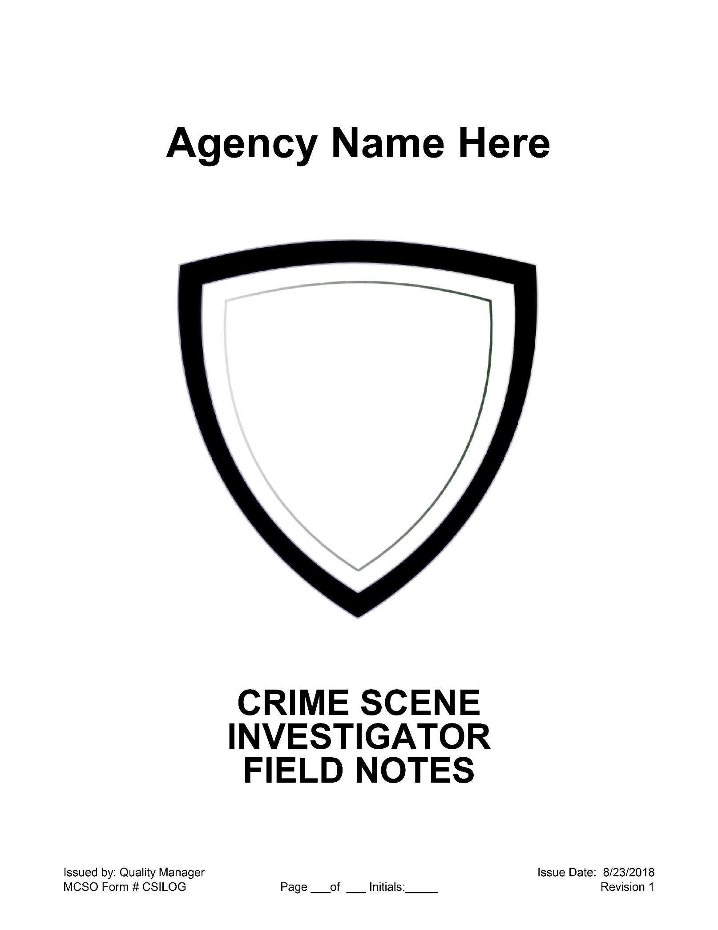
Appendix C: Scene Notes

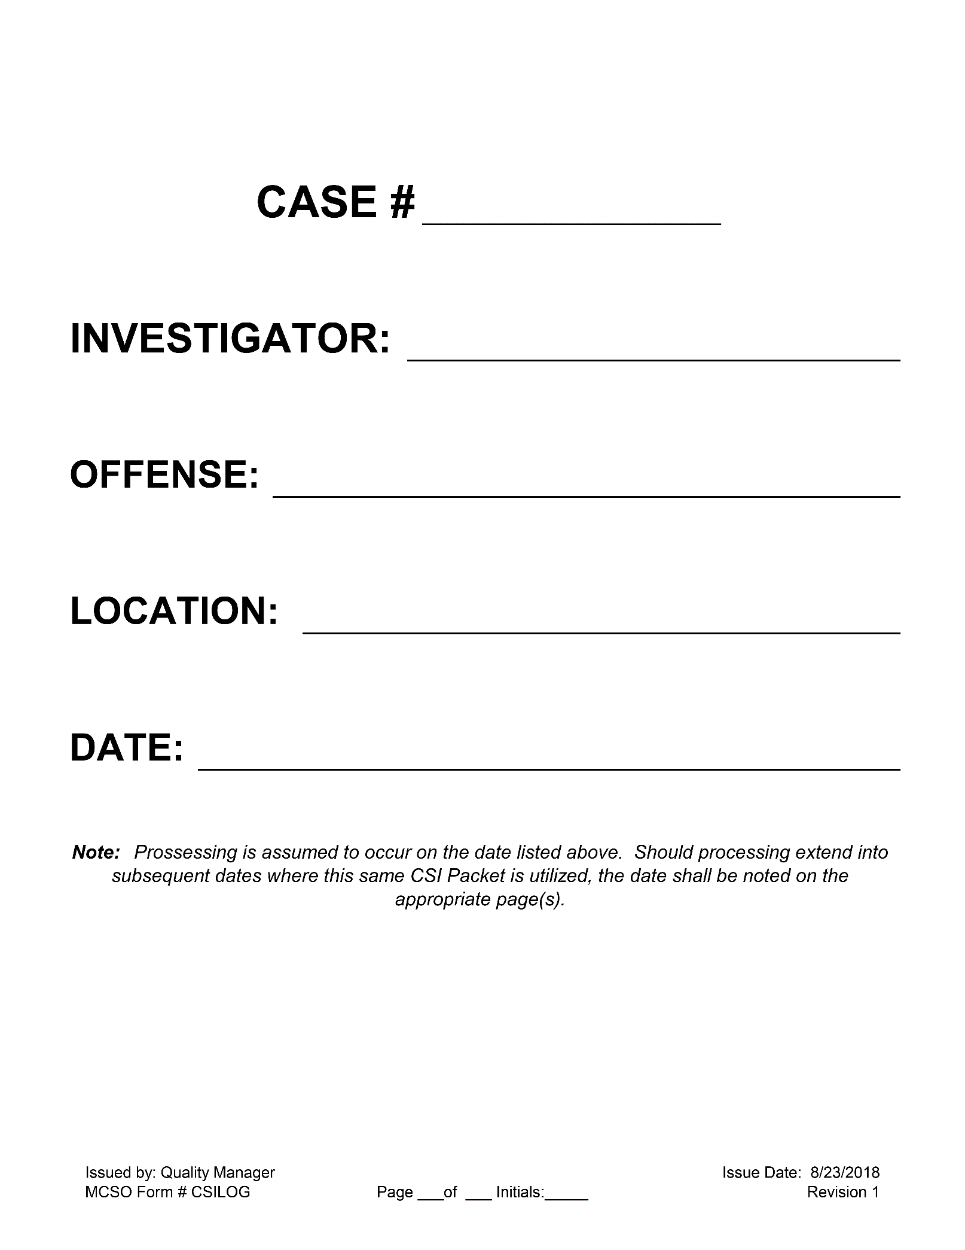

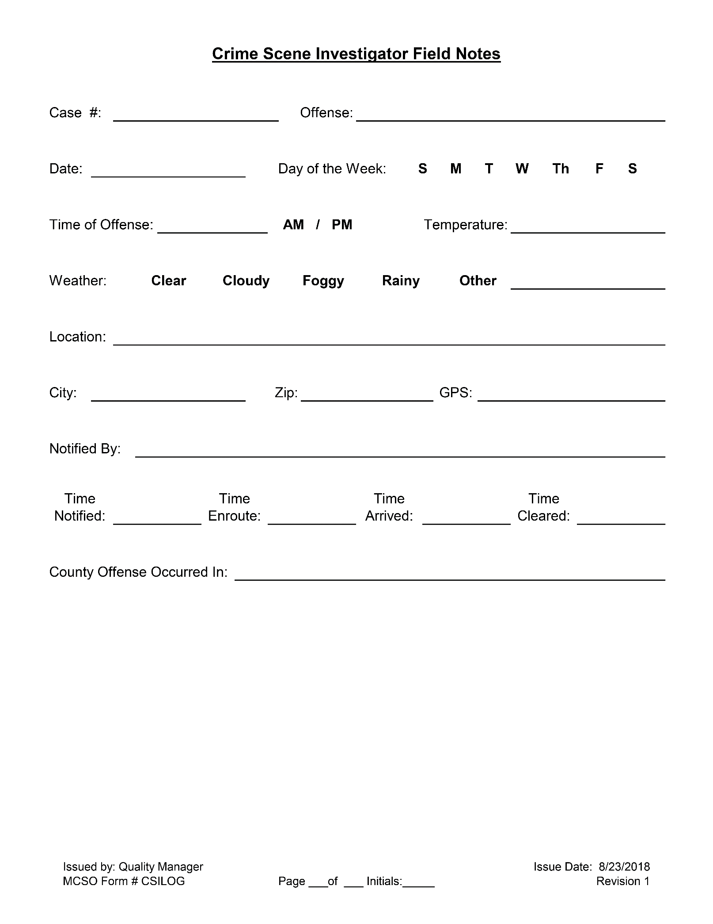
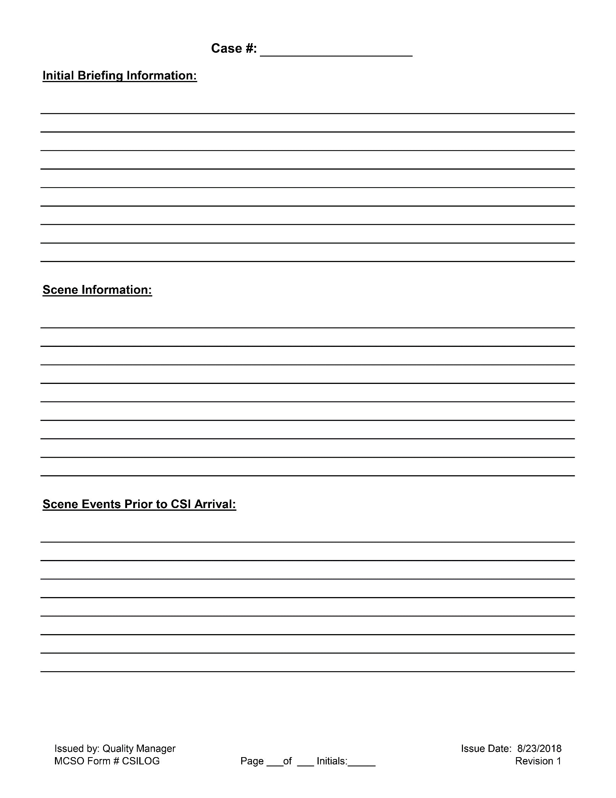
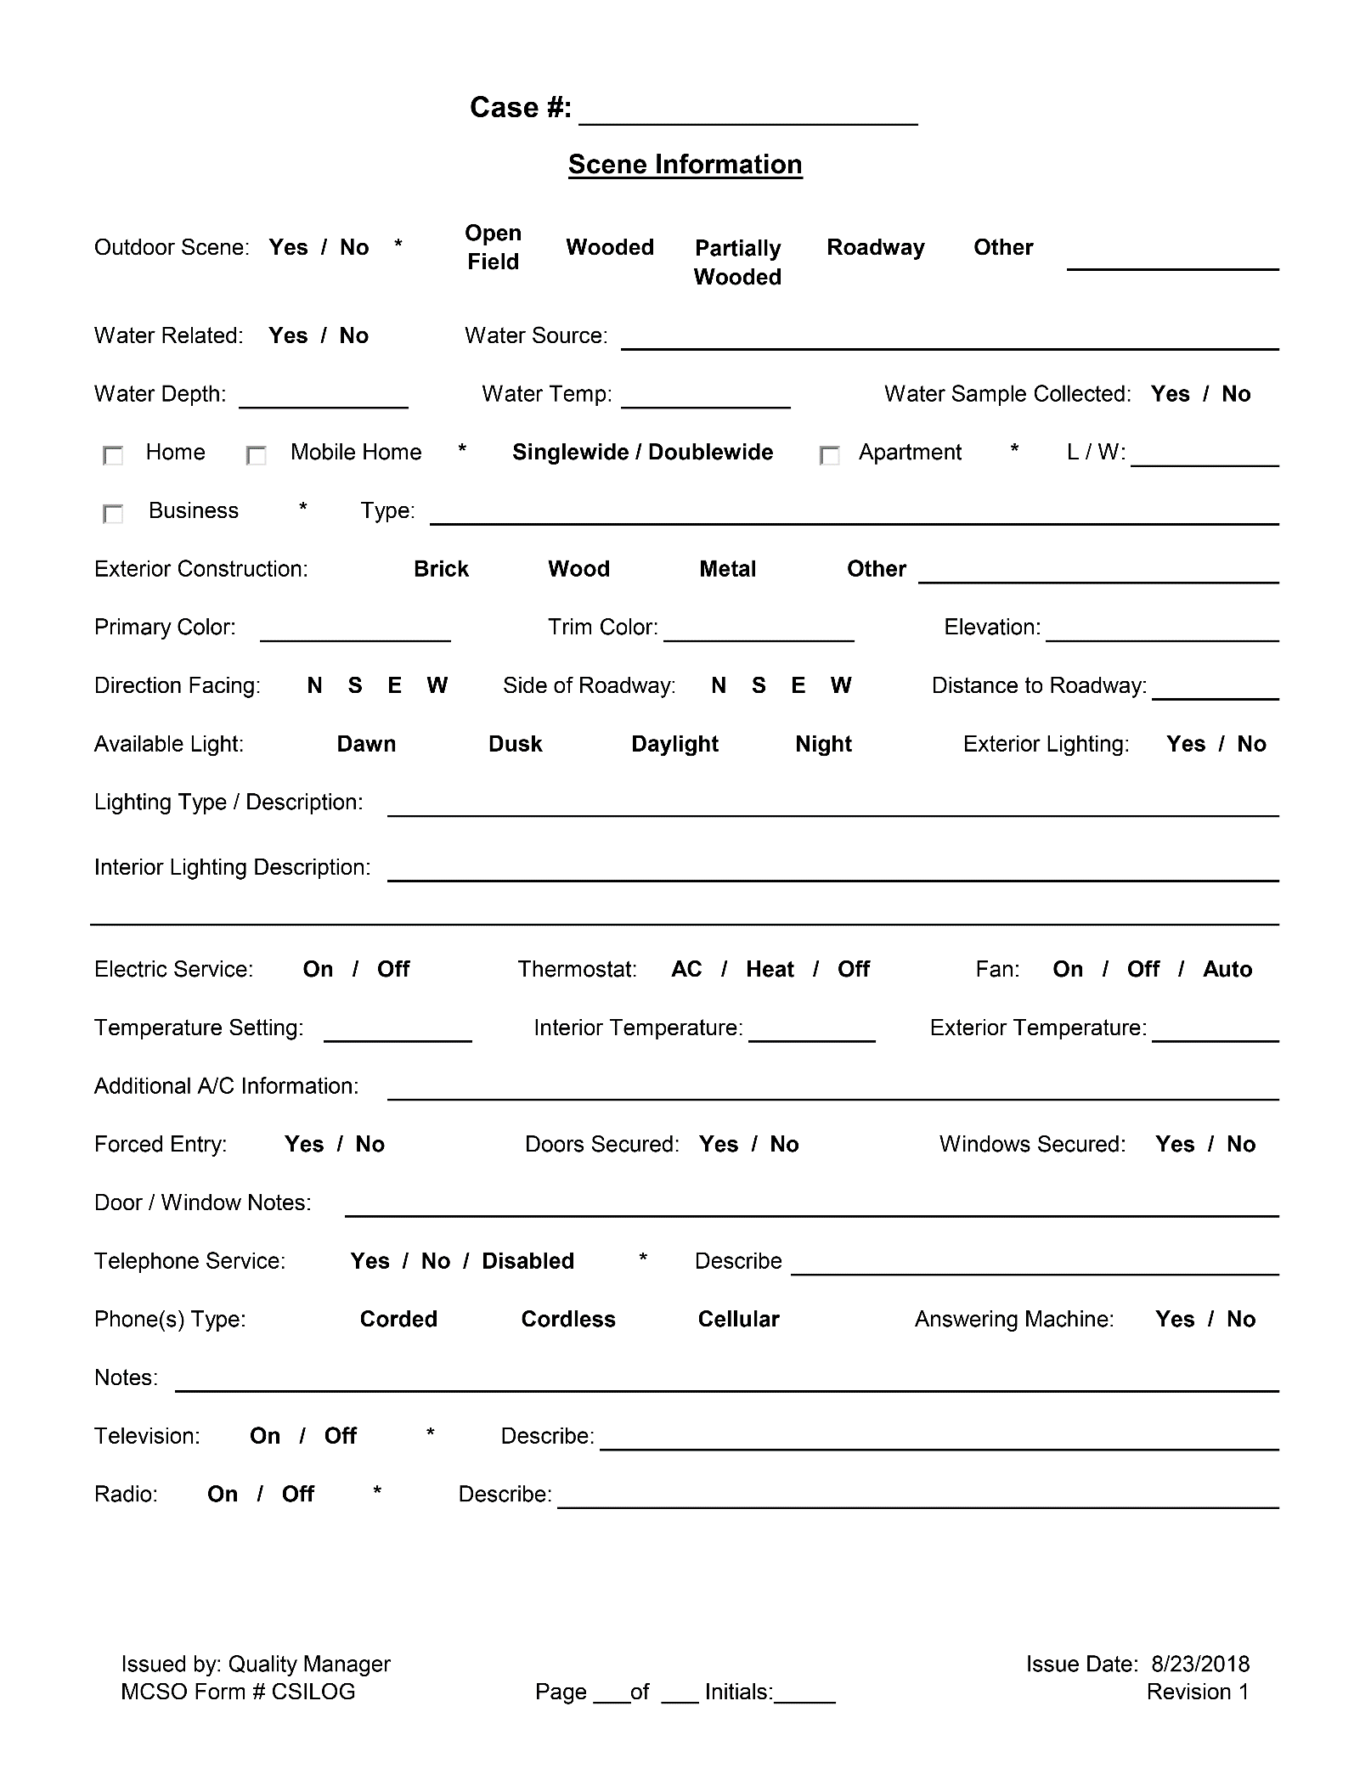
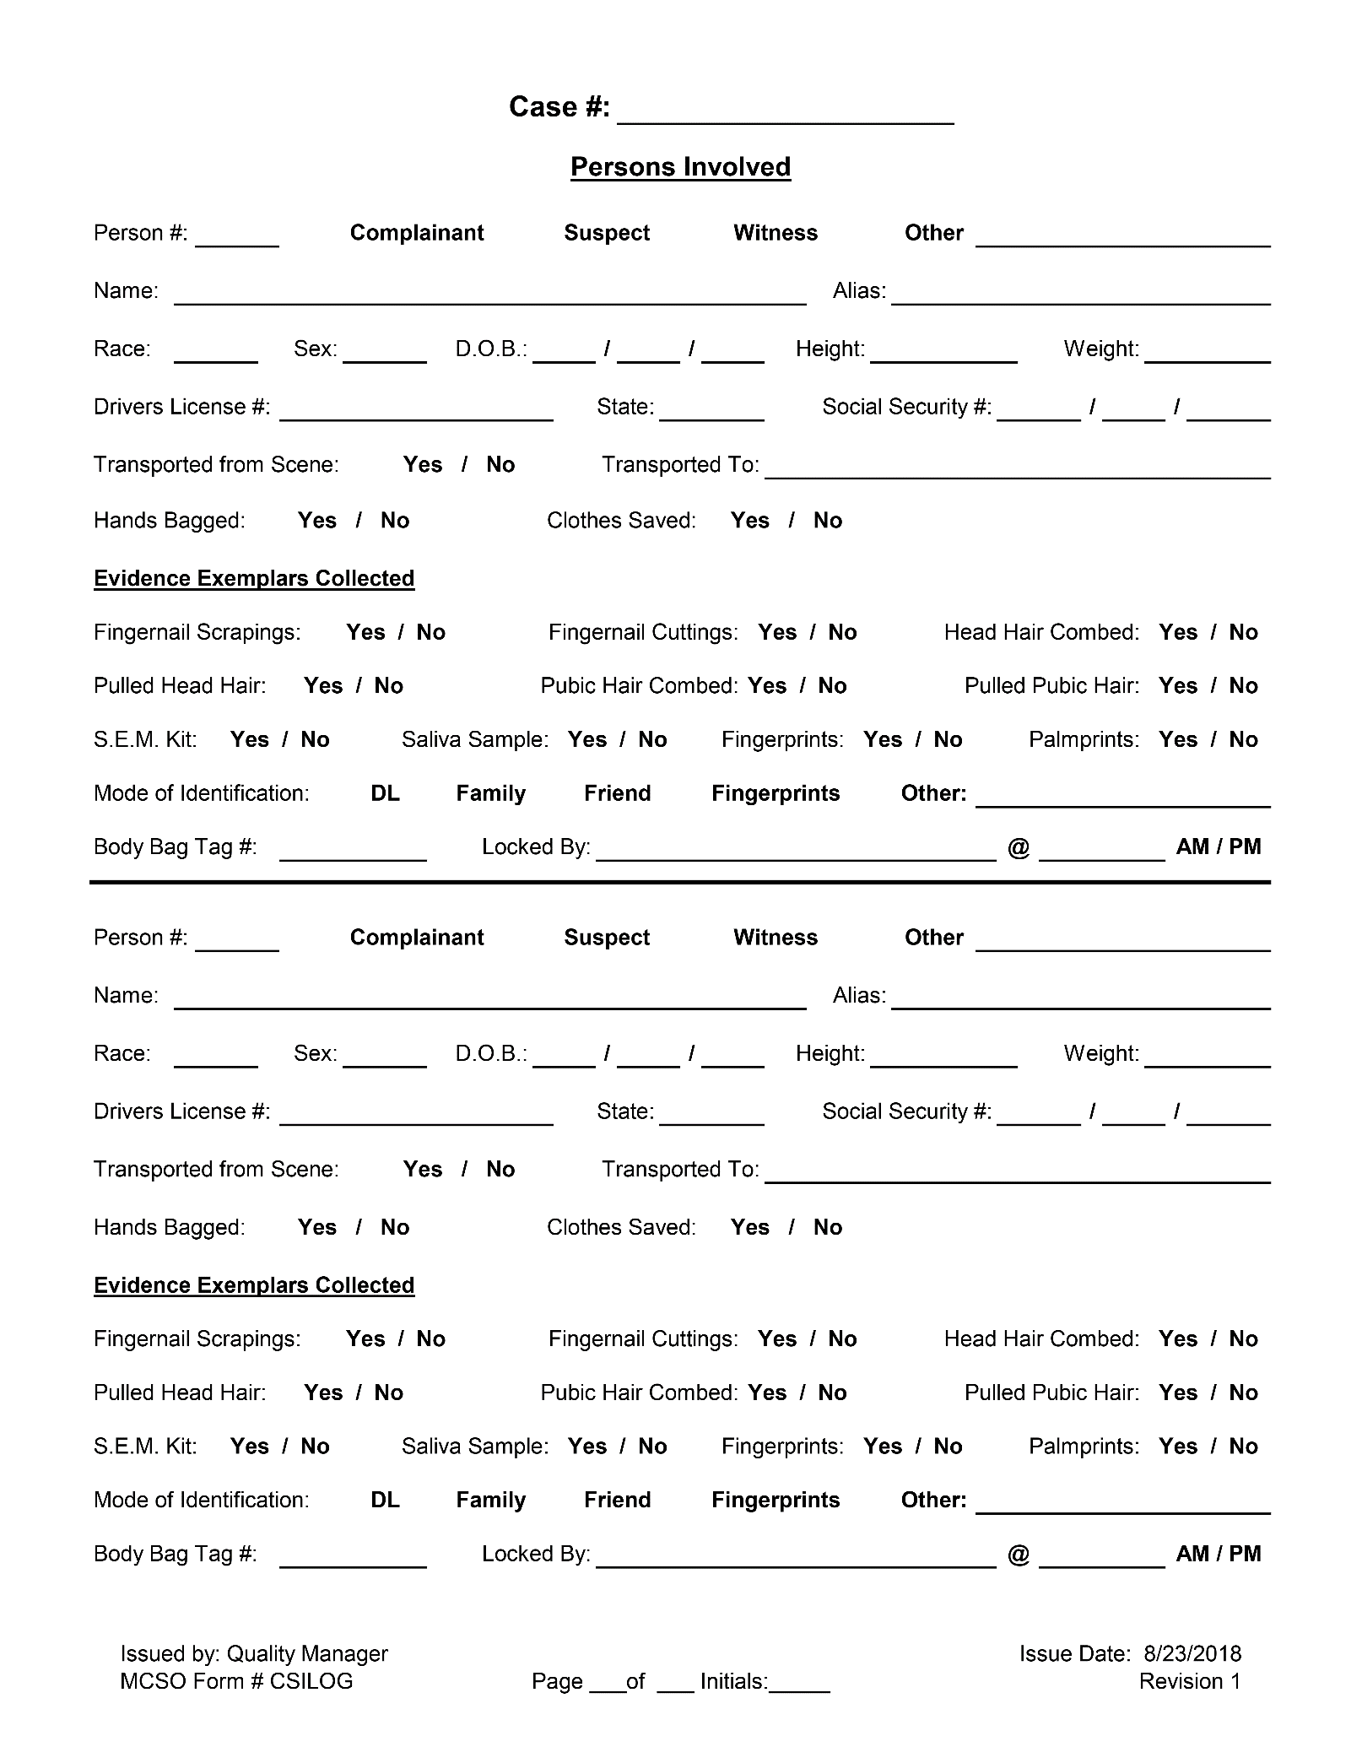
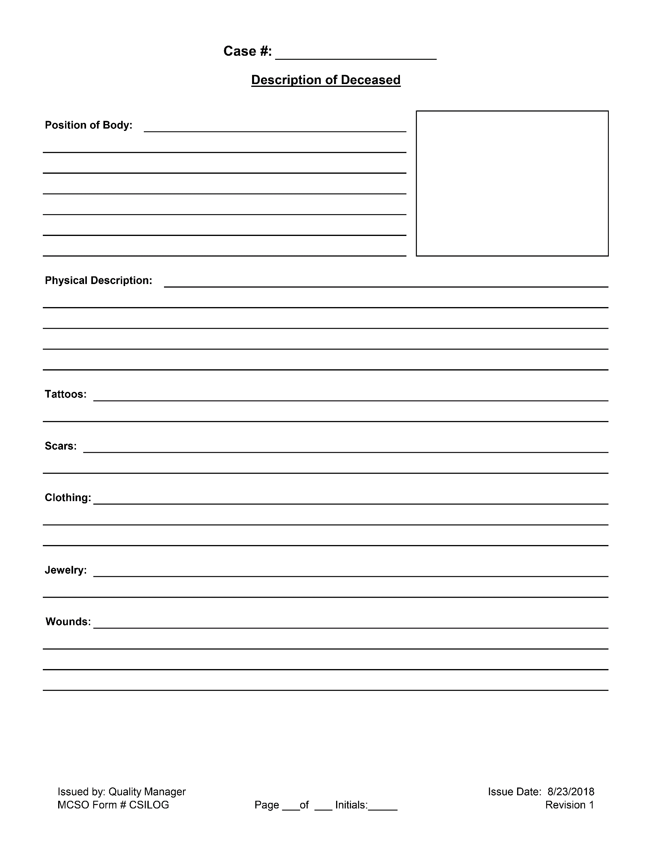
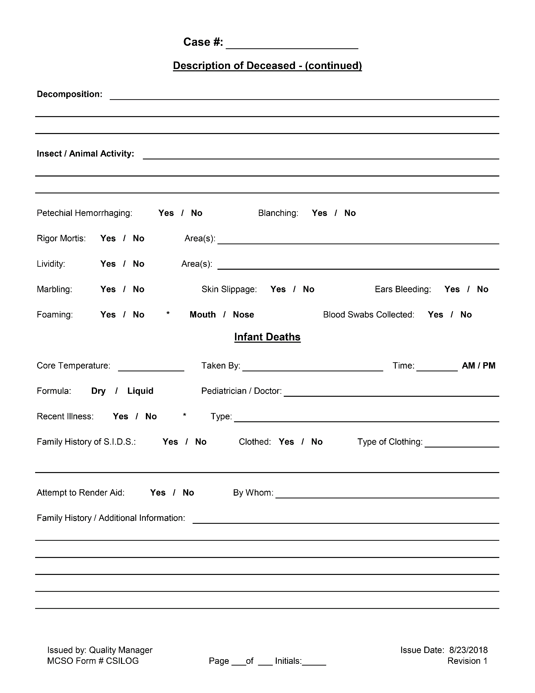
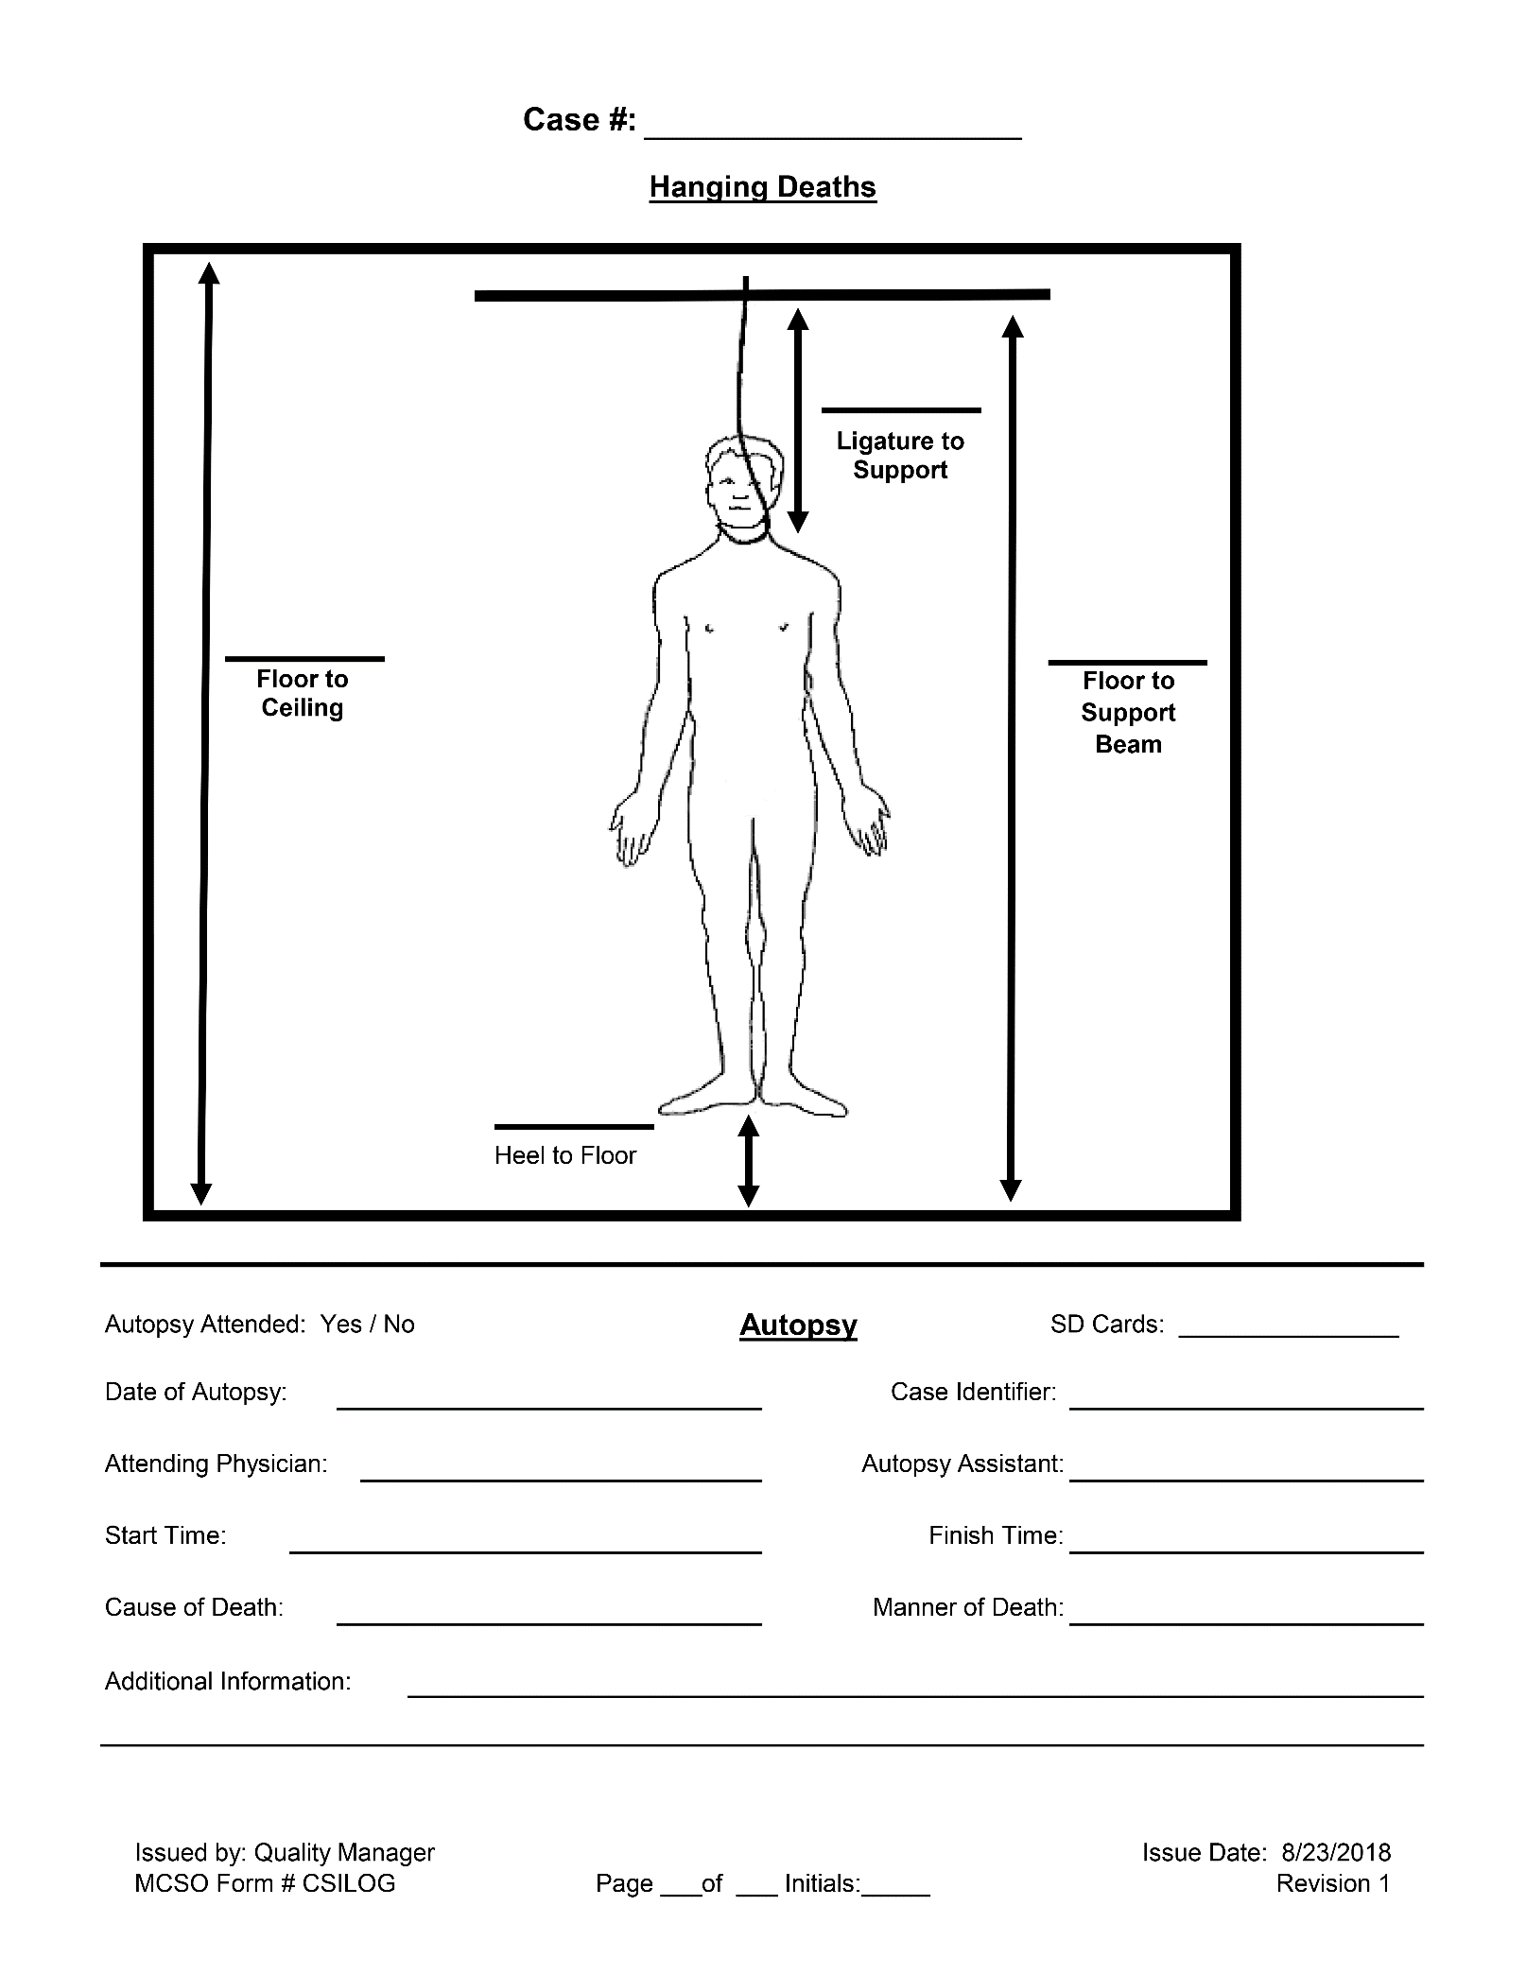
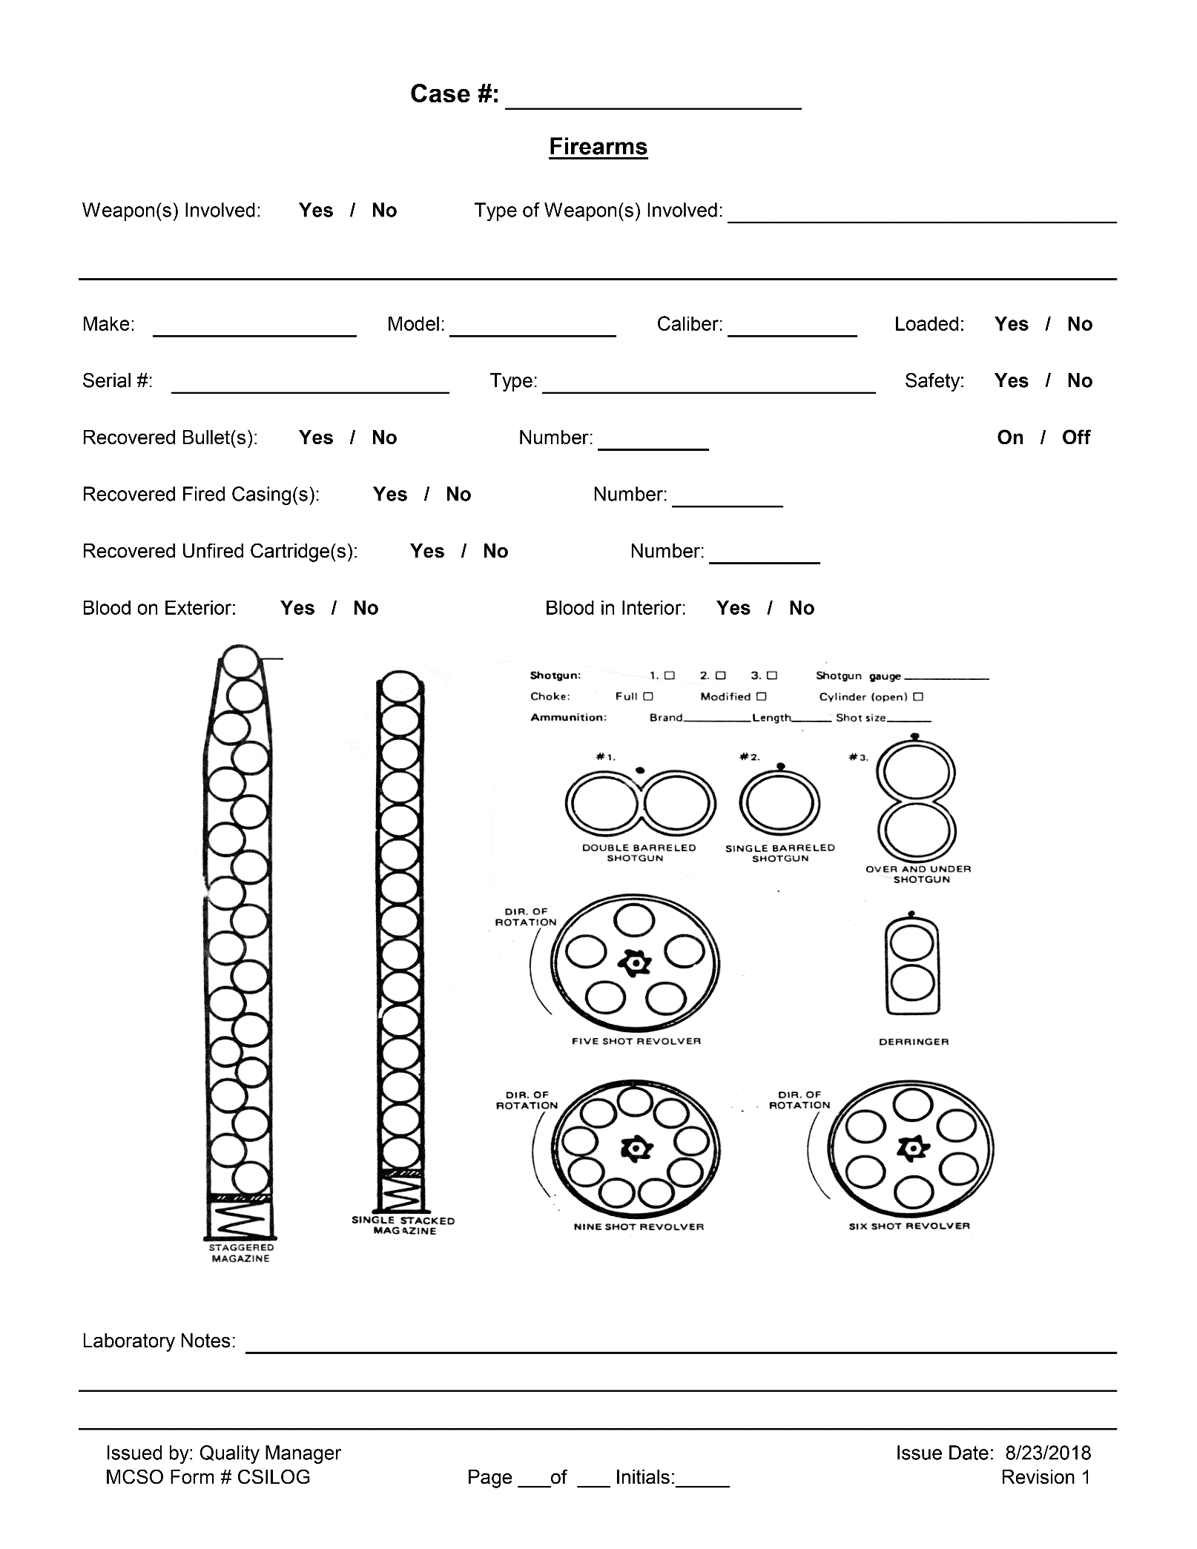
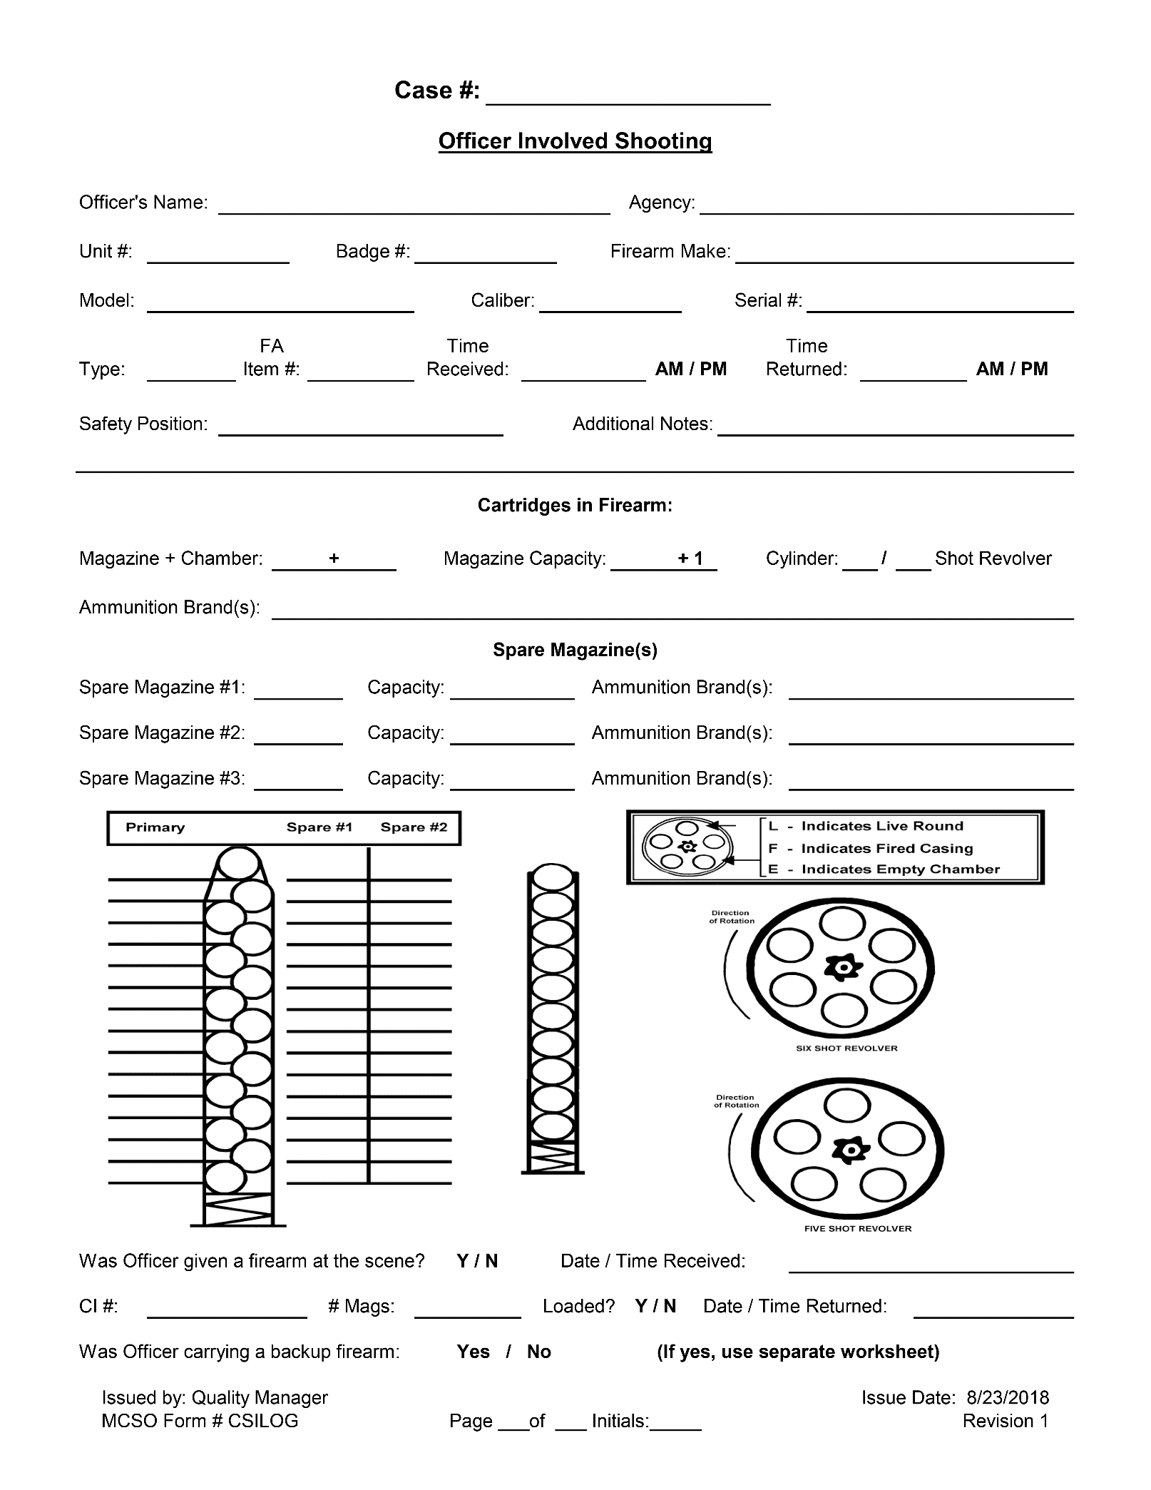
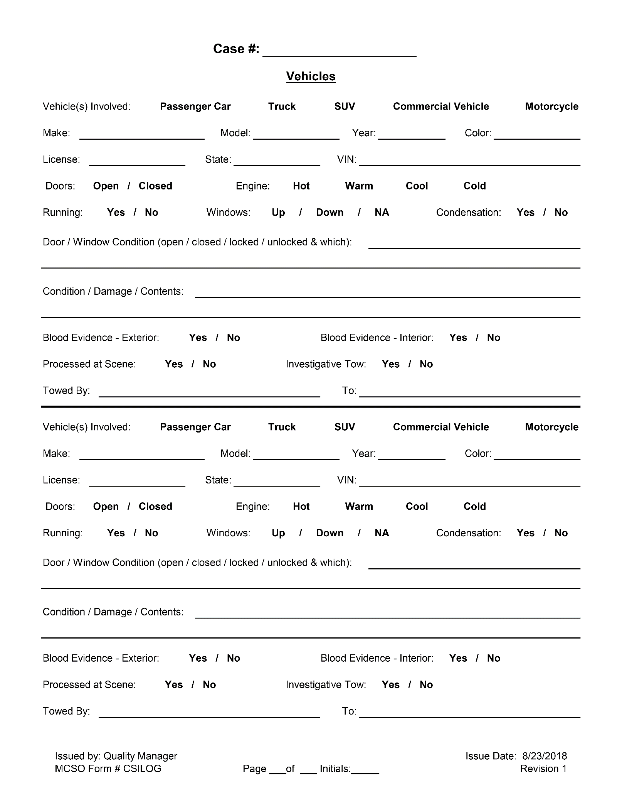
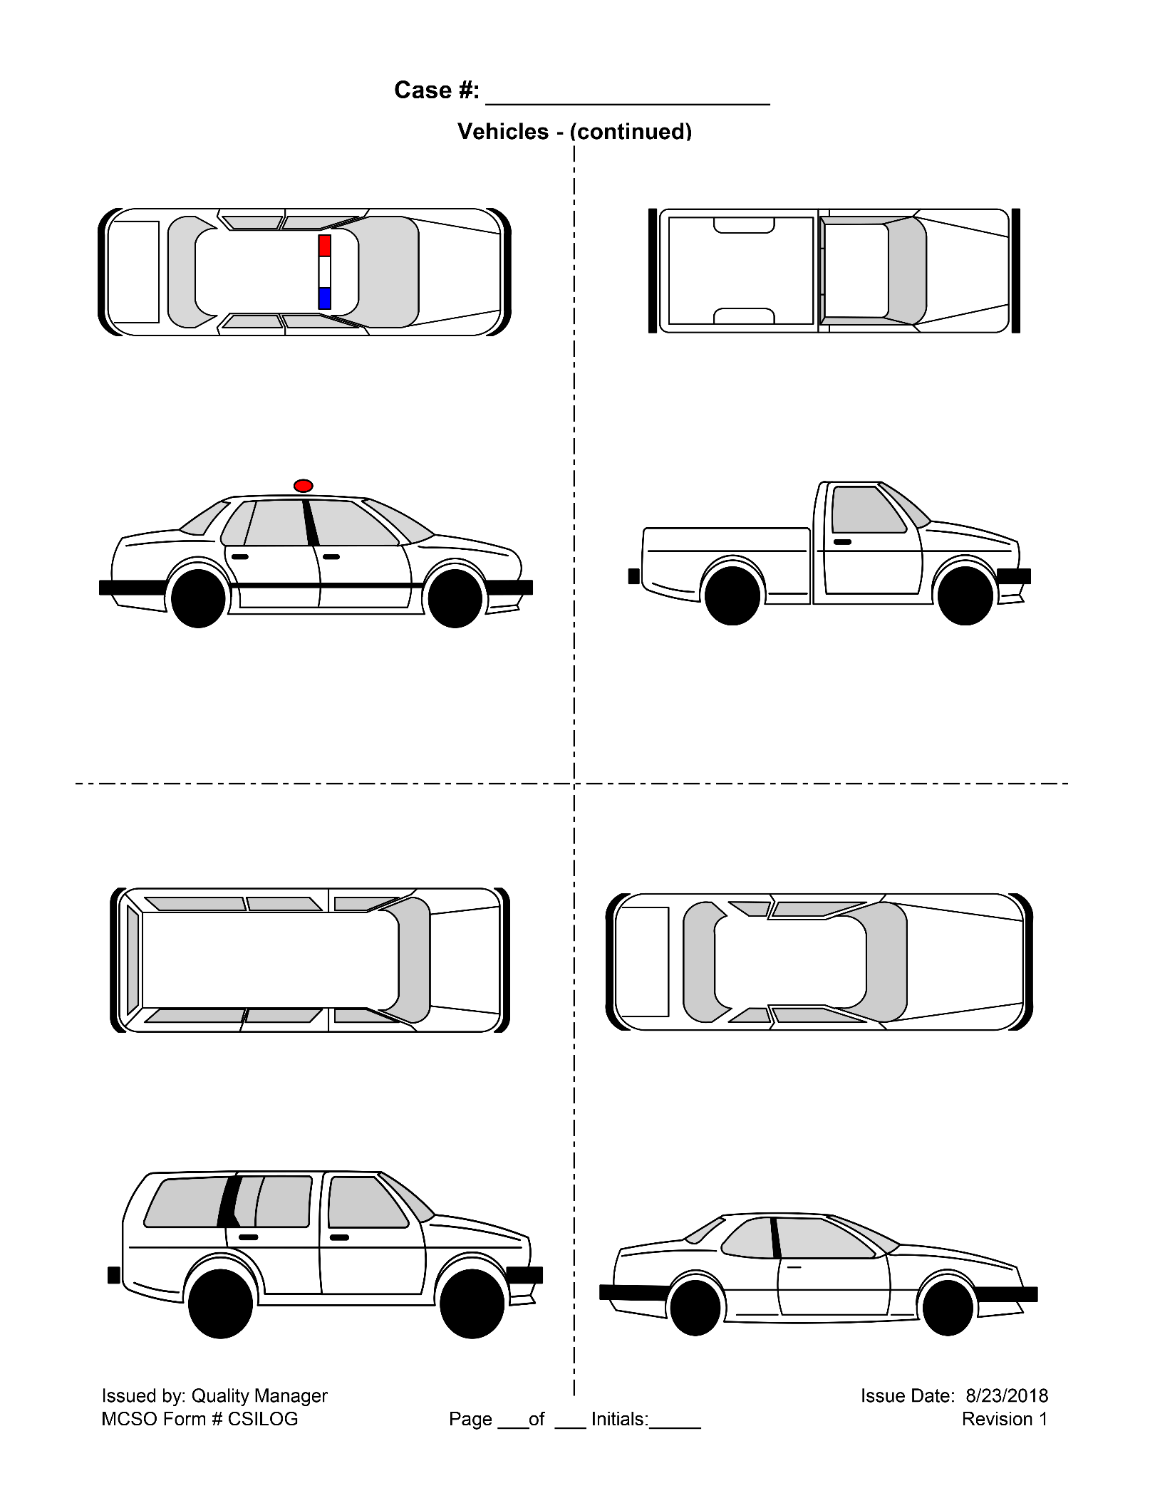
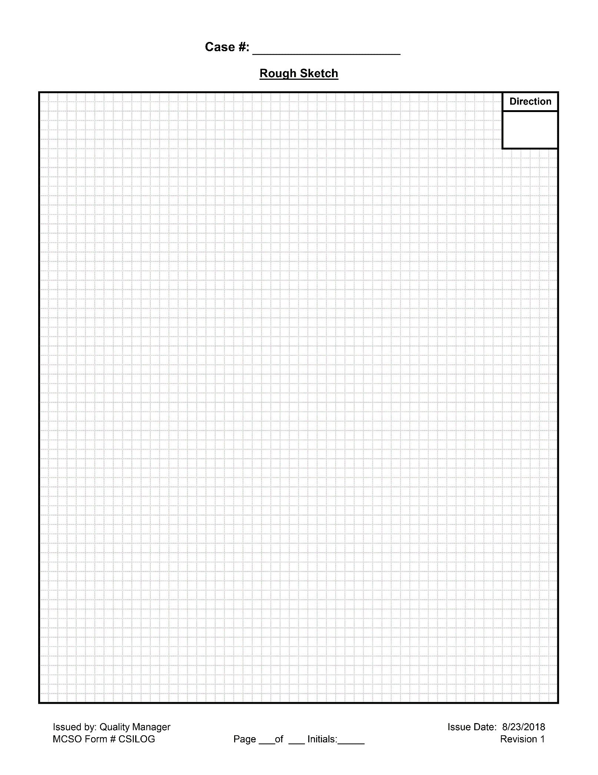
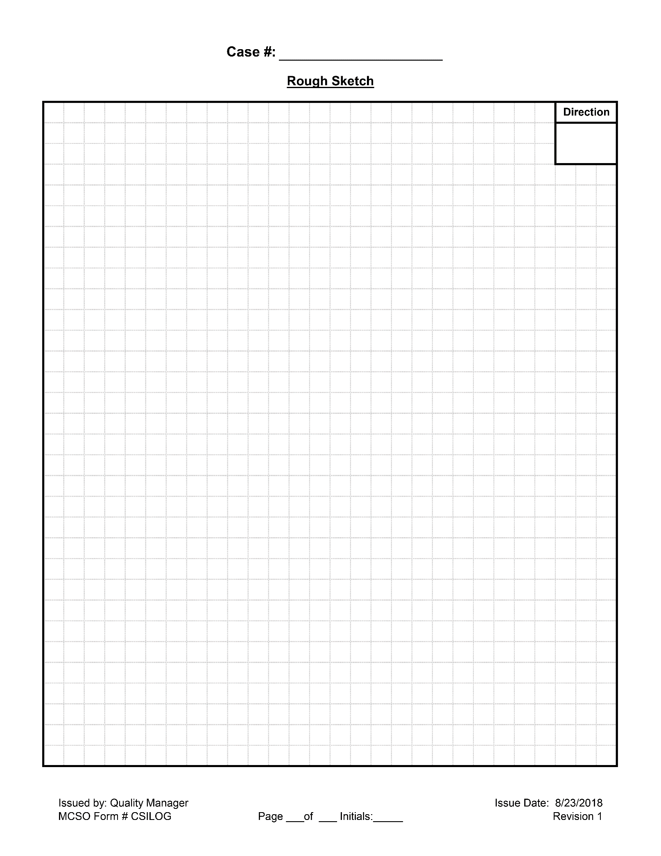
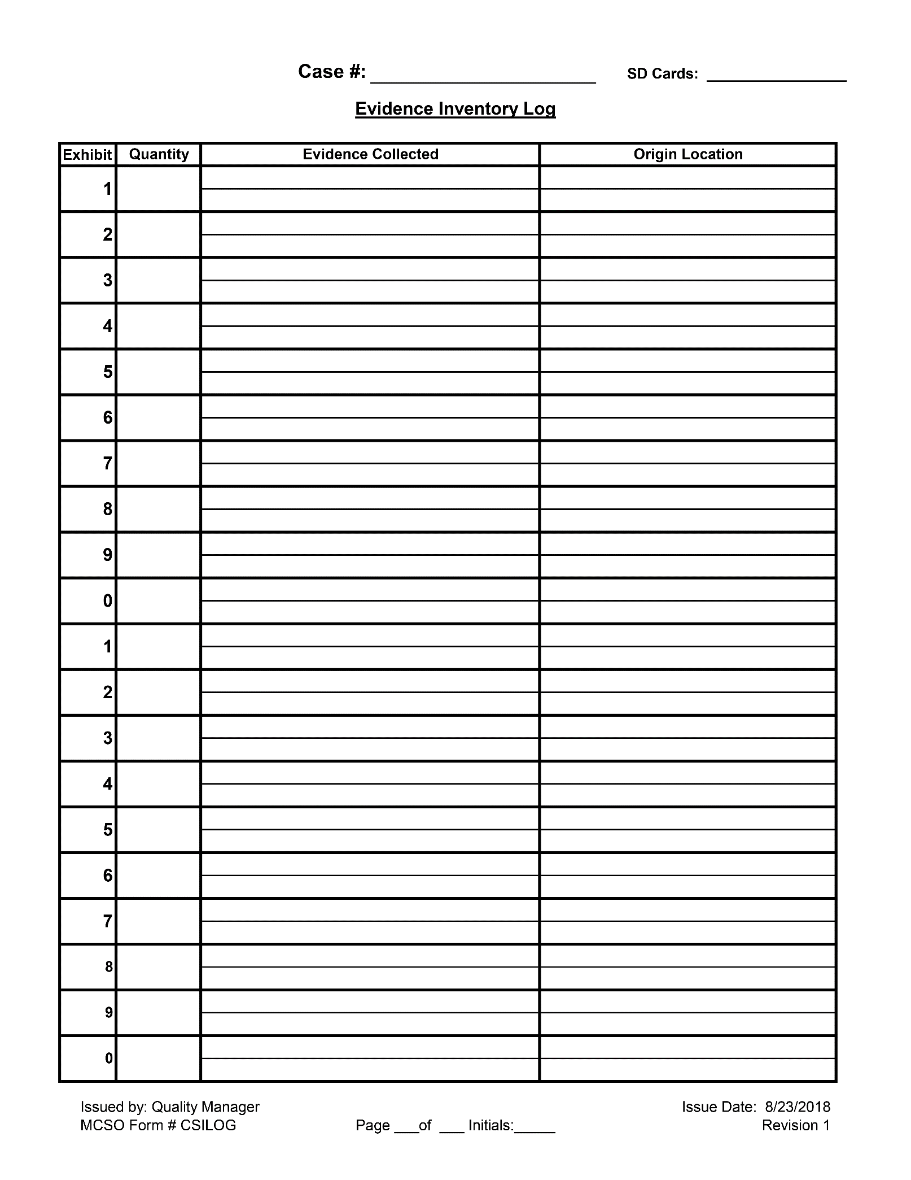
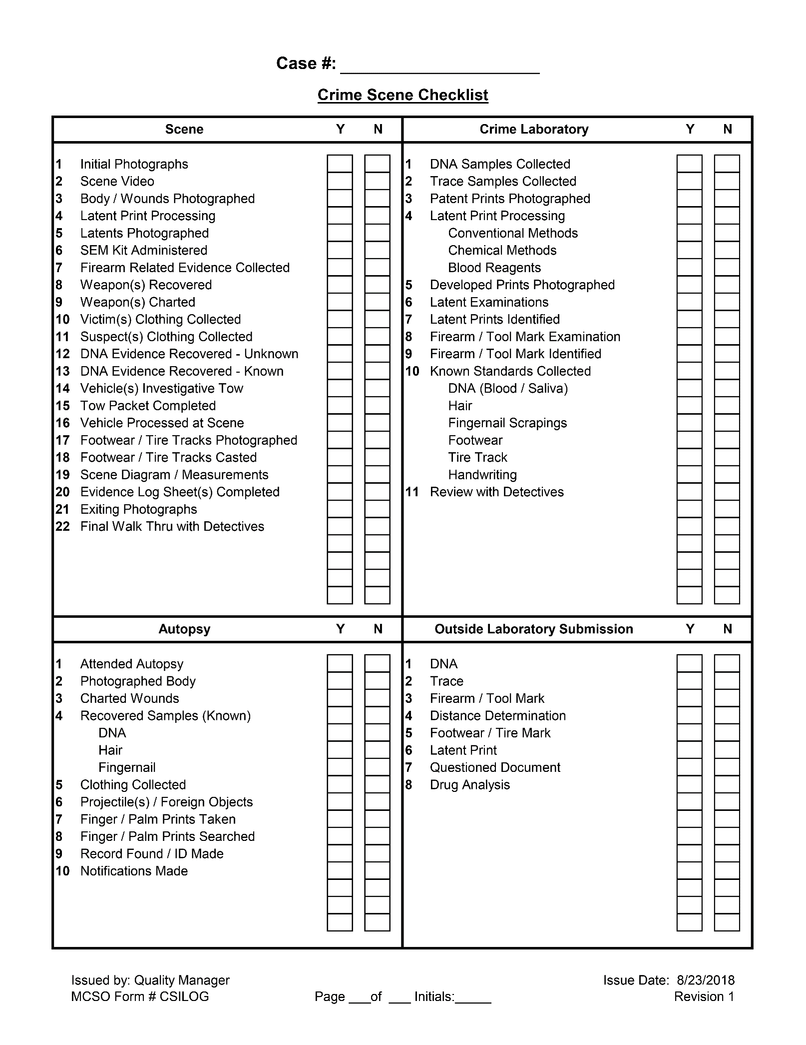
Appendix D: Technical Resources List

Agencies in Texas

Austin Police Department
715 East Eighth Street
Austin, TX 78701
http://www.ci.austin.tx.us/police

Bexar County District Attorney's Office
300 Dolorosa
San Antonio, TX 78205
Phone: 210-335-2974/210-335-2991
E-mail: rbrandau@co.bexar.tx.us
dgetrost@co.bexar.tx.us

Dallas Police Department
2014 Main Street
Dallas, TX 75201
http://www.ci.dallas.tx.us/dpd

Federal Bureau of Investigation
Dallas Field Office
1801 North Lamar Street
Dallas, TX 75202-1795
Phone: 214-720-2200
http://www.fbi.gov/contact/fo/dl/dallas.htm

Houston Police Department
1200 Travis Street
Houston, TX 77002
http://www.ci.houston.tx.us/departme/police

Portland Police Department
902 Moore Avenue
Portland, TX 78374
Phone: 361-643-2546
Fax: 361-643-5689
E-mail: telliott@portlandpd.com; http://www.portlandpd.com

Texas Department of Public Safety
5805 North Lamar Boulevard (street address)
Austin, TX 78752-4422
Phone: 512-424-2200/800-252-5402
E-mail: specialcrimes@txdps.state.tx.us
http://www.txdps.state.tx.us

National Agencies and Organizations

Computer Analysis Response Team
FBI Laboratory
935 Pennsylvania Avenue N.W.
Washington, DC 20535
Phone: 202-324-9307
http://www.fbi.gov/programs/lab/org/cart.htm

High Tech Crime Consortium
International Headquarters
1506 North Stevens Street
Tacoma, WA 98406-3826
Phone: 253-752-2427
Fax: 253-752-2430
E-mail: admin@hightechcrimecops.org
http://www.HighTechCrimeCops.org

Information Systems Security Association (ISSA)
7044 South 13th Street
Oak Creek, WI 53154
Phone: 800-370-4772
http://www.issa.org

Internal Revenue Service
Criminal Investigation Division
2433 South Kirkwood Court
Denver, CO 80222
Phone: 303-756-0646
E-mail: richard.mendrop@ci.irs.gov

National Aeronautics and Space Administration
NASA Office of the Inspector General
Network and Advanced Technology Protections Office
300 E Street S.W.
Washington, DC 20546
Phone: 202-358-4298

National Center for Forensic Science
University of Central Florida
P.O. Box 162367
Orlando, FL 32816
Phone: 407-823-6469
Fax: 407-823-3162
http://www.ncfs.ucf.edu

National Criminal Justice Computer Laboratory and Training Center
SEARCH Group, Inc.
7311 Greenhaven Drive, Suite 145
Sacramento, CA 95831
Phone: 916-392-2550
http://www.search.org

National Law Enforcement and Corrections Technology Center
(NLECTC)-Northeast
26 Electronic Parkway
Rome, NY 13441
Phone: 888-338-0584
Fax: 315-330-4315
http://www.nlectc.org

National Law Enforcement and Corrections Technology Center
(NLECTC)-West
c/o The Aerospace Corporation
2350 East El Segundo Boulevard
El Segundo, CA 90245
Phone: 888-548-1618
Fax: 310-336-2227
http://www.nlectc.org

National Railroad Passenger Corporation (NRPC) (AMTRAK)
Office of Inspector General, Office of Investigations
10 G Street N.E., Suite 3E-400
Washington, DC 20002
Phone: 202-906-4318
E-mail: oigagent@aol.com

National White Collar Crime Center
7401 Beaufont Springs Drive
Richmond, VA 23225
Phone: 800-221-4424
http://www.nw3c.org

Scientific Working Group on Digital Evidence
http://www.for-swg.org/swgdein.htm

Social Security Administration
Office of Inspector General, Electronic Crime Team
4-S-1 Operations Building
6401 Security Boulevard
Baltimore, MD 21235
Phone: 410-965-7421
Fax: 410-965-5705

U.S. Customs Service's Cyber Smuggling Center
11320 Random Hills, Suite 400
Fairfax, VA 22030
Phone: 703-293-8005
Fax: 703-293-9127

U.S. Department of Defense
DoD Computer Forensics Laboratory
911 Elkridge Landing Road, Suite 300
Linthicum, MD 21090
Phone: 410-981-0100/877-981-3235

U.S. Department of Defense
Office of Inspector General
Defense Criminal Investigative Service
400 Army Navy Drive
Arlington, VA 22202
Phone: 703-604-8733
E-mail: dtrosch@dodig.osd.mil
http://www.dodig.osd.mil/dcis/dcismain.html

U.S. Department of Energy
Office of the Inspector General
Technology Crimes Section
1000 Independence Avenue, 5A-235
Washington, DC 20585
Phone: 202-586-9939
Fax: 202-586-0754
E-mail: tech.crime@hq.doe.gov

U.S. Department of Justice
Criminal Division
Computer Crime and Intellectual Property Section (CCIPS)
Duty Attorney
1301 New York Avenue N.W.
Washington, DC 20530
Phone: 202-514-1026
http://www.cybercrime.gov

Drug Enforcement Administration
Computer Forensics
Special Testing and Research Lab
10555 Furnace Road
Lorton, VA 22079
Phone: 703-495-6787
Fax: 703-495-6794
E-mail: mphelan@erols.com

U.S. Department of Transportation
Office of Inspector General
111 North Canal, Suite 677
Chicago, IL 60606
Phone: 312-353-0106
E-mail: wentej@oig.dot.gov

U.S. Department of the Treasury
Bureau of Alcohol, Tobacco and Firearms
Technical Support Division
650 Massachusetts Avenue N.W.
Room 3220
Washington, DC 20226-0013
Phone: 202-927-8037
Fax: 202-927-8682
E-mail: jlhunter@atfhq.atf.treas.gov

U. S. Postal Inspection Service
Digital Evidence
22433 Randolph Drive
Dulles, VA 20104-1000
Phone: 703-406-7927

U.S. Secret Service
Electronic Crimes Branch
950 H Street N.W.
Washington, DC 20223
Phone: 202-406-5850
Fax: 202-406-9233

Veterans Affairs
Office of the Inspector General
801 I Street N.W., Suite 1064
Washington, DC 20001
Phone: 202-565-5701

E-mail: robert.friel@mail.va.gov

Appendix E: Nationwide Technical Training List

DoD Computer Investigations Training Program
911 Elkridge Landing Road
Airport Square 11 Building
Suite 200
Linthicum, MD 21090
Phone: 410-981-1604
Fax: 410-850-8906
E-mail: info@dcitp.gov
http://www.dcitp.gov

FBI Academy at Quantico
U.S. Marine Corps Base
Quantico, VA
Phone: 703-640-6131
http://www.fbi.gov/programs/academy/academy.htm

Federal Law Enforcement Training Center
Headquarters Facility
Glynco, GA 31524
Phone: 912-267-2100
http://www.fletc.gov

Federal Law Enforcement Training Center
Artesia Facility
1300 West Richey Avenue
Artesia, NM 88210
Phone: 505-748-8000
http://www.fletc.gov

Federal Law Enforcement Training Center
Charleston Facility
2000 Bainbridge Avenue
Charleston, SC 29405-2607
Phone: 843-743-8858
http://www.fletc.gov

Florida Association of Computer Crime Investigators, Inc.
P.O. Box 1503
Bartow, FL 33831-1503
Phone: 352-357-0500
E-mail: info@facci.org
http://www.facci.org

Forensic Association of Computer Technologists
P.O. Box 703
Des Moines, IA 50303
Phone: 515-281-7671
http://www.byteoutofcrime.org

High Technology Crime Investigation Association (International)
1474 Freeman Drive
Amissville, VA 20106
Phone: 540-937-5019
http://www.htcia.org

Information Security University
149 New Montgomery Street
Second Floor
San Francisco, CA 94105
http://www.infosecu.com

Information Systems Security Association (ISSA)
7044 South 13th Street
Oak Creek, WI 53154
Phone: 800-370-4772
http://www.issa.org

Institute of Police Technology and Management
University of North Florida
12000 Alumni Drive
Jacksonville, FL 32224-2678
Phone: 904-620-4786
Fax: 904-620-2453
http://www.iptm.org

International Association of Computer Investigative Specialists (IACIS)
P.O. Box 21688
Keizer, OR 97307-1688
Phone: 503-557-1506
E-mail: admin@cops.org
http://www.cops.org

James Madison University
800 South Main Street
Harrisonburg, VA 22807
Phone: 540-568-6211
http://www.cs.jmu.edu/currentcourses.htm

Midwest Electronic Crime Investigators Association
http://www.mecia.org

National Center for Forensic Science
University of Central Florida
P.O. Box 162367
Orlando, FL 32816-2367
Phone: 407-823-6469
E-mail: natlctr@mail.ucf.edu
http://www.ncfs.ucf.edu

National Colloquium for Information Systems Security Education (NCISSE)
http://www.ncisse.org

National Criminal Justice Computer Laboratory and Training Center
SEARCH Group, Inc.
7311 Greenhaven Drive, Suite 145
Sacramento, CA 95831
Phone: 916-392-2550
http://www.search.org

National Cybercrime Training Partnership (NCTP)
1000 Technology Drive, Suite 2130
Fairmont, WV 26554
Phone: 877-628-7674
E-mail: info@nctp.org
http://www.nctp.org
Note: New CD-ROM available, Prosecuting Cases That Involve Computers:
A Resource for State and Local Prosecutors

National White Collar Crime Center
1000 Technology Drive, Suite 2130
Fairmont, WV 26554
Phone: 877-628-7674
http://www.cybercrime.org
Note: New CD-ROM available, Prosecuting Cases That Involve Computers:
A Resource for State and Local Prosecutors

New Technologies, Inc.
2075 N.E. Division Street
Gresham, OR 97030
Phone: 503-661-6912
E-mail: info@forensics-intl.com
http://www.forensics-intl.com

Purdue University
CERIAS (Center for Education and Research in Information and Assurance
Security)

Purdue University
West Lafayette, IN 47907-1315
Phone: 765-494-7806
E-mail: acs@cerias.purdue.edu
http://www.cerias.purdue.edu

Redlands Community College
Criminal Justice and Forensic Computer Science
1300 South Country Club Road
El Reno, OK 73036-5304
Phone: 405-262-2552, ext. 2517
E-mail: hoskinsonc@redlandscc.net

University of New Haven
School of Public Safety and Professional Studies
300 Orange Avenue
West Haven, CT 06516
http://www.newhaven.edu

University of New Haven-California Campus
Forensic Computer Investigation Program
6060 Sunrise Vista Drive
Citrus Heights, CA 95610
http://www.newhaven.edu

U.S. Department of Justice
Criminal Division
Computer Crime and Intellectual Property Section (CCIPS)
1301 New York Avenue N.W.
Washington, DC 20530
Phone: 202-514-1026
http://www.cycbercrime.gov

Wisconsin Association of Computer Crime Investigators
P.O. Box 510212
New Berlin, WI 53151-0212
http://www.wacci.org

