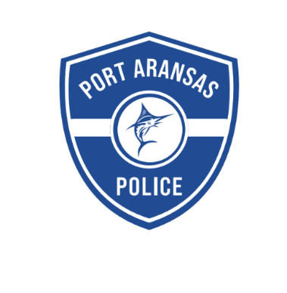 **Now Hiring - Patrol Officer Position**

**Port Aransas Police Department**

Do you want to work for a community that appreciates and supports what you do and compensates you accordingly? Do you want to work for an agency that invests in its Officers through consistent training and values Officer wellness? Do you want to be outfitted with top-of-the-line vehicles, technology and duty gear? The Port Aransas Police Department offers all of these things and is seeking a Patrol Officer candidate for immediate hire.

**PAY SCALE and APPLICATION LINK**: [**https://cityofportaransas.org/departments/police-department/police-employment/**](https://cityofportaransas.org/departments/police-department/police-employment/)

**Benefits Include:**

* BRAND NEW Public Safety Building
* Lateral service credits (one-year of credit for every two years of experience, up to fifteen years)
* Take home patrol vehicle
* Gym membership reimbursement
* Department provides off-duty weapon (Glock 42), patrol rifle, training ammunition and duty gear
* TMRS retirement with five-year vesting and a 2 to 1 match at 7%
* Longevity pay
* Uniform + cleaning pay

**Job description:**

The Port Aransas Police Department provides patrol services, including criminal and traffic law enforcement to a 12.1 square mile beach community that is just outside of Corpus Christi, TX. The local population is 3,442 (as of 2023), and 1,050,000 tourists visited Port Aransas in 2022. The Police Department provides twenty-four-hour, seven day a week coverage. Officers work rotating shifts. Applicants must have a valid TCOLE Peace Officer License, valid Texas driver’s license, and pass a physical examination including a drug screen.

Questions? Contact Lt. Mike Hannon, 361-749-6241, mhannon@cityofportaransas.org