Trauma Affected Veterans Training

Course # 4067
Texas Commission on Law Enforcement
May 2019

Trauma Affected Veterans Training
Course # 4067
ABSTRACT

This guide is designed to assist the instructor in developing an appropriate lesson plan or plans to teach the course learning objectives. The learning objectives are the minimum required content of the Trauma Affected Veterans Training course.
Note to Trainers: it is the responsibility of the coordinator to ensure this curriculum and its materials are kept up to date. Refer to curriculum and legal resources for changes in subject matter or laws relating to this topic as well as the Texas Commission on Law Enforcement website at www.tcole.texas.gov for edits due to course review.
Target Population: Licensed Peace Officers, Jailers, and Telecommunicators
Student Pre-Requisites: None
Instructor Pre-Requisites:
- TCOLE Instructor and/or subject matter expert
- If not a subject matter expert: recommended contact with the Military Veteran Peer Network (MVPN) for relevant information and/or scheduling a guest instructor/speaker. Contact Information: vmhp@tvc.texas.gov (512)463-6091.
Length of Course: 24 hours
Training Delivery Options: This course is legislatively restricted to face-to-face delivery only. No distance education options are approved.
Methods of Instruction:
- Lecture
- Group Discussion
- Case Studies
- Scenarios
Assessment: Assessment is required for completion of this course to ensure the student has a thorough comprehension of all learning objectives. Training providers are responsible for assessing and documenting student mastery of all objectives in this course.

In addition, the Commission highly recommends a variety of testing/assessment opportunities throughout the course which could include: oral or written testing, interaction with instructor and students, case study and scenario, and other means of testing students’ application of the skills, as the instructor or department deems appropriate.
Reference Materials:
- House Bill 1338
- Occupations Code 1701.261 &262
- Health and Safety Code Chapter 573

Instructor Guide
Trauma Affected Veterans Training
Day One:
- Goal: Introduction
Instructor Note: Due to the intense emotions and feelings that this topic can produce, instructors should open with a statement asking for sensitivity and respect for all instructors, guests, and anyone participating in class. If anyone needs to step out to take a moment, they will do so as needed. You may also want to explain that while this course will explore and discuss many topics that are widespread amongst veterans, it is in no way implying that every veteran will have incurred any or all of these traumas or react in a manner outlined in this course. This course is for those outliers that come to the attention of law enforcement. This course was implemented because there have been too many calls involving veterans and force being used against them by the police (some justified, some not). We as Peace Officers have to educate ourselves to continue learning and adjusting our policing style so that it is effective and safe for everyone. Although we encourage class participation, keep in mind that sharing detailed stories from serving in the U.S. Military may be a trigger for someone in the class.
Instructor Note: Each instructor should introduce themselves. This is the time to discuss military connection if you have any. Introduce the Military SME.

Purpose of training
- To train law enforcement officers about military-related trauma and the impacts trauma may have.
- To prepare law enforcement officials to respond effectively and safely to an increasing number of veteran-related crisis incidents.
- To meet recent guidelines set by House Bill 1338 in providing training about trauma affected veterans to law enforcement communities.
Instructor Note: You are already well trained as police officers. Having specialty training in working with veterans, as with any other specialty population, can enhance effectiveness and promote safety. Currently there are frequent encounters between police officers, veterans, and active duty service members. As more service members return from combat operations, these incidents are likely to increase. veterans’ issues require a heightened sense of awareness and sensitivity, whether you are responding to a crisis situation, a call for service or making a traffic stop. Often individuals with Traumatic Brain Injury (TBI) and/or Posttraumatic Stress Disorder (PTSD) are not aware that they have these combat-related condition or injuries.
The goal of this training is so that both the officer and the veteran are safe and go home to their families.
Video: Rambo as he is being antagonized by local police. Refer to PowerPoint for access to this video.
Instructor Note: For a visual reference point out “John Rambo” from the first Rambo movie. Rambo was a Vietnam Veteran with PTSD who was a “drifter.” Note how Law Enforcement reacted toward Rambo and Rambo’s reaction to the provocation of assumptions. Have class discuss all the ways Brian Denehy breaks safety rules and antagonizes John Rambo.
  - Goal: Why are you here?
1.1.1 Discuss student’s current understanding of the impacts of trauma on veterans.
Instructor Note: Instructor should ask the class to provide their understanding of the impacts of trauma on veterans. Specifically, the instructor should encourage a frank discussion about perceptions and stereotypes involving veterans who have experienced trauma.
The real purpose of this training:
- To help law enforcement officers (LEOs) better understand the impacts of military-related trauma on the veteran community in order to expand the knowledge of how to appropriately identify and respond to a trauma affected veteran
- To empower LEOs to de-escalate situations including trauma affected veterans so LEOs don’t have to live with a life-changing decision
- LEOs are able to go home safely at night
- Do not make the news headlines for inappropriately engaging with a trauma affected veteran
Some recent headlines
Texas cops shoot, kill machete-wielding Army veteran
4ValleyCentral.com, MONDAY, APRIL 27TH 2015
Army vet shot by Killeen police dies in hospital; autopsy results pending
Killeen Daily Herald, Wednesday, September 16, 2015 5:48 pm
Video Shows Confrontation That Left Local Veteran Mortally Wounded
KWTX.com, September 23, 2015
Veteran shot by police sues city of Austin, APD
KXAN.com, November 11, 2015, 6:07 pm
Instructor Note: Each of these headlines involve LEOs that are now living with the decisions they have had to make and the moral and legal implications of those decisions. In every story, the LEO was pointed out, by name, for the actions they took in relation to the incident. The court of public opinion can be much worse than an actual courtroom. Regardless of the outcome from each inquiry initiated, the LEO will have to face his or her family, friends, and community. Perhaps more stressful is that each LEO involved will likely relive these events for years to come.
Instructor: facilitate a short discussion about the implications of being pointed out by the media for a fatal shooting involving a veteran (public and private).
How Americans view post 9/11 veterans, Americans have split perceptions about veterans. “Broken” and “Heroes” This belief is not deeply rooted and can be changed.
Instructor Note: There is a split perception in our nation about how they view returned veterans. Many people view returned veterans as “broken” or “damaged.” This is often based on media portrayals of veterans suffering significant mental health issues (such as severe posttraumatic stress disorder) and news reports of shootings, suicides, and family violence. Another faction in 0America views our returned veterans as “heroes” based on those wanting to acknowledge the service and sacrifice of the U.S. military post-9/11. Sometimes this is out of a desire to atone for the treatment of Vietnam Veterans; sometimes it is out of genuine respect and honor. Whatever motivates individuals to feel one way or the other; this impacts how our nation’s veterans are viewed and treated.
When compared to civilians, people believe most post 9/11 veterans are more likely to suffer from mental illness. The facts are:
- Veterans are wrongly believed to suffer from more mental illness than civilians
- 7.7 million Americans deal with diagnoses of PTSD in any given year, whereas between 300,000 and 500,000 service members have dealt with PTSD across 12 years of combat
- Conservatively, >95% of Americans with PTSD are civilians
Instructor Note: People tend to ignore police, fire and EMS PTSD and focus on veterans PTSD. Discussion should be about why this is, or if this is even true?
Reality Check?
Most Americans believe that combat veterans are more likely to be dealing with significant mental, physical and emotional problems. Those beliefs are not based on data, but more likely related to how veterans are portrayed in pop culture.
Pop culture does veterans few favors in how they are shown. Be careful about making assumptions.
Instructor Note: Do we, as a culture, fear veterans? Is it because we know so few of them and so little about them? What do you think is the root of this false belief?
Video: “Now, After” This is a video of a soldier returning from Operation Iraqi Freedom with PTSD. (Refer to PowerPoint for access to this video.)
Instructor Note: Please stop this video at 8:30, when the veteran receives the letter from the school and punches the mailbox. At this point, you can have a short discussion about why the police might be called and what the first responders could be responding to. Save discussion about police responses until day 2. Watch movie all the way through and discuss afterwards.
1.2 Goal: Veteran Defined
Throughout this program, the term “veteran” will be utilized to include Reservists, National Guard members, and active duty service members; inclusive of all men and women who have been discharged from active duty services, from all branches of the United States Armed Forces.
1.2.1 Explain the term Veteran.
The term, “veteran” includes all persons that have served in the U.S. Military, encompassing active duty members, reservists, and national guard members.
Instructor Note: Military includes Army, Navy, Air Force, Marines, Coast Guard, National Guard and their respective reserve troops, including members of allied foreign national military services who are training in or visiting the United States.
Consult your department policy on how to handle foreign nationals and/or foreign national military service members who are in your custody and/or under arrest.
What is meant by Veteran issues?
For the purpose of this course, “veteran issues” are circumstances for which law enforcement officers may be called upon in response to veterans affected by TBI, PTSD, or a combination of both.
Instructor Note: During this course, you will hear the term “veteran Issues” multiple times. It is important to make the distinction that what we are referring to are the impacts that trauma can have on veterans. This trauma can be induced both by the battlefield and through intense, rigorous training which closely mirrors combat and, at times, results in horrific accidents that result in the death or dismemberment of service members. Although we are using the term veteran issues, this could include its impact on family members as well.
1.2.2 List three common characteristics that are associated with a trauma affected veteran.
A Trauma Affected Veteran is:
- Very well trained
- Intimately skilled in tactical movement beyond the scope of typical police operations
- May be hypervigilant
- Strongly in tune with non-verbal communication
- May react aggressively to crowding (fear-based response to perceived threat)
- Understands escalation of force procedures
- Can be very easily de-escalated if the situation is handled properly
Instructor Note: Have you seen these symptoms in peers? Questions?

1.3 Goal: An overview of the Military
In the last 3,421 years of recorded history, only 268 years have not seen war.
Instructor Note: War in the U.S. is declared by Congress. Not all conflicts the U.S. is involved in are declared wars (example: there was never a declared war in Korea, nor Viet Nam). The U.S. Military has been engaged in combat operations more than 134 times since the end of the draft. Many combat operations are classified and, therefore, not made public. In general, the media has not taken an active role in telling the stories of combat until recent times.
Some U.S. Armed conflicts since 1900

- World War I
- World War II
- Korean
- Viet Nam
- Lebanon
- Operation Just Cause
- Desert Shield/Storm
- Restore Hope
- Allied Force
- Operation Enduring Freedom
- Operation Iraqi Freedom
- Operation New Dawn
- Other conflicts across the globe

Instructor Note: Viet Nam was the last major combat operation that included conscripted U.S. Servicemen. While the OPTEMPO (Operational Tempo) of deployments has actually increased, the number of personnel who are required to participate in them has only come from the All-Volunteer Force. Yes, Selective Service still exists today and has not been used since its implementation in 1973.
Combat deployments have increased while the number of civilians entering service has declined:
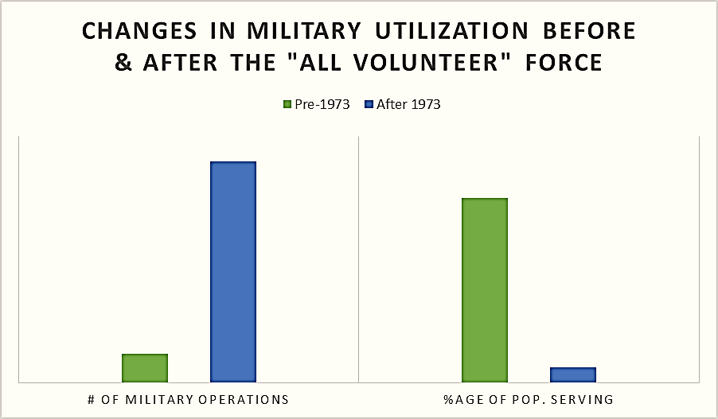
Instructor Note: As you can see, since the end of the draft, the U.S. Military has been used more often while the burden for those deployments has fallen on the shoulders of a decreasing number of willing participants.
Since September 11, 2001:
- Over 2 million U.S. Military personnel have deployed
- Over 33% of those 2 million have deployed multiple times
- Many Active Duty, Reservists, and National Guardsmen volunteered for their service based on the impact of 9/11
- 500,000+ enlisted in the National Guard & Reserves
- Lives have been forever changed by combat operations
Instructor Note: The terrorist attacks on the World Trade Center and the US Pentagon served as a call-to-arms for many Americans. At the height of combat operations in Iraq and Afghanistan, recruitment standards were reduced in order to ensure we had the numbers of personnel needed to fight our declared enemies on two separate battlefields at the same time. Currently, the military is in the midst of a congressionally mandated drawdown and greater numbers of combat experienced servicemen and women are leaving the U.S. military.

1.3.1 Identify three non-traditional tactics that are being used in modern warfare today.
Differences in Modern Warfare
- No front or rear lines (asymmetrical warfare)
- Adversaries often disguised as the civilian population
- Asymmetrical tactics of the enemy include:
- IEDs
- Suicide bombers
- Women and children decoys
- Use of religious structures and practices
Instructor Note: In the past, the enemy was located in fixed positions and followed traditional battle operation techniques. Today, the enemy could be anywhere on the battlefield. Often, the enemy looks and acts just like the metal worker, the restaurant chef, or the child walking down the road to greet U.S. forces. Our enemy has learned that guerilla warfare is the only chance they have for successfully engaging U.S. forces. This has created a battlefield that is filled with constant hypervigilance and distrust for all non-U.S. Military personnel and exceptionally intense urban- and close-quarters combat.
Urban Conflict
- Military operations in urban terrain pose greater challenges specifically due to non-combatants being “in theater”
  - Opposition forces blend with population within the city
  - Structural damage and city destitution is part of the war terrain
- Urban warfare is increasingly complex and dangerous
  - No line of sight for enemies
  - Civilian casualties are high, Including children and women non-combatants
Instructor Note: Most U.S. forces have at least the basics of combat training while some have been highly trained in detailed, focused close-quarters combat.
‘In theater’ describes the area of operations the veteran was deployed to.
The U.S. military has learned a great deal about urban combat operations since the start of Operation Enduring Freedom (OEF) and Operation Iraqi Freedom (OIF). Every Marine and Army post in the U.S. and abroad has implemented close-quarter an urban combat training. Generally, this training culminates in live-fire training exercises that closely mirror the actual environment U.S. forces face in theater. Both civilian and military actors play the role of combatants and employ techniques learned on the battlefield.
1.4 Goal: Military Training and Culture: Veterans in Texas
1.4.1 Verbalize the city in Texas with the greatest number of veterans residing in it.
Veterans & Military in Texas

Ranks 2nd in U.S. in number of veterans
- Approximately 1.6 million
- Est. family members 2.6 million
- Total is approx. 18% of the state’s population
Instructor Note: Only California has more veterans than Texas. California has approximately 2 million veteran residents. However, as we continue to see, the number of people moving to Texas as a result of the economy and job opportunities continues to grow which, in turn, also means the number of veterans will continue to grow.
1.4.2 State how many total U.S. Military installations are in Texas.
Military Installations in Texas: 15 Total Installations
- 6 Air Force
- 5 Army
- 2 Navy
- 2 Joint Reserves
Various Reserves and National Guard Units are located throughout the state.
Instructor Note: It is natural that these locations also have a very high veteran resident population because of the access to military installation facilities such as hospitals, commissaries, and exchange retail stores.
Learning Objective: The student will examine why a force reduction in the U.S. Military could pose serious concerns for law enforcement.

U.S. Military Force Reduction by 2017/2019
- Fort Hood, Texas will discharge 9% of its Active Duty force
- Fort Bliss, Texas will discharge 5% of its Active Duty force
- These reductions ultimately result in approximately 15,000 veterans and their family members being integrated into, or moving away from, our Texas communities
- Military may have a reduction of up to 26% by 2019 depending on governmental budget decisions
Instructor Note: Most of these veterans will, at least initially, return to the communities they enlisted from. Many others will remain very near the military installation they just left. As with all past military drawdowns, only a small percentage of those individuals impacted will be well prepared to return to civilian life with immediate employment and realistic expectations for civilian life.
Questions?
1.5 Goal: Military Culture 101
1.5.1 List the five branches of the U.S. Military.

The Military
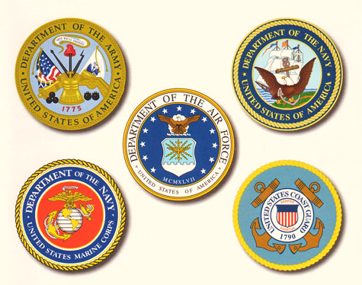
Instructor Note: There are five branches of the U.S. Military: The U.S. Army, the U.S. Navy, the U.S. Air Force, the U.S. Marine Corps, and the U.S. Coast Guard.
The Department of Defense has oversight of the Army, Marine Corps, Navy, and Air Force. The Department of Homeland Security has oversight of the Coast Guard.
Each of these branches has a specific mission:
- Army – Land-based combat and command forces – an occupying force
- Navy – Sea and Ocean-based combat and command forces – a water superiority force
- Marine Corps – Amphibious-based land assault force of the Navy – an assault force
- Air Force – Air-based combat and command forces – an air superiority force
- Coast Guard – Inter-coastal and riverine patrol of the U.S. and its interests – an interdiction force

Active/Reserve Components
ACTIVE COMPONENT
520,000 - Army
323,600 - Navy
190,200 - Marine Corps
327,600 - Air Force
40,000 - Coast Guard
RESERVE COMPONENT
205,000 - Army
59,100 - Navy
39,600 - Marine Corps
70,400 - Air Force
7,500 - Coast Guard

Instructor Note: Each of the branches has an active component and a reserve component. The active component performs training and missions every day of the year. The reserve component of each force performs training 39 days of each year to be capable of performing missions. Both the active and reserve components have the exact same missions. Naturally, when called upon to perform missions, the reserve components require rigorous training which generally involves up to three months of direct training by their active component.
NATIONAL GUARD
Army National Guard: 354,200
Air National Guard: 105,400
Instructor Note: The National Guard, which can be Army or Air Guard forces, fall under the jurisdiction of the Texas Military Department. They have two missions: State and Federal. This means they have two Commanders in Chief: the Governor and the President of the United States. Quite often, the National Guard represents the most deployed U.S. force because of their dual-mission requirements. Just like Reservists, when Guardsmen are not conducting State or Federal missions they reside in every community of Texas and, often, are disconnected from military life as a result.
1.5.2 Explain the most common processes after someone enlists into the U.S. Military.
Forging the Warrior from the Civilian
Basic or Initial Training: 8 to 12 Week Process
- Initial indoctrination training
- Well-refined process of stripping away individuality and civilian mindset and replacing them with mission and team focus based upon steeped military culture
- Physically demanding
- Every service member goes through this training
- Instills the basics of fighting, closing with, and killing the enemy while also learning how to survive as a member of a team
Continuous Training for War
Post-Initial Training – this training is constant and non-stop. It will continue for the duration of a veteran’s career (a couple years or up to and beyond 20 years of service). This includes Advanced Individual and Unit Training.
- Individuals receive advanced job-related skills and integrate into their units at duty stations across the world
- Training continues in these units which culminates in combined arms exercises (multiple forces and military disciplines) and with live-fire operations.
- Joint operations training centers across the U.S. replicate the battlefield of today’s conflict-area landscapes
- Training is extremely intense and creates the best-prepared military in the world.
- The U.S. military publicizes its training as a deterrent to armed conflict.
- Training ends with declaration of readiness and preparations for combat
Combat Deployments
Deployment – these can be 4 months’ to 18 months’ duration, and may be multiple, back-to-back.
- International – currently U.S. forces are deployed to more than 150 countries around the world in both combat and non-combat roles.
- Federally activated Reservists and National Guardsmen are deployed for 12 months plus a 3-month pre-deployment preparation phase at an active duty installation and 3-month post-deployment stand-down phase (18 months total)
- Active duty deployments: Marines – 9 months, Air Force – 4 months, Navy – 6 months, Army – 9-12 months
- Deployments may be extended per the needs of the Theater Forces Commander (generally 3-6 month extension period)
- Back-to-back deployments are common since 9/11
- Families serve and suffer through deployments, too
What about Families?
Families:
- Serve and share the same joys and sorrows of military life as the service member
- Form very tight bonds within the military community
- Communities and school with few service members or veterans may have reduced knowledge or empathy for military families
- Kids acting out may be labeled troubled kids when they are reacting to parent(s) combat experience
- Silent suffering is common among military families in civilian communities
- Service Members returning from war may have emotional detachment
- May have seen their military family (unit) in danger, wounded, or killed
- May have little empathy or understanding for civilian priorities
- Family and soldier will need to forge new bonds and create new communication
- TBI, PTSD and Military Sexual Trauma (MST) may adversely affect family reunification
Re-deployment and Reintegration Training
Re-deployment means you are coming home: This is a 2 to 3 week process
- Reintegration training begins in the combat theater
- Can be distracting since action might be happening during training
- Most people are just focused on going home
- Service Members can forget life went on without them while they were gone
- Family dynamics change while Service Member is gone (one parent or guardian has to make all the decisions)
- Can lead to conflict upon return

Transition is a 60-90 day process…Or is it?
- By federal law, a veteran is entitled to 365 days of transition services before leaving active military service.
- Per mission requirements, the veteran may get 90 days of transition preparation.
- Training covers:
  - Reintegration
  - Education
  - Employment services and
  - Family reunification
- Transition planning is often started during the deployment; there may be bombs going off or shooting happening while the training is going on, distracting the veteran. Veterans are often more focused on leaving, not on transition. The trainer is usually a person who just retired from active duty and may not have any more experience in the civilian world than the trainee.

1.5.3 Identify reasons why someone may not qualify for VA benefits.
Hand-off to the Veterans Administration? …Not so easy
- VBA- Veterans Benefits Administration- Controls who gets what benefits, including healthcare.
- VHA- Veterans Healthcare Administration- charged with taking care of the men and women who have gone to war.
- Not all veterans qualify for free services and some do not want VA healthcare. If someone receives a “Bad Conduct Discharge” or “Dishonorable” discharge listed on their DD-214, they will not be eligible for VA benefits
- All combat theater veterans discharged after 2003 are eligible for 5 years FREE healthcare from VA service providers
  - This allows time to process service connection claims and/or obtain alternate health coverage
- Must have service-related condition or injury to be eligible for lifetime free service (limited to service-connected injury or disease).
  - Must have been awarded the benefit by the VBA, which can be a complicated claims process.
- Healthcare assistance varies depending on the injury. The veteran’s healthcare can be just for a specific condition or injury, or for all healthcare based upon the disability rating given by the VBA.
- There are additional guidelines for veterans receiving VHA healthcare services, though are beyond the scope of this training. For more information, refer to VA.gov resources or your local VHA facility.

Service Member Life Cycle: an example
- At 22 years of age, the average military service member has relocated from home more than once, has family and friends often residing in at least 2 other states, has traveled the world, through peacekeeping or wartime missions/deployments, been promoted 3 times, bought a car and wrecked it, married and had children, has had relationship and financial problems, seen death, is responsible for dozens of soldiers, maintained millions of dollars’ worth of equipment, and gets paid less than $32,000 per year.
- If this average service member enlisted directly after high school, they have already completed their first enlistment contract.
Instructor Note: Questions?
1.6 Goal: Military Trauma
1.6.1 List five types of injuries that a veteran may endure.
Physical Injuries are Common
- The most common injury in veterans are the physical injuries
- More and more veterans are surviving military injuries that would have killed them in previous wars:
  - Amputations, poly-trauma injuries (e.g. internal and external physical injuries. Ex: head trauma + amputation + broken bones + severe blood loss, though stabilized in theater and returned home)
Veterans live with multiple unseen injuries:
- Post-Traumatic Stress Symptoms or Disorder (PTSS/PTSD)
- Traumatic Brain Injury (TBI)
- Military Sexual Trauma (MST)
- Moral Injury
- Depression
- Comorbidity

Instructor Note: Stress the importance of identifying that these are all injuries related to military service and are not illnesses a person is born with.
Unlike mental illness, these did not manifest on their own. Most of these are a direct result due to their service in the armed forces.
Graphic:
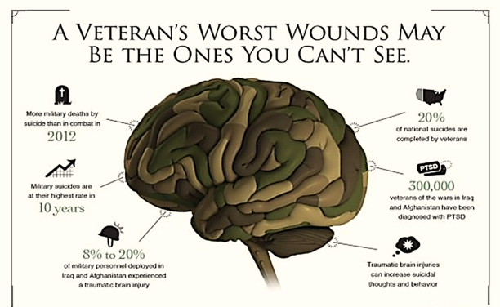

Instructor Note: Today’s training will explain these “Invisible Wounds of War” and discuss how these translate into your communities through law enforcement interactions.
- More military deaths by suicide than in combat in 2012
- Military suicides are at their highest rate in 10 years
- 8-10% of military personnel deployed in Iraq and Afghanistan experienced a traumatic brain injury
- 20% of national suicides are completed by veterans
- 300,000 veterans of the wars in Iraq and Afghanistan have been diagnosed with PTSD
- Traumatic brain injuries can increase suicidal thoughts and behavior
Types of Traumatic Exposures
- Moral injuries
  - Acts that go against the way we were raised or against our belief systems (e.g. killing children)
- Physical injury
- Witnessing/experiencing combat situation, etc.
- Military sexual trauma
  - ~40% personal trauma (e.g. rape)
  - ~85% incl. sexual harassment, witnessing or experiencing

What is “Traumatic” in the Military?
- Potentially traumatic events include those that involve actual or threatened death, serious injury, or sexual violence.
- Everyone’s experience while deployed to a war zone, whether on a front-line or support role, is unique and the same event may or may not be perceived as traumatic by different people.
- Most traumatic stress reactions are “normal responses to abnormal events” and only become symptoms of a disorder when they persist and cause significant distress or impairment in life functioning.
Current Combat Stressors
- Being attacked or ambushed = 60%
- Receiving incoming fire = 86%
- Being shot at = 50%
- Discharged weapon = 36%
- Seeing dead bodies or remains = 63%
- Knowing someone personally who was seriously injured or died = 79%

1.6.2 Identify three common reactions to critical incidents.
How the Brain Reacts to Trauma
- When traumatic exposure occurs, the brain sends an alarm throughout the body to ACTIVATE the person to defend themselves.
- Once the alarm sounds, an adrenaline rush occurs, which tenses muscles, increases alertness, attention, heart rate and blood pressure, and changes how a person “sees” their environment.
- The brain releases chemicals that increase a person’s endurance and dulls the awareness of pain.
- The trauma response then “hijacks” the conscious, rational part of the brain, so that one’s entire attention and focus is directed toward survival.
How the Brain Reacts to Trauma
- The brain ensures that one reacts immediately to threats and then helps to keep reactions in balance.
HOWEVER ……
- The part of the brain that helps balance out protective reflexes may not work well when a person suffers from –
- Sleep deprivation
- High intensity combat
- Hunger/thirst
- Repeated trauma

Flight, Fight, or Freeze Response
- Basic to survival in all animals
- Automatic response to perceived threat
- Activates processes needed for survival (heart rate and respiration increase, stress hormones released)
- Shuts down processes not vital for immediate survival

Instructor Note: Any one of these three responses is common when faced with a critical incident. Arousal continues after the perceived threat ends as a protective mechanism in case danger returns. If stress response is allowed to stay “on,” such as in a combat arena – continued arousal (chronic stress) can interfere with natural immune system function and negatively affect health. Prolonged stress activation leads to a chronic state of hyper- arousal, alternating with numbness, and depletion of natural chemicals that help us calm down and return to “normal.”

Witnessing or Participating in Potentially Traumatic Events
- Not everyone who witnesses or participates in the same events react the same way
- When someone perceives an event as traumatic they can develop symptoms that cause significant distress:
- Some people’s reactions are short-lived = “acute”
- While other’s reactions are longer term = “chronic”
- It is believed that early intervention (during the “acute” reaction phase) that individuals can be less likely to have symptoms become “chronic”
Instructor Note: For example, firing your weapon at an individual could result in, “trauma” for one individual while another may not perceive it as traumatic as they feel they were protecting themselves or others.
Factors that Influence Severity of Impairment from Trauma:
- Biological vulnerabilities
- Pre-trauma life experiences
- Age at the time of trauma
- Frequency and severity of traumatic stressors
- Environmental support after trauma

1.7 Goal: Post-Traumatic Stress Disorder (PTSD)
1.7.1 Define what PTSD is and what can cause it.
Instructor Note: Video: “What is PTSD?” (Access PowerPoint for video)
Post-Traumatic Stress Disorder (PTSD)
- PTSD can occur after you have been through a traumatic event. A traumatic event is something terrible and scary that you see, hear about, or that happens to you, like:
  - Combat exposure
  - Child sexual or physical abuse
  - Terrorist attack
  - Sexual or physical assault
  - Serious accidents, like a car wreck
  - Natural disasters, like a fire, tornado, hurricane, flood, or earthquake
Instructor Note: During a traumatic event, you think that your life or others’ lives are in danger. You may feel afraid or feel that you have no control over what is happening around you. Most people have some stress-related reactions after a traumatic event; but, not everyone gets PTSD. If your reactions don't go away over time and they disrupt your life, you may have PTSD.
1.7.2 Identify at-risk occupations for developing PTSD.
Who gets PTSD?
Not everyone gets PTSD and it isn't clear why some people develop PTSD and others don't. Whether or not you get PTSD depends on many things:
- How intense the trauma was or how long it lasted
- How often you were exposed to the trauma(s)
- If you were injured or lost someone important to you
- How close you were to the event
- How strong your reaction was
- How much you felt in control of events
- How much help and support you got after the event
Instructor Note: What occupations may be at a higher risk of developing PTSD? Military and first responders, including dispatchers and call takers?
Video: Law Enforcement and PTSD. (Access PowerPoint for Video)
Instructor Note: This is the police PTSD video. The conversation after this video should be about the similarities between law enforcement and military. Also consider dispatchers and law enforcement civilian personnel. Sample questions include:
What are the similarities and differences between veterans and LEOs? Are the PTSD symptoms similar? What are some other examples of PTSD that you have seen (not necessarily personal experiences- this isn’t the right place to have people addressing their PTSD). It will be important to have phone numbers for self-care available in case this training triggers someone. National Suicide Hotline- 800-273-8255, Veterans Crisis Line is the same number, just press 1. Police crisis line- 800-267-5463. A break may be appropriate after this discussion.
What are the symptoms of PTSD?
- Re-living the event (also called re-experiencing symptoms)
- Avoiding situations that remind you of the event
- Negative changes in beliefs and feelings
- Feeling keyed up (also called hyper-vigilance)
Instructor Note: You may have bad memories or nightmares. You even may feel like you're going through the event again. This is called a flashback.
You may try to avoid situations or people that trigger memories of the traumatic event. You may even avoid talking or thinking about the event. This is a fear-based (and patterned), behavioral response to stressors.
The way you think about yourself and others may change because of the trauma. You may feel fear, guilt, or shame. Or, you may not be interested in activities you used to enjoy. This is another way to avoid memories.
You may be jittery, or always alert and on the lookout for danger. You may have trouble concentrating or sleeping as a result.
Rates of PTSD in Veterans
The number of veterans with PTSD varies by service era:
- Operations Iraqi Freedom (OIF) and Enduring Freedom (OEF): About 11-20 out of every 100 veterans (or between 11-20%) who served in OIF or OEF have PTSD in a given year.
- Gulf War (Desert Storm): About 12 out of every 100 Gulf War Veterans (or 12%) have PTSD in a given year.
- Vietnam War: About 15 out of every 100 Vietnam Veterans (or 15%) were currently diagnosed with PTSD at the time of the most recent study in the late 1980s, the National Vietnam Veterans Readjustment Study (NVVRS). It is estimated that about 30 out of every 100 (or 30%) of Vietnam Veterans have had PTSD in their lifetime.
http://www.ptsd.va.gov/public/PTSD-overview/basics/how-common-is-ptsd.asp
Triggers
- High levels of stress may cause a breakdown in information processing, leading memories to be stored as physical or sensory cues.
- Experiences associated with the original event(s) (e.g. emotions, smells, sounds, humidity, visual images, taste, people/objects that were present, etc.) may have the power to evoke memories of the event.
Instructor Note: In the most extreme cases, triggers can cause a person to have a “flashback” of the event. That is, they lose touch with their current environment and feel as if they were back in the traumatic situation (e.g., back in Vietnam, Iraq or Afghanistan). What could be triggers for someone? Seeing an empty box or broken down vehicle near the roadway, smells of gasoline, police responses such as tactical deployments, etc.
As LEOs are collecting information about the call or while on scene, these may be indicators to notice related to PTSD and should be documented.
Behavioral symptoms

- Intrusive memories
- Avoiding reminders
- Trouble concentrating
- Emotional outbursts
- Hypervigilance
- Flashbacks
- Loss of interest in hobbies
- Withdrawal from others
- Reckless or self-destructive behavior
- Increased self-medication

Instructor Note: More examples of potential problem behaviors:

- Tendency to isolate
- Uncomfortable interacting in social situations
- Inability to show loving feelings
- Avoidance of war movies, news, etc.
- Problems sleeping
- Yelling, and thrashing in sleep without remembering why later
- Can’t wait in line or tolerate crowds
- Angry outbursts
- Doesn‘t want to go anywhere

Emotional Symptoms:
- Anger
- Irritability
- Sadness
- Anxiety
- Hopelessness
- Guilt

Effects on relationships
- Becomes withdrawn, detached, or disconnected
- Loss of desire for intimacy, closeness
- Mistrust
- Over-controlling/overprotective behavior
- Argumentative
- Family violence may result

The Road to Recovery with PTSD (video)
Instructor Note: Emphasize the reality that recovery is possible, but it requires work.
Asking a veteran if they have already sought counseling is appropriate. If they have not, the suggestion to do so may come across as offensive, but may also plant the seed to do so.
What Does Recovery Mean?
Recovery is a complex and dynamic process encompassing all the positive benefits to physical, mental and social health that can happen when people, or their family members, get the help they need.
Questions?
1.8 Goal: Traumatic Brain Injury (TBI)
1.8.1 Define traumatic brain injury
Video: A Marine veteran talks about the effects of multiple brain injuries had on his ability to function and perform basic tasks.
Instructor Note: Discuss what behaviors that may cause you to ask this individual questions related to alcohol or substance use?
Definition of TBI
- A TBI is a blow or jolt to the head or a penetrating head injury that disrupts the normal function of the brain.
- The severity of injury may range from a mild concussion to severe closed or open head injury.
- The injury may not be reported or diagnosed.
- TBI symptoms may not appear for months or years.

Instructor Note: A TBI can result in short- or long-term problems with functioning (e.g., daily activities, social functioning, work/school, etc.).
TBI is the signature wound of Operation Enduring Freedom (OEF)/ Operation Iraqi Freedom (OIF)/Operation New Dawn (OND)
- An estimated 15 to 23% of OEF/OIF/OND Veterans have a TBI.
- TBI increases difficulty in reintegrating into home and community.
- Mental health problems (including encounters with law enforcement) are often due to undiagnosed / untreated TBI and/or PTSD.
Instructor Note: The Department of Defense (DoD) has named TBI the, “signature wound” of the Iraq/Afghanistan war because there are more TBIs reported and undiagnosed than any other injury.
Suicide prevention is a major priority for DoD, the Department of Veterans Affairs, and law enforcement agencies (i.e., preventing suicide by cop).
Most Common Causes:
- Training accidents (e.g. falls)
- Motor Vehicle Accidents (e.g. roll-overs)
- Concussive blast exposures (e.g. bombs, IEDs, mortar explosions)
- Assaults

Instructor Note: There are more TBI injuries from training exercises, vehicle crashes and rollovers than there are from combat.
1.8.2 Name the three classifications for traumatic brain injuries.
Severity of Brain Injuries
- Concussion/Mild TBI: confusion/disorientation less than 24 hours, loss of consciousness (LOC) up to 30 minutes, memory loss less than 24 hours, normal MRI or CT scan.
- Moderate TBI: confusion or disorientation more than 30 minutes/less than 24 hours, LOC more than 30 minutes, MRI/CT scans normal to abnormal.
- Severe TBI: confusion or disorientation more than 24 hours, LOC more than 24 hours, memory loss for more than 7 days, imaging may be normal or abnormal.
Instructor Note: TBI is not just a bullet in the head or open head injury, but can include concussion, blast injury, blows to the head, etc.
Structure and Function
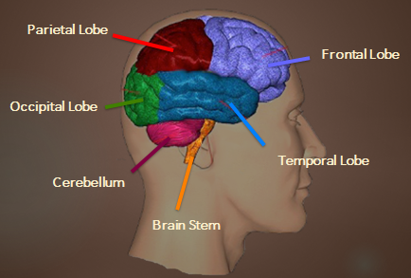
Instructor Note: The most common injury in military accidents is a FRONTAL LOBE (Front of head) injury, which may impact:

Initiation
Problem solving
Judgment
Inhibition of behavior
Planning/anticipation
Self-monitoring
Motor planning
Personality/emotions
Awareness of abilities/limitations
Organization
Attention/concentration
Mental flexibility
Speaking (expressive language)

Other parts of the brain that may be affected and the functions they perform:

PARIETAL LOBE
Sense of touch
Differentiation in size, shape, color
Spatial perception
Visual perception
OCCIPITAL LOBE
Vision
CEREBELLUM
Balance
Coordination
Skilled motor activity
BRAIN STEM
Breathing
Heart rate
Arousal/consciousness
Sleep/wake functions
Attention/concentration
TEMPORAL LOBE
Memory
Hearing
Understanding language (receptive language)
Organization and sequencing

Instructor Note: The student will not need to memorize these, but are listed for familiarity and to expose the student to the impact that at TBI can have.
1.8.3 Recognize several symptoms that may accompany a traumatic brain injury.
TBI Symptoms

- Irritability
- Aggression
- Paranoia
- Disinhibition
- Anxiety
- Apathy/Depression
- Insensitivity
- Egocentricity
- Lack of concentration
- Difficulty with memory
- Reckless decision-making
- Agitation
- Anger
- Lack of empathy

Instructor Note: These are the cognitive and emotional symptoms of TBI.
Observable Symptoms of TBI
- Persistent talking
- Inability to recognize an object moving
- Slurred speech
- Poor postural control
- Muscle tremors
- Impaired fine motor skills

Instructor Note: Other symptoms which may occur are: Anomia (the inability to name something, like “apple”); Agraphia (the inability to remember how to write a word, like their name); and a lack of facial expressions.
These symptoms are often mistaken by LEOs as symptoms of intoxication. We would advise LEOs to approach these symptoms with safety first, and if intoxication can be ruled out, consider TBI as a potential challenge in the encounter.
Behavioral symptoms of TBI

- Lack of inhibition
- Impulsivity
- Reckless decision-making
- Aggression
- Agitation
- Paranoia

Instructor Note: Many times these behavioral symptoms are what initiate LEOs responding to calls. Veterans who exhibit these symptoms are often afraid, anxious, and nervous. These symptoms can be de-escalated with skilled use of de-escalation strategies.
TBI and Law Enforcement
- TBI symptoms often result in increased verbal and physical altercations
- Inappropriate or impulsive behavior/aggression or abusive language is common
- TBI symptoms may appear to be resistance to authority
- Veteran may have difficulty remaining focused
- TBI symptoms may present as early dementia
- Veteran may not remember, or respond well to, instructions or questions

TBI and Law Enforcement
- Law enforcement personnel may mistake individuals with brain injury for individuals under the influence of alcohol or other substance, especially in conjunction with traffic stops.
- When responding to home calls, symptoms of TBI may create a difficult environment which law enforcement may perceive as deliberate or argumentative.
Instructor Note: What can LEOs do to de-escalate situations where veterans exhibit these symptoms? What would ESCALATE the situation?
Questions?
1.9 Goal: Military Sexual Trauma (MST)
1.9.1 List what types of offenses are included in the classification of Military Sexual Trauma.
Military Sexual Trauma
MST is the term that the Department of Veterans Affairs uses to refer to sexual assault or repeated, threatening sexual harassment that occurred while the veteran was in the military. When the perpetrator is a military member, it is a violation of the personal trust that is developed through military service.
MST includes:
- Rape
- Unwanted sexual touching or grabbing
- Threatening, offensive remarks about a person’s body or sexual activities
- Threatening and unwelcome sexual advances
Instructor Note: The key point to identify here is MST is perpetrated by a person trusted to be the other person’s brother- or sister-in-arms.
What is Military Sexual Trauma?
It includes any sexual activity where someone is involved against his or her will – he or she may have been pressured into sexual activities (for example, with threats of negative consequences for refusing to be sexually cooperative or with implied faster promotions or better treatment in exchange for sex), may have been unable to consent to sexual activities (for example, when intoxicated), or may have been physically forced into sexual activities.
Other experiences that fall into the category of MST include unwanted sexual touching or grabbing; threatening, offensive remarks about a person’s body or sexual activities; and/or threatening or unwelcome sexual advances.
Instructor Note: It is important to note the public perception of MST is focused on rape cases only. The reality is that MST can and does include sexual harassment. Generally, the sexual harassment this describes is so dominating on the victim’s psyche that it causes depression, anxiety, and a hostile working environment.
Sexual harassment in the military most frequently exceeds what most people think of when they think of the words “sexual harassment” and is not limited to females. In the military, sexual assault and harassment most commonly occurs against MALES.
Military Sexual Trauma
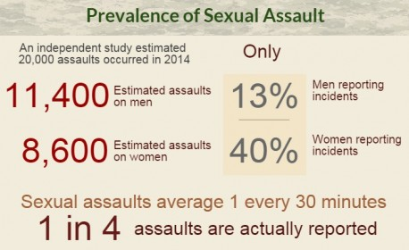

- Both women and men can experience MST during their service.
- Considering the small percentage of women in the military (~15%) most experiences will occur with males, though a higher percentage of females report
- Between 13-40% of all veterans will report a significant MST event during their military service that resulted in significant mental health symptoms
- It is estimated that roughly 80% of all veterans report some level of MST (primarily sexual harassment) being experienced or witnessed during their service
- Data is limited because of the low incidence of reporting
Instructor Note: The RAND foundation found 20,000 service members experienced at least one sexual assault which includes either rape, and attempted rape, and non-penetrative (sexual harassment) crimes during 2014.
It is also important to be specific that MST does often occur with male veterans and is significantly under-reported because of the stigma associated with it.
What are the symptoms of MST?
- Intimate partner and domestic violence
- Anxiety Disorders
- Depression
- Mood swings
- Anger
- PTSD
- Substance abuse

Instructor Note: How does this relate to LEOs?
- LEOs should afford male and female veterans both the opportunity to interact with their choice of male or female LEO, when applicable. This can assist with de-escalating a negative situation and decrease the fear of the veteran.
- LEOs should practice asking ALL veterans whether they have experienced sexual assault or harassment when obtaining a history (when it is appropriate to do so and the scene is secure)
What else can LEOs do when responding to veterans with MST?
Questions?
1.10 Goal: Moral Injury
1.10.1 Define moral injury.
What Is A Moral Injury?
- Psychological trauma through a violation of deeply held moral beliefs.
- A moral injury may occur when people are directed to do things or witness things that go outside of what they believe to be “right.”
  - Example: The use of children or women as suicide bombers in Iraq or Afghanistan and veterans being in positions where they are forced to kill these individuals to protect themselves or others.
  - Example: The use of male children as sexual objects, which is a culturally accepted practice in Afghanistan and veterans are directed to “do nothing” because it would be imposing American values into another country – which goes “against military rules.”
Instructor Note: A moral injury is an injury to an individual’s moral conscience resulting from an act of perceived moral transgression which produces profound emotional shame. –Wikipedia
Types of Moral Injuries
- Unintentional errors: Military personnel are well trained in the rules of engagement and do a remarkable job making life or death decisions in war; however, sometimes unintentional error leads to the loss of life of non-combatants, setting the stage for moral injury.
- Transgressive acts of others: Service members can be morally injured by the transgression of peers and leaders who betray expectations in egregious ways.
How Do Moral Injuries Relate to a Diagnosis of PTSD?
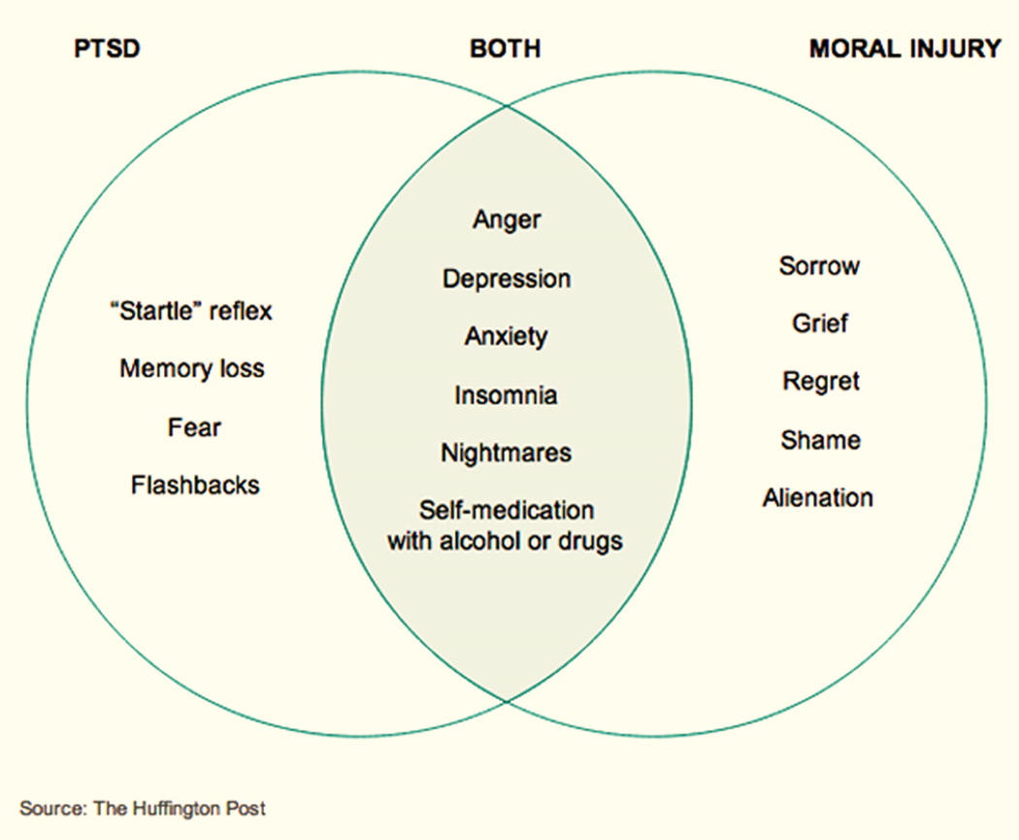
Instructor Note: Symptoms related to moral injury are the descriptions we have heard from our veterans across war eras.
Video: Moral Injuries (Access PowerPoint for Video)
Questions?
1.10.2 Discuss what role Depression plays in Moral Injury
Instructor Note: Many service members and veterans will suffer from depression. Due to the amount of information, the impact that depression can have on an individual, and how this will often result in law enforcement encounters. We will delve deeper into this topic on day 2.
1.10.3 Define Comorbidity
Instructor Note: Comorbidity means that two or more traumas are impacting the behavior or life of the person experiencing them. Often, the symptoms or effects of one trauma are heightened or made more severe by the symptoms of another trauma.
Video: Comorbidity

Similarities between PTSD & TBI and the heightened effect
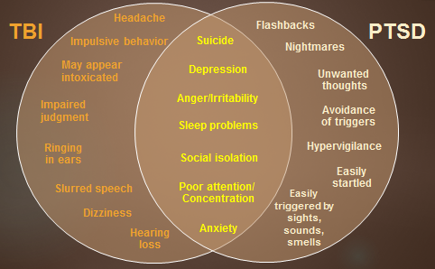
Instructor Note: PTSD and TBI are often co-existing conditions that may not be recognized – even by the veteran.
Because the symptoms can’t easily be distinguished in an initial encounter, it is best to approach any person in crisis with the mindset that they may have both PTSD and TBI.
The words in yellow may be heightened when both PTSD and TBI are present (although MST or other traumas may have a similar effect).
Questions?
1.11 Goal: Understanding Military Families
1.11.1 List how the military culture can affect the family of the service member.
Instructor Note: Graphic of military family: Why does understanding military life optimize working with military children and families? What are some things military families go through that civilian families never encounter?
- Consider cultural implications of military affiliations
- Recognize potential influences on child development
- Military families deal with significant stressors (incl. deployment to reintegration)

Identifying Military Families
- Many agencies fail to ask basic questions, such as “Is there a veteran or military service member in the home?”
- This can lead to missing warning signs in military families that may point to abuse, neglect, or family strains that may affect their ability to meet the veteran or family’s basic needs.
Instructor Note: Why is it important to know if there is a service member in the family?
Entities such as schools, daycares, medical offices, social services including the police, etc., fail to ask basic questions, such as “Is there a veteran or military service member in the home?”
This can lead to missing warning signs in military families that may point to abuse, neglect, or family strains that may affect their ability to meet the child’s basic needs.
Are there any weapons in the house that may be accessible to a child?
The Influences of Military Culture on Families

- Attitudes
- Beliefs
- Custom
- Traditions
- Clothing
- Food
- Language
- Achievements

Instructor Note: Military families are in the military themselves. The actions taught to the soldier are used at home. Have the MVPN veteran talk about how military service affected his/her family.
Military Impact on Parenting
- Deployment (self or spouse)
- Displaced from traditional family supports
- If deployed, exposure to environmental triggers and high-stress work place
- If not deployed, single-parent household management
- Inexperience with day-to-day responsibilities of parenting
- Unrealistic expectations of parenthood

Instructor Note: Depression or feelings of isolation for the parent not serving or vice versa. Feelings of being overburdened while service member is, “having fun.”
Service member may find themselves giving orders to their children, having them do physical training as punishment, talking to their spouse as a subordinate
Nature/Nurture
The military life cycle puts children at risk and tries to protect them at the same time.

Environmental Risk Factors
- Child Abuse
- Maternal Depression
- Domestic Violence

Environmental Protective Factors
- Family-centered Support
- Community Advocacy

Children in Military Families
- Children in military families are often affected by stress and trauma associated with deployments and homecomings
- Military life is often demanding
- Military has unique cultures that can vary by branch, installation, mission and family
- Military families have historically been remarkably resilient

Instructor Note: How are today’s circumstances different than the days before? Is it harder or easier to be a military family in today’s world?

Military Family Life is Its Own Culture
- Saying good bye to loved ones as they deploy, multiple times
- The non-military parent usually functions as a single parent
- Some families are “born to the life,” while others are thrusted into the military life
Instructor Note: Families say goodbye to their loved ones multiple times, for months at a time. Their partners may or may not be able to communicate regularly. This process can occur more than once, especially if the service partner had chosen to make a career with the U.S. services. Families are used to making, “lists,” including:
- Packing lists
- Deployment lists
- Moving lists
- Lists for wills & insurance

The non-military parent usually functions as a single parent:
- Taking care of residence and all finances, caring for children and attending school functions/events/meetings, oversees all medical needs for family members, may experience life events alone; such as a death in family, birth of a child, serious injury
- Even when their military partner is home, they are often not available due to unpredictable training, missions, etc.

Some families are “born to the life” while others are thrusted into the military life:
- Failure to cope, struggles with the separation and hardships it can present
- Spouse may be in a new geographical location, where prior support networks are no longer easily available. This can create feelings of isolation and instability in getting help when it’s needed most
Are there any other challenges that the spouse may face?
After all that time away…
The service member may have developed behavioral health issues or received traumatic brain injuries from their service.
Because of the issues going on, they may have a substance abuse problem– their reintegration difficulties are now transferred to the family.
What other issues could the service person come home to?
Instructor Note: Example: Serviceman left for deployment and his wife was two months pregnant. When he returns, she has given birth to the child and the baby is one month old. How could this affect the stress level at home?
Spousal Aggression/Divorce
- Upon transitioning home service members often have relationship problems with their spouses and children (36% reported)
- Struggle with personal levels of aggression and anger (43% reported)
- 1 in 5 service members have filed for divorce since 2001
- As of 2004, there was a marked increase in divorce filings (estimate 44% increase since before 9/11)
- Domestic violence is often underreported due to potential negative consequences (e.g. discharge from military service)
Unspeakable Truth
- Military families live with the fact this is one of the few professions in which their loved one may not ever return home.
- Many families are plagued with the anxiety of “the knock on the door from uniformed officials.”
Instructor Note: Military Families understand their fathers, husbands, mothers, wives, brothers, sisters, sons and daughters may not return from their deployments. Does this type of truth exist for LEOs’ families?
Questions?
1.12 Goal: Law Enforcement/Military Similarities
1.12.1 The student will list similarities between law enforcement and the military
- Graphics of the similarities of military and law enforcement:
- Badges/Patches
- Large Crowd Control/Riot Control
- Clearing a building
- Tactical Approach/Making a room or building entry
- Funeral

Different and Similar
Law Enforcement Officer:
- Trained to ensure protection/safety of others.
- Trained to ensure safety of self with force when needed.
- Faces traumatic stress daily in the course of duty.
- May experience symptoms of traumatic stress and hesitance to report to chain of command.
- Trained in use of physical force to receive desired response.
- Trained in the use of weapons to ensure safety of self/others.
- Traumatic and life threatening encounters happen at home/community.

Combat Veteran:
- Trained to ensure protection/safety of others.
- Trained to ensure safety of self with force when needed.
- Faces traumatic stress daily in the course of duty.
- May experience symptoms of traumatic stress and hesitance to report to chain of command.
- Trained in use of physical force to receive desired response.
- Trained in the use of weapons to ensure safety of self/others.
- Traumatic and life-threatening encounters happen in foreign battlefields.

Comfort with Violence
- Both are trained to make safety for themselves and those around them a top priority
- Both are trained in the use of violence, if necessary, to complete the mission or get the subject into custody.
- Both professions present risks of traumatization by their duties

Instructor Note: When two highly trained, and often armed, professionals encounter each other in a heightened or frightening situation, either one can overreact due to hyper-vigilance, fear for their own or others’ safety, or as a result of trauma-induced symptoms and escalate the situation. The outcome can be deadly. This trauma can lead to under-reported and under-treated Post-Traumatic stress.

Why is this important?
In the line of duty, first responders are trained to utilize tactical strategies in crisis situations, and they are quick to respond to protect the lives and property of those they serve. Unfortunately, a hidden danger is often ignored: Traumatic Stress

Instructor Note: The impact for LEOs can be the same as for service members - PTSD. Both groups face the stigma of getting help and not being able to keep their job if they are found, “Not fit for duty”.

Examples of Critical Incidents
Law Enforcement Officer:
- Sustained Exposure to Trauma/Stress
- Officer-involved shootings
- Line of duty injuries/deaths
- Incidents when a child is a victim
- Incidents involving death/serious injury to others
- Disasters
- Comrade suicide

Combat Veteran:
- Active Combat/Sustained Exposure to Trauma and Stress
- IEDs, Indirect Fire, Snipers, Suicide Bombers
- Observing the death of friends
- Incidents when a child is a victim
- Incidents involving death/serious injury to others
- Line of duty accidents/injuries
- Comrade suicide

Instructor Note: All of these events can lead to or produce stress in a multitude of ways. Immediate, brief, confidential intervention can assist with mitigating the long lasting effects of stress both mentally and physically. Denial of the severity of stress can lead personal relationship difficulties and professional decline. Not talking about the situation does not promote healing.
-A problem shared by two lightens the load.

Similar Outcomes
- Heightened divorce rates
- Substance dependence/abuse
- Depression
- Financial difficulties
- High rates of suicide

Instructor Note: There have always been multiple stressors associated with being a first responder such as:
- ‘Do more with less’ mentality.
- Socioeconomic stressors due to unemployment
- Limited access to affordable healthcare
- Parenting stressor
- Relationship stressors

Questions?

Military Veteran Peer Network
Instructor Note: Have the Military Veteran Peer give description of the program, what resources they offer, and how to find their representative for their area.

Various Resources available for veterans and service members

End of Day One

Day 2:

2.0 Introduction

Instructor Note: The introduction to day two is a review and/or recap of Day 1. Students should be guided through an active discussion of Day One information to verify internalization of topic areas.

Questions?

2.1 Goal: LEO/Veteran Encounters

2.1.1 Discuss common types of offenses that may be committed by trauma affected veterans.

Common types of offenses related to combat trauma

Instructor Note: The intent of this block of instruction is to facilitate a discussion among the audience regarding their experiences with veterans. What are the offenses the LEOs have been called out to? What types of situations did they encounter? Did the offense they were called out to escalate into other offenses/charges?

Instructor Note: Video: One veteran’s story, TedTalk: veteran convicted of assault & battery and served 10 years. (Refer to PowerPoint for video access)
Possible Encounters:

- Self-medication
- Driving while intoxicated
- Public intoxication
- Drug crimes
- Homelessness
- Weapon charges
- Criminal trespass
- Domestic violence
- Assault
- Self-harm
- Traffic/Aggressive Driving

Instructor Note: May be a result of PTSD, TBI, or MST. Does the audience agree with these factors? Do they see these factors routinely in their dealings with Veterans? Are there other factors that may not be addressed here?
Aggressive driving could include the following: speeding, sudden lane changes, failure to pull over, driving down the middle of road, avoidance of objects on side of road, swerving under bridges, driving over curbs, etc. In traffic jam, may panic or feel “ambushed” if stuck in traffic, causing erratic driving responses.

A look at Travis County
Source: Veterans Intervention Project, July 2009

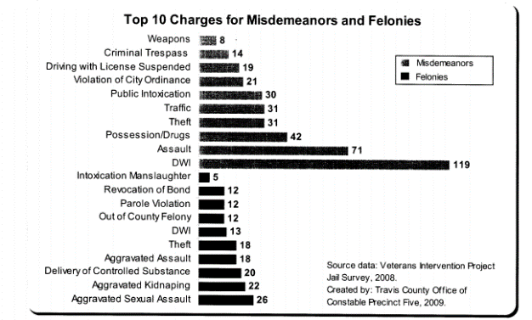

Instructor Note: This data comes from a report from the Veterans Intervention Project which studied the types of charges filed against veterans booked into the Travis County Jail in Austin, TX.
Are these the same types of offenses encountered by other LEOs across the state?
Of note, and indirect relation to a familiarity to a culture of violence, it is no small fact that there is a strong representation of ‘violent’ acts on this report.
National Veteran Incarceration
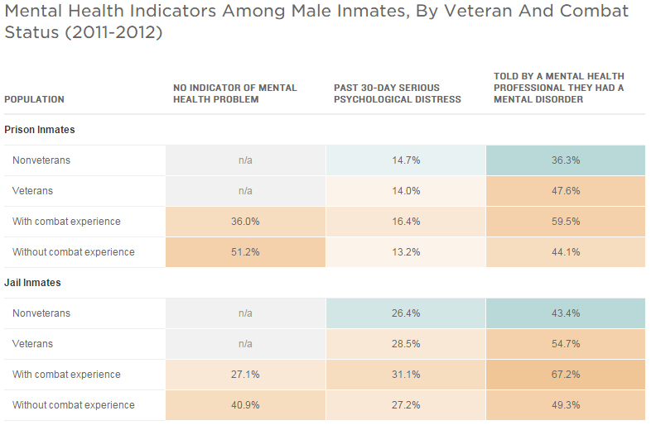
Instructor Note: This report, from the Bureau of Justice Statistics, points out that a very large number of combat veterans self-report having a history of veteran issues.
Discussion point: Do you think these incarcerated veterans have received appropriate treatment? Do you think they will receive that treatment in prison/jail?
2.2 Goal: Depression/Suicide
2.2.1 Compare the risk of suicide for a veteran vs. the general population.
Suicide
- 20 Percent of U.S. deaths from suicide are veterans
- Veterans are more likely than the general population to use firearms as a means for suicide
- Decreased suicide rates in veterans aged 18-29 who use VA healthcare services
- 33 percent of recent veteran suicides have a history of previous attempts
- Every day in the US, there are 22 suicides completed

Instructor Note: Refer students to hand-out (1)- Suicide rate by year after discharged (deployment status, also) of veterans.
Instructor Note: *The rate of suicide was greatest for veterans within 3 years after leaving service. The graph shows the breakdown for both deployed veterans and non-deployed.
Suicide rate is higher for veterans that did NOT deploy. Are you surprised by this? Any reasons why you think this may be?
Notice that between 6-9 years that the deployed veteran is at higher risk than the deployed veteran.
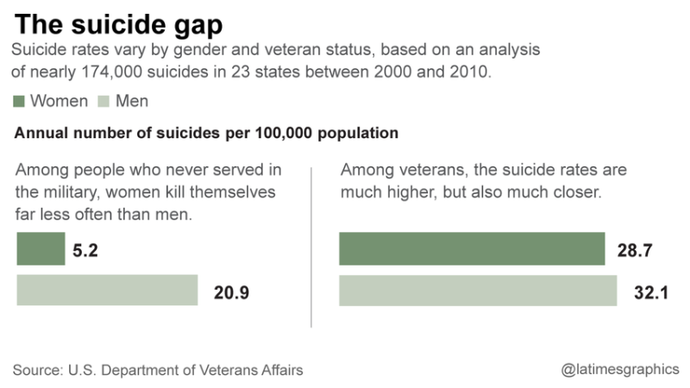
Instructor Note: The take away from this is that women and male veterans have an almost equal rate of suicide.
Responding to a Situation Involving Potential Mental Health Concerns
- TCOLE Mental Health Officer course is highly recommended. Responding officers should at least have received Crisis Intervention Training and Advanced Crisis Intervention Training.
- Nationally, officers are being expected to use less force and more de-escalation tactics on all calls
- Treat the call like a welfare concern or emotionally disturbed person (EDP)
- Utilize de-escalation and active listening skills

Instructor Note: Know your department policies and SOPs; if you suspect that the subject has mental health concerns or the person is in crisis, call a MHO or CIT officer to the scene to assist immediately.

2.2.2 List questions used to assess a suicide risk

Instructor Note: Have students share the process they follow when trying to identify if a person is displaying suicidal behavior.

Suicide Assessment
- Are they seeing a doctor or therapist? Get name and contact number for doctor.
- Diagnosed with any conditions? Or taking medication?
- When you are assessing for suicide risk, ask them directly if they are currently thinking or have been thinking about committing suicide in the past.
- Attempted suicide before?
- What method to kill them self? Do they have means to those methods?
- How long they have been depressed or sad?
- Determine if they have long term plans that indicate they are planning on living.
- Support systems?

Instructor Note: If you are able to get contact information for a doctor, have a backup officer contact them and get past history and prescribed medications. Explain to the doctor why you are interacting with their patient and see if they have completed a risk assessment. Some doctors will be very hesitant to tell you anything. Explain to them that this is extenuating circumstances and that you are needing the information so that you can make an assessment if an apprehension is needed.

Ask them if they have been diagnosed with any conditions. Leave this generic- both psychological and medical conditions are important. When asking if they are taking any medication, be sure to ask about prescribed and other such as drugs or alcohol.

It is an old myth that if you ask the subject if they are thinking about, “killing themselves,” that you are going to put the thought into their head. You are not. Either they have contemplated suicide or they haven’t. Asking someone if they have thought about killing themselves can be intimidating and uneasy, but you need to know the information. So a way to ask is to preface it as, “I know this is uncomfortable, but I have to ask you if you are thinking about killing yourself?” Or, “I don’t mean to pry, but before I leave, I have to know if you have thought about killing yourself?”

2.2.3 Identify what gives Texas peace officers the authority to detain someone for the purpose of mental health well-being.
Health and Safety Code
- Chapter 573: Emergency Detention
- Make determination if the person qualifies for emergency detention
  - Person with mental illness
  - Substantial risk of serious harm to the person or to others unless the person is immediately restrained
- Seizing of any firearm found in possession of the person
- Complete necessary paperwork for the hospital staff and your department. Be detailed and specific.

Instructor Note: HSC Chapter 573 is extremely important and grants Texas peace officers a great deal of power and responsibility.

For the actual Health and Safety Code that details apprehensions see the following link: http://www.statutes.legis.state.tx.us/Docs/HS/htm/HS.573.htm
(h) A peace officer who takes a person into custody under Subsection (a) may immediately seize any firearm found in possession of the person. After seizing a firearm under this subsection, the peace officer shall comply with the requirements of Article 18.191, Code of Criminal Procedure.

It is up to us to get the person transported to the nearest inpatient mental health facility so they can get professional help. Know your department policies and SOPs; if you suspect that the subject has mental health concerns or the person is in crisis, call a MHO or CIT officer to the scene to assist immediately.

The two most common mental illnesses we may see with veterans includes, but is not limited to: Post Traumatic Stress Disorder and depression. Diagnostic and Statistical Manual of Mental Disorders, 5th Edition: DSM-5

Criteria for Major Depressive Disorder (MDD): Depressed mood or a loss of interest or pleasure in daily activities for more than two weeks.

Risk of serious harm can also include a deterioration of quality of life. Include everything that you see, smell, or hear into your paperwork.

(Refer to Handout #2)

Questions?
2.3 Goal: De-Escalation
2.3.1 Identify steps to take to de-escalate an encounter with a trauma affected veteran.
The goal of this training is so that both the officer and the veteran are safe and go home to their families.
“911, what is your emergency?”
- Dispatchers play a vital role in gaining valuable information for officers responding to the scene
- Set the tone for how officers respond
- Ask pertinent questions
- Attempt to send officer who served in the military
- Know your local resources that may be used in conjunction with law enforcement

Instructor Note:
Questions to ask:
- “Have you or anyone on scene ever served in the military?”
- “What branch of service?”
- “Have you or anyone ever been deployed to a combat zone?”
- “Are there any weapons or anything that could be used as a weapon available? Are they secured?”
Use common sense and good judgement when selecting an officer to send. Utilize local resources such as: Military Veteran Peer Network
If caller self-discloses any information, make sure to put it out to officers.

Information 911 should ask:
- Are there other circumstances law enforcement needs to know (recent arguments, domestic violence, verbal outbursts, hallucinations, etc.)?
- Location of family members in the house
- Location of pets
- Recent medical appointments or difficulty obtaining them?
- Medications and/or drugs or alcohol?
- Name of counselor/ doctor?
- Date of most recent deployment and where?

Instructor Note: Gaining this information may assist the dispatcher and officer in understanding the situation and quickly de-escalating it.

Real life snippet: A wife calls for 911 because her husband who is a Navy Seal falls and hits his head on nearby concrete. The dispatcher hears him yelling in the background, cursing, and telling her to hang up the phone because he is fine. The dispatcher puts the call out as a disturbance as opposed to a medical assist. How does this affect the response from officers?

Negotiations for Dispatchers
- Do your dispatchers go through a basic negotiation course?
- Explain to the caller about law enforcement responding
- Place weapons in a different room than where they are
- Ask about triggers that may cause them to have flashbacks
- Remember: your job is not to interpret the information you are getting on the phone- it is to put it over the radio as quickly as possible to the officers

First Officer on Scene
- Officer Safety and Subject safety are top priorities
- Remember your tactics and do not jeopardize them just because you are dealing with someone who is a veteran
- Get as much information as possible from dispatch or family member who called 911
- Slow the scene down
- Don’t rush into a scene, unless someone is in need of emergency assistance
- Start looking for any insignia that may indicate military involvement. This could include what?

Insignia
- There are 139 Military and Veteran type of license plates available for Texas
- Emblems or stickers on vehicles
- Tattoos
- Clothing
- Flags in front of residence
- Bracelets
- Tactical gear

Considerations that may improve your interaction:
- Identify yourself as a police officer
- Not crowding and tactically approaching
- Use a non-authoritative stance and commands
- Resting your hand on your pistol can be considered threatening
- Do not tell war stories
- Utilize de-escalation and active listening techniques
- When you are speaking with them, show empathy and be genuine

Instructor Note:
- Coming up from behind them may cause an adverse reaction
- Barking orders can escalate the situation; the veteran is not your subordinate
- Keep your hands where they can be seen. If you need to reach behind you, tell the veteran why.
- Stories can be a trigger. Tell the veteran if you served in the military and were in combat, but leave it at that.
- Be honest with the subject

Think about what you consider threatening actions. The veteran’s training, just like yours, focused on recognizing and reacting to threatening actions.
2.4 Goal: Active Listening Skills
2.4.1 Name the acronym for Active Listening Skills through the discussion of active listening skill techniques.

Active Listening Skills: MORE PIES

- Minimal Encouragers
- Open ended Questions
- Reflecting/Mirroring
- Emotional Labeling
- Paraphrasing
- “I” Messages
- Effective Pauses
- Summarize

Instructor Note: MORE PIES is an acronym used by negotiators to remember and utilize active listening skills. There will be one or two that will work better for you, but try to implement more of them in your conversation as you are building rapport.
Active Listening Skills: Minimal Encouragers
- Need not be lengthy
- Well timed vocal replies
- Simple phrases such as:
- “yes”
- “ok”
- “I see”
- “uh-huh”
- “right”

Active Listening Skills: Open Ended Questions
- This stimulates the subject to talk
- Helps you avoid asking “why” questions which could imply interrogation.
- Examples include:
  - “Can you tell me more about that?”
  - “Can you help me understand that better by explaining it further?”
  - “Could you tell me more about what happened today?”

Active Listening Skills: Reflecting/Mirroring
- You repeat only the last few words or the main idea of the subject’s message
- Indicates both interest and understanding
- Especially helpful in early stages of a crisis as you attempt to establish non-confrontational presence, gain intelligence and begin rapport building
- Also frees you of pressure to have to direct the conversation
  - Subject: “I’m just frustrated because I can’t get ahold of anyone about my benefits!”
Officer: “You’re frustrated because you can’t get any help.”
Active Listening Skills: Emotion Labeling
- This addresses the emotional dimensions of a crisis as the subject sees them
- Allows you to attach a label to feelings expressed or implied by the subject
- Shows you are paying attention to the emotional aspects of what the subject is conveying
- Helps you to identify what is driving the subject’s behavior
  - Subject: “I can’t take it anymore. My wife cheated on me when I was overseas. My bills have been sent to collections, and now this!”
Officer: “It sounds like you feel like you were taken advantage of and defeated.”
Active Listening Skills: Paraphrasing
- Consists of repeating in your own words what the subject is saying
- Conveys that you are not only listening, but also understanding the message
- Allows you to have something to say instead of an unreasonable, awkward silence
  - Subject: “I’m just frustrated because I can’t get ahold of anyone about my benefits! My wife cheated on me when I was overseas. My bills have been sent to collections, and now this!”
  - Officer: “You can’t get anyone to help you with your benefits, your wife cheated on you, and you have been reported to collections for past due accounts?”
Active Listening Skills: “I” Messages
- Use of “I” messages is very strong
- It helps to personalize the dispatcher/officer
- Portrays a more personalized tone from you to the subject instead of “police vs suspect”
  - “I am sorry to hear that. How can I help?”

Active Listening Skills: Effective Pauses
- Harnesses the power of silence for effect at appropriate times
- It consciously creates space that will encourage the subject to speak freely
- This, in turn, can enable you to acquire additional information that negotiators may need later
- Silence is also an effective response during highly charged emotional outbursts
Active Listening Skills: Summarize
- A brief statement of the main points
- Useful to use toward a shift in the conversation or at the end of the conversation
  - “You haven’t been able to take your medications because you can’t get an appointment with your doctor?”
  - “You are frustrated and feel trapped because you recently lost your job and can’t find another one?”

2.5 Goal: Empathy
2.5.1 Define Empathy.
The capacity to understand or feel what another person is experiencing from within the other person's frame of reference, i.e., the capacity to place oneself in another's position -Wikipedia
Every person deserves your respect and empathy. Give it to them.

Instructor Note: As you are speaking with the individual, you want to attempt to build a rapport and be empathetic. Listen to the person. The video below demonstrates empathy.
Video: https://www.youtube.com/watch?v=cDDWvj_q-o8
Building Rapport
- Building rapport is going to be a culmination of being empathetic and utilizing active listening skills
- If you find that you are not able to build that rapport, find someone who can better assist you
- Easier said than done

Instructor Note: An officer that is a military veteran might be able to step in and build a rapport much quicker. Finding another veteran who served in the same branch of service may also be helpful. The Military Veteran Peer Network is also available. (Have MVPN speak about what they can offer both the department and the veteran in crisis.)
If you thought the person you were responding to was an officer, would that change your tactics?
- What are some considerations for officer safety?
- Would you be more willing to talk and to listen than to use force right away?
- What are some of the resources that you know that may be able to assist you?
- What information do you know from dispatch or the family member that called?

Instructor Note: Considerations: Probably armed, potentially with multiple weapons, may have extensive training on weapons and tactics, what life stressors could they possibly be facing?
Resources: Other cops that are veterans, Military Veteran Peer Network.
Now what if that person was a chief of police or the Sheriff somewhere? How would you handle this call and treat that person?
2.5.2 List triggers that may negatively affect a call.
Triggers:
- Resting your hand on your gun, appearing ready to pull it
- Surrounding the person with multiple officers
- Being “tactical”
- Having lights and sirens activated as you respond
- Having multiple vehicles, including tactical vehicles, respond and staging outside of their residence
- Giving commands or “barking orders”
- They feel you are not respecting the veteran status

Grief, guilt, and shame impact people differently.

Instructor Note:
The veteran may:
- be re-experiencing a traumatic event.
- be upset about their own words, behaviors, or actions or the impact they have caused
- be affected by the anniversary of a traumatic event or the loss of a friend.
- be using alcohol or drugs in an attempt to forget or run away from the trauma
- be crying out for help in the only way he or she knows how to

All of these are common experiences for a trauma affected veteran. They not be easily identified and may be confused for hallucinatory behavior. If drugs or alcohol are involved (and often are), the veteran may be disengaged with their current reality.
If you suspect that grief or guilt are involved in the situation, recognize that this requires a great deal of supportive, assuring postures, tones, and language. While you may have no clue what the actual situation involves, the individual may become calm, if you simply remain calm.

Recap on scene:
- Did you gather all available information about the veteran?
- Are you using tactical movement?
- Does the veteran pose a real threat? Do you need to place your hand on your weapon? Do you need to take aggressive postures as you would in any other situation to demonstrate superiority in control?
- Is your language clear, consistent, and calm?
- Have you explained what is happening? Why you are there, locations and number of officers, the actions you are willing to and have to take based upon the actions you witness.
- Did you serve in the military? Did you share this with the veteran?
- Did you provide empathy? Did you actually listen? Do not say you understand- use active listening skills instead.

Instructor Note: The goal of this training is so that both the officer and the veteran are safe and go home to their families.
Remember, the veteran is likely as well trained as you are and is looking for assurances that this is not a volatile situation requiring him or her to become reactive. Keep this in mind when you are speaking with the veteran. They, just like you, want to know that they are safe and stable with you.
Questions?
2.6 Goal: Case Studies
2.6.1 Discuss a case study.
Instructor Note: Due to the sensitive nature of using actual Texas cases, TCOLE cannot endorse or recommend any cases. It is the responsibility of the instructor to research pertinent cases that the instructor think will enhance the learning experience. The instructor should strive to find media clips, any affidavits, 911 call recordings, and incident case reports that are available. Instructors should use due diligence and sensitivity when covering Texas cases. There are two generic case studies provided, but instructors have the discretion to use or remove these.
(Refer to Handout #2 for case studies)

Day 3:

3.0 Introduction
Instructor Note: The introduction to day three is a review and/or recap of day two. Students should be guided through an active discussion of day two information to verify internalization of topic areas.

Questions?

Recap of day two:
- Dispatcher’s role
- Officer safety
- Tactics
- Active listening skills
- Empathy
- Avoid triggers

Instructor Note: A brief discussion of each subject. Have the class attendees describe each and what they learned
3.1 Goal: Scenarios
3.1.1 Student’s will actively participation in role play scenarios
Instructor Note: The instructor should have a whole day dedicated to role playing scenarios. There are 5 scenarios that have been designed for this class specifically. If the instructor chooses to use role players that are a veteran themselves, they should have an open and honest conversation with the role player about playing the part. Sensitivity and awareness for any potential concerns should be used at all times.
(Refer to Handout #3 for Scenarios)
Video: It would be helpful to find a video that portrays that it gets better and that veterans can overcome many obstacles and get back to the lifestyle they had before joining the U.S. military.
Questions?
Handout #1
Handout #2
Notification Emergency Detention Incident Number: 2015-181234 DATE:___10/14/2015______ TIME:__1540___
THE STATE OF TEXAS
FOR THE BEST INTEREST AND PROTECTION OF:

_______Michael Smith________________________ _

NOTIFICATION OF EMERGENCY DETENTION

Now comes ____Happy Officer_, a peace officer with Special City Police Department, of the State of Texas, and states as follows:

1. I have reason to believe and do believe that (name of person to be detained) __Michael Smith___ evidences mental illness.
2. I have reason to believe and do believe that the above-named person evidences a substantial risk of serious harm to himself/herself or others based upon the following:
I responded to the City Library, where I made contact with Michael Smith. By the time that we had arrived, Smith had already taken a lethal amount of pills as an attempt to kill himself. As we talked with Smith, he started to lose consciousness and had to be transported by EMS to receive medical care.

3. I have reason to believe and do believe that the above risk of harm is imminent unless the above-named person is immediately restrained.
4. My beliefs are based upon the following recent behavior, overt acts, attempts, statements, or threats observed by me or reliably reported to me:
Dispatch received a call from John Doe stating that he was worried about his friend. Doe stated that Smith wrote a post on Facebook and it said he (Smith) loved everyone but hoped to see them again one day. Doe said that Smith always enjoyed visiting the public library, so he wanted us to check for Smith. We located Smith on the 3rd floor. Smith advised me that he had been feeling depressed for 5 weeks. Smith explained he got discharged from the military approximately 6 months ago and has not been able to find a job. Smith further stated that some of his bills have gone to collections. Smith researched and sought out a doctor to prescribe him prescription pills and took a lethal amount of those pills. Smith had written and had letters laid out to give to his family. He said that he had a “solution” to his problem and that things would be better because of it. Smith said that his phone was unlocked and that we could contact his family, although he didn’t want to be a “burden” to us.
5. The names, addresses, phone number, email address, and relationship to the above-named person of those persons who reported or observed recent behavior, acts, attempts, statements, or threats of the above-named person are (if applicable):
John Doe (812)321-1234 Friend that served with Smith in the military.

For the above reasons, I present this notification to seek temporary admission to the (name of facility) _Austin State Hospital inpatient mental health facility or hospital facility for the detention of (name of person to be detained) __Michael Smith_on an emergency basis.

6. Was the person restrained in any way? Yes X No □

_Happy Officer___________ #1433
PEACE OFFICER'S SIGNATURE Identification Number

Address: 1801 Humpback Whale Drive Special City, Texas Zip Code: 87618

Telephone:(512)321-1234

Handout #3

Case Study #1: Traffic Stop
- Tommy, an OEF veteran, is driving without a front license plate on his car
- A canine officer pulls over the car
- Tommy reacts negatively to the dog
- The officer restrains Tommy
- Tommy begins fighting the officer’s restraints
- The officer calls back up
- Tommy is tased and restrained by 5 officers

Case Study #2: Troubled Veteran

- Veteran Charlie calls the suicide hotline for help
- The police are dispatched to his home and find Charlie lying face down in the middle of the street in front of his house
- Charlie states “I am praying” when the officer asks him why he is in the street.
- The officer is able to get Charlie to stand up and move off the street, Charlie thanks the officer and goes inside his home.
- Fifteen minutes later, officers are called back to Charlie’s home.
- Officers knock on the door, Charlie throws a knife out the door at the officers
- Charlie exits the home, still has knives in his hands and stretches his arms out asking the officers to shoot him.
- Ultimately, Charlie is shot twice and arrested for aggravated assault on a public servant

Handout #4

Veteran De-escalation Training Scenario (Intense Flashbacks)
Situation:
The 911 dispatch call center has received a call at 2:00pm. The caller reported a suspicious male roaming about her apartment complex. She is a single mother of two infants and is concerned that the person is looking in the windows of the apartments. His actions do not look threatening, but there have been a few break-ins in the apartment complex since she has lived there and it looks like this person is trying to determine if people are home as he looks into the windows. She has seen this person in her complex before, but does not know if he is a resident or not. As she is on the call, the male approaches her apartment and knocks on her door. She is afraid to answer it and does not respond. As she begins to retreat to the back of the apartment, she hears the man call out, “Allen, you in there? Are you okay?” Dude, it’s me, Smith!” The caller has no idea what he is talking about and asks dispatch to get police to the scene quickly because she is scared.
The caller remains on the line with dispatch and updates them that the person seems to have found ‘Allen’ behind the bushes at a neighboring apartment building and that ‘Allen’ is screaming at him to “Get down! They are everywhere!” She sees ‘Allen’ trying to talk to the man in the bushes, but has no idea what he is saying because it is in a low tone. ‘Allen’ keeps yelling about “Incoming” and calling for a medic.
Background:
The male in this situation is a combat veteran (Smith) who has a buddy that lives in the apartment complex. His buddy is also a combat veteran (Allen) who called his friend because he has been self-medicating and said he was going to leave his apartment because it is “just like being in the C-barriers”. Smith is trying to find Allen because he knows Allen has also recently begun treatment for Post-Traumatic Stress Disorder with the Veterans Administration and said that the sessions are way too intense, bringing back all of the feelings of being in a war zone again. Smith simply wants to find his friend and help him.
Role Player (Smith): Your goal is to get Allen the help he needs. Your emotion is concern and fear for your friend. You know he is suffering flashbacks, induced by the intensity of the therapy sessions and the drinking. Your sole focus is to get the police to not treat Allen like a criminal. You may plead, argue, and become verbally bold with the police (including physically crowding their space) to help protect Allen (who you deployed and fought with in combat). You are concerned that the VA is not helping him. You do not know what Allen has been self-medicating with, but you do know he has smoked marijuana and K2 in the past.
Role Player (Allen): Your goal is to get away from the perceived threat. Your emotional state is fear and confusion. You feel like you are back in combat. You are having visual and auditory hallucinations which are playing out as an artillery attack on your combat position. Smith is one of the people you deployed and fought with in combat and is the only person you are willing to respond to/speak with. Everyone else is perceived as threat.
Veteran De-escalation Training Scenario (Tactical Driving, Recent Combat Exposure)

Situation:
You are walking back out to your patrol car from a gas station where you are getting a soda. You witness a pick-up truck cut through the parking lot of the gas station in an obvious effort to avoid waiting for the stoplight at the four-way intersection the gas station sits on. The pick-up truck speeds out of the gas station parking lot. You immediately call in the situation to dispatch and begin to pursue the pick-up.
As you begin to gain on the pick-up, you see the truck swerve to the far left of the two-lane road around a cardboard box on the right side of the road. It appears the pick-up is speeding and you initiate a traffic stop.
When you turn on your lights, the truck slows to around five miles-per-hour but does not immediately stop. The driver puts the four-way indicator lights on and eventually pulls into a large parking lot at a strip mall. The pick-up truck drives through the parking lot and parks in a manner that looks to you like the driver is trying to ensure he can immediately flee the scene with the nose of the vehicle facing the street. The driver of the vehicle appears to be fidgeting around in the vehicle and seems to be looking for something in the center console of the truck.
As you approach the vehicle, you notice the vehicle has been turned off and the driver is sitting with his hands on the steering wheel. He looks in his side-view mirror several times as you approach and appears to be very nervous.
Background:
The driver of the vehicle has very recently returned from a combat deployment to Afghanistan. During the combat deployment, the driver performed numerous mounted combat patrols along roads through urban areas and has witnessed several IED explosions. The driver has been taught how to tactically navigate urban areas and avoid IEDs. He is currently on leave from his military duty and is at home visiting with his friends and family.
Role Player (Driver): You are not aware that you are driving in a very defensive and dangerous manner. Your initial reaction to the police officer is you do not understand why you are being pulled over. You are slightly agitated, but recognize the police officer as an authority figure. You will provide information only when asked. You are simply trying to avoid what you perceive as choke-points and suspicious items in the road. You are accustomed to giving orders to your convoy team and respond to authority with authority. You have been in charge of numerous combat convoys and are very used to giving the orders, not taking them. You also know that your military career may be in jeopardy if you get in trouble with the law. Your goal is to get out of receiving a ticket.
Veteran De-escalation Training Scenario (Domestic Disturbance)
Situation:
You receive a call from dispatch advising you to respond to a domestic disturbance at a single family residence. You are advised a neighbor called in concerned about an approximately 35yr old male who has been arguing loudly with his wife. The neighbor reported drinking a few beers with the man earlier in the day while watching a football game. The caller also advised the man is probably armed.
As you are in route to the scene, dispatch updates you with additional information from the neighbor. The neighbor says that while they were watching the game the husband was cleaning his ‘K-Bar’ and it looks like he is preventing the wife from leaving the house. He tried to talk to the neighbors and heard the husband screaming at the wife, stating, “I bet your ass wouldn’t have screwed him while I was home! But noooo, you have to wait until I’m deployed to act like such a bitch!” Dispatch advises that neighbor saw and heard them through the living room window and has now gone home.
Upon arrival to the scene, the wife and husband can be seen through a window in the living room. The husband is pacing around the room with a knife in his hand and occasionally pointing the knife at the wife while apparently yelling at her. The wife looks out the window and sees you, points at you, and the husband also sees you. The wife draws the blinds.
As you approach the door, the wife comes to the door and tells you to leave. She says her husband is having a hard time and needs to go to the hospital but that you are only going to make things worse.
Background:
The husband and wife have been having marital problems for some time. He has accused her of cheating on him numerous times during his 4 combat deployments to Afghanistan. The wife adamantly denies this but does admit to having friendships with men at her work and has gone to social gatherings where some of them are present.
The neighbor and the husband were watching a football game at the husband’s residence earlier in the day. They consumed several beers while watching the game. When the wife walked in, she was talking on the cell phone. The husband made a comment to his neighbor about it, stating, “She’s always talking to that asshole! I’m gonna find out who the hell he is and beat his ass!” The neighbor left after this exchange.
Approximately 45 minutes later, the neighbor’s wife said she could hear the couple yelling at each other and asked the neighbor to go talk to them. When the neighbor went to talk to them, he saw the couple in the living room arguing loudly and both being very animated in their argument. He says it appeared the husband was holding something in his hand.
Role Player (Husband): You are extremely agitated. You are certain your wife has been having multiple affairs. You have been home 3 months since your last combat deployment to Afghanistan where you were directly engaged in multiple firefights. Your sole focus is to find out who, exactly, your wife was talking to on the phone when she walked in because you just know that is the person she is having an affair with. You have a hunting knife in your hand and are not using it as a weapon. Instead, you are using it to point at people. You are willing to listen to reason, but only when you feel calm enough to do so. You can very easily become agitated if you feel you are not being listened to.
Role Player (Wife): You are very concerned about your husband’s mental health. He has not been the same since he returned. You are scared the police are going to attack or hurt him and want to protect him. You will do whatever you can to keep your husband safe. You are not afraid of your husband, but you do acknowledge his behavior has been escalating since you arrived home. This is not the first time your husband has been verbally aggressive with you, but it is the first time he has pointed anything but his finger at you during an argument.
Veteran De-escalation Training Scenario (Barricade)
Situation:
You are responding to a call in which a mother reports that her daughter has barricaded herself in her room and she is concerned that the daughter may hurt herself. Upon arrival, the mother explains her daughter (Anna) has been acting really different since she got out of the Navy and has been very withdrawn. She also states she thinks her daughter may have recently lost her job. The daughter has locked herself in the bathroom. The mother tried the skeleton key for the door, but said her daughter somehow barricaded the door.
The mother states she tried to talk to her daughter to convince her to come out of the bathroom but that her daughter refused. What finally made the mother call is when she heard what she thought was crying. The mother knows her daughter was recently prescribed antidepressants and is worried that she may try to do herself harm.
When you go to the bathroom, you hear the radio playing at a loud volume and think you hear crying. The door is locked.
Background:
The daughter experienced MST while in the military and has, sporadically, sought treatment for it. She has been out of the Navy for 2 years and moved back in with her mom when she wasn’t able to effectively manage her finances. Three months ago, Anna was hired by a temp agency to be a data entry clerk at a legal firm. While working at the firm, she was sexually harassed by another employee. Instead of a decrease in work performance, Anna’s performance actually improved and she asked to be moved to the night shift so she could focus more on the work. Before the move to the night shift, the other employee actually put his hands on Anna, trying to get her to kiss him. Anna ran away from the job site and hasn’t been back.
Role Player (Anna): You feel depressed, overwhelmed, frustrated, and worthless. You feel you cannot escape the fear caused by your experiences. You were making some progress in learning how to better cope with life when you were in counseling, but you didn’t go very often. You also feel guilty about letting this situation happen again and will do anything to prevent it from ever happening again. This situation is so bad that you just want to be left alone, permanently. You have barricaded yourself in the bathroom because you want to take a bunch of pills and just go to sleep, forever, but you don’t want anyone to stop you. Men in authority positions make you very nervous and you do not want to talk to anyone. You just want to end it.
You will react violently if a man puts his hands on you, doing anything you can to get away from him. You will not let yourself be hurt again.
Role Player (Mom): This is not the first time your daughter has acted out. You are frustrated, upset, concerned, and worried. You have seen a serious decline in how your daughter has taken care of herself since she lost her job, but she won’t talk to you about it. You think your daughter may have a drug problem. You want your daughter to be taken care of and receive whatever medical care is needed.

Veteran De-escalation Training Scenario (Suicide by LEO)
Situation:
You receive a call to respond for a back-up call for an officer dealing with a hostile subject. When you arrive, you see your fellow officer outside of her car with his weapon leveled at the suspect who is standing in the middle of the street, screaming obscenities at the officer. You hear your fellow officer continually tell the man to “Show me your hands!” You notice the suspect is waiving and pointing with his right hand, yelling at the officer to “Come on, bitch! You think you can take me? I’m not going out like that! The only way you’re gonna get me is to kill me!” His left hand is behind his back. Regardless of how many times he is ordered to show his hands, he refuses and continues to scream at your fellow officer.
As you reach your fellow officer, she tells you she thinks the suspect has a knife in his hand. At the same time, the suspect brings his hand from behind his back and has a large knife in it. He points it at both of you and says, “Put YOUR fucking weapons down! Ya’ll think you can take me? Come on, then! I ain’t scared of your bitch asses! I’ve dealt with badder motherfuckers than you in Iraq! You ain’t shit! COME ON! Get some!”
Background:
The subject (John) recently lost custody of his children and is facing the reality that his wife has moved on. John appears to be under the influence.
John is a combat veteran with multiple tours in Iraq. He was discharged from the Marine Corps because he was found unfit for duty (medical discharge). In the Marine Corps, John was a highly decorated Staff Sergeant and earned two Purple Hearts.
Since John was discharged, he became very angry and has increasingly turned to drugs and alcohol. This is not John’s first encounter with law enforcement; he has been arrested for several minor offenses related to drugs and alcohol.
Role Player (John): You are angry as hell and want to die. Your life is not what it was supposed to be. You are a Marine! Marines don’t lose their shit, they don’t cry, and they don’t take shit from some pansy-assed police. Losing custody of your children was the last straw and now you want to go out in a blaze. Your wife is a bitch for not sticking it out with you, you are pissed at the Marine Corps for chaptering you, and you know you should still be in combat with your brothers. You can comprehend the commands being given to you, but you don’t care: your goal is to get the police to kill you. You do not actually want to do anything to hurt the police, but you have to convince them that you are serious and that they HAVE TO kill you.
Resources and References:
- http://www.publichealth.va.gov/epidemiology/studies/suicide-risk-death-risk-recent-veterans.asp
- http://stopsoldiersuicide.org/
- http://www.mentalhealthportland.org/cops-director-of-crisis-intervention-training-speaks/
- http://www.slideshare.net/gnastia/crisis-intervention
- http://www.statutes.legis.state.tx.us/Docs/HS/htm/HS.573.htm

- Trauma and Recovery (1992), Judy Herman
- Treating Complex Traumatic Stress Disorders (2009), Christine Courtois and Julian Ford, eds.
- Treatment of Complex Trauma: A Sequenced, Relationship-Based Approach (2012), Christine Courtois, Julian Ford, and John Briere
- The Trauma Recovery Group: A Guide for Practitioners (2011), Michaela Mendelsohn, Judith Herman, Emily Schatzow, and Diya Kallivayalil
- Seeking Safety (1998), Lisa Najavits
- Skills Training Manual for Borderline Personality Disorder (1993), Marsha Linehan
- Motivational Interviewing, 3rd Ed. (2012), William Miller and Sam Rollnick
- Trauma Focused-Cognitive Behavioral Therapy : http://tfcbt.musc.edu
- EMDR: http://www.emdr.com and http://emdria.org
- Seeking Safety: http://www.seekingsafety.org and
- http://vaww.collage.research.med.va.gov/collage/E_behav/SS/
- Dialectical Behavior Therapy: http://www.behavioraltech.com
- Cognitive Processing Therapy: http://vaww.collage.research.med.va.gov/collage/CPT/
- Prolonged Exposure: http://vaww.collage.research.med.va.gov/collage/E_behav/PE
- Acceptance and Commitment Therapy: www.act-for-anxiety-disorders.com and
- http://vaww.collage.research.med.va.gov/collage/E_ACT/training.asp
- International Society for Traumatic Stress Studies: http://www.istss.org
- Motivational Interviewing http://www.motivationalinterview.org/ and
- http://www.motivationalinterview.org/ clinical/METDrugAbuse.PDF
- Motivational Enhancement Therapy Manual (1994), NIH Pub. No. 94-3723. Order from http://pubs.niaaa.nih.gov/publications/ match.htm
- Self-assessment Mental Health screening http://www.militarymentalhealth.org/
- Problem-solving http://startmovingforward.t2.health.mil/
- Wellness resources http://afterdeployment.t2.health.mil/
- Military Families Struggle to Acclimate
https://youtu.be/Vc1oonj3qXI
- Military Deployments Affect on Families
https://youtu.be/iDbIDPb6A7w
- Military Families Reflect on Sacrifice
https://youtu.be/gdHfv5w9tMY
- A Military Family’s Sacrifice
https://youtu.be/881qNpnIwr4
- Tribute to Courage - Military Family Documentary - While Time Stands Still
https://youtu.be/UXLr8Dx9aAk

